**Class 1 (Day 1)  
Software Testing:**

Ensuring the software/product bug free and works as expected, meeting the customer requirement.

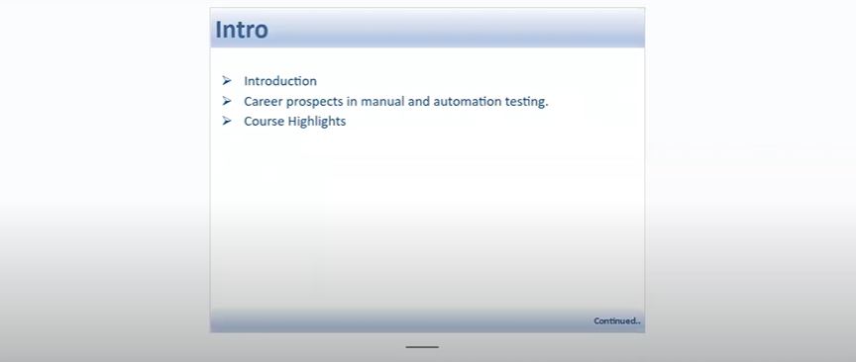

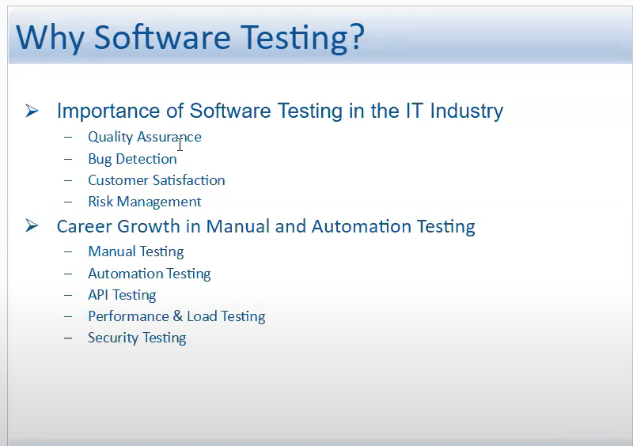

Performance & Load Testing: We use JMeter, LoadRunner tools. This is an advance level.

Security Testing - Banking app example - After refresh it logs out, to safegaurd from hacking.

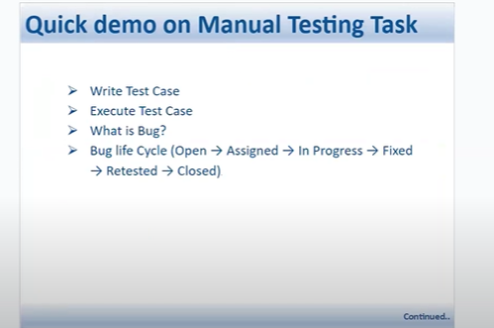

Example:

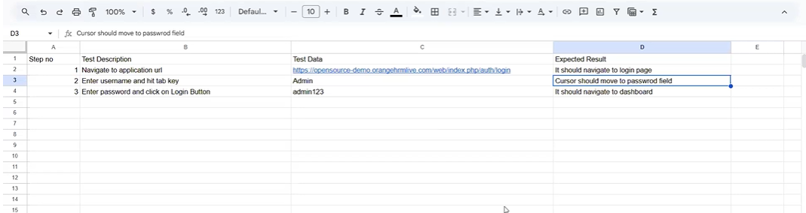

Automation Testing:

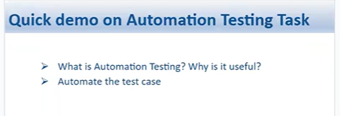

Example: watering to 100 plants daily, instead of manually watering, we can set a drop irrigation (automation).

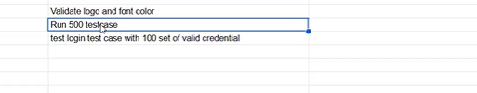

Manualy we can validate logo and font color

Run 500 TCs &

Test login test case with 100 set of valid creds - these both can be done through automation testing

Amazon - Example:

Steps to shop from amazon:

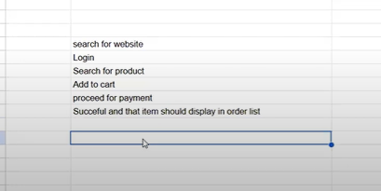

**When there is Repetitive task to perform, time-consuming task and same task with different set of data - we go for the Automation testing.**

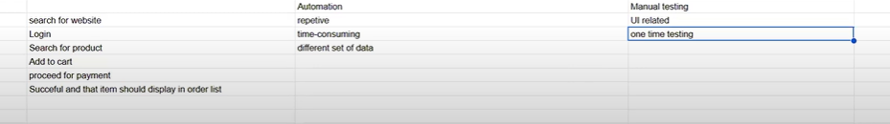

Session Approach:

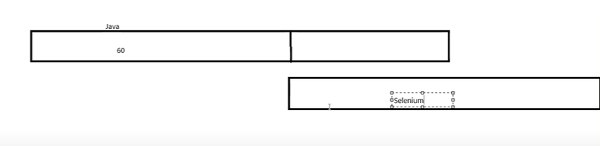

**Class 2 (Day 2)**

**ECLIPSE**

We can’t directly code in Eclipse.

We need to create Repositories / Projects first.

In one project we can have multiple folders ( Package), but we can’t have project under the project.

**Post installation of Java:**

CMD prompt : java --version

**Setting up the Path in the environmental Variable:**

Search - Environment variable

Click on “Edit the system environmental variable”

Click on the Environment Variable.

Navigate to the System Variable on the environment variable page>

Create a variable in the System Variable section.  
 Variable Name : JAVA_HOME

Path : JDK path (wherever we have installed the JDK)

Windows+E > This PC > C drive > Program files > Java > JDK  
Now copy the path.

In system Variable Section > Click on New button > and give the variable name and the path.

Now again navigate to the JDK folder > Open Bin folder > Now copy the URL   
Go back to Environment Variable > under system variable section > check if there is any Path variable available > select the path > click on Edit  
> Click on New  
> Now paste the BIN URL.   
> Click on Ok.

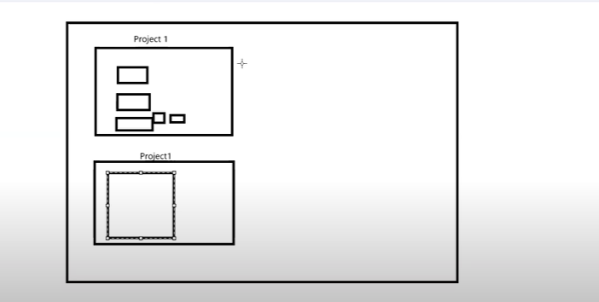

How to Create Project ?

Always the project name should be in CamelCase.

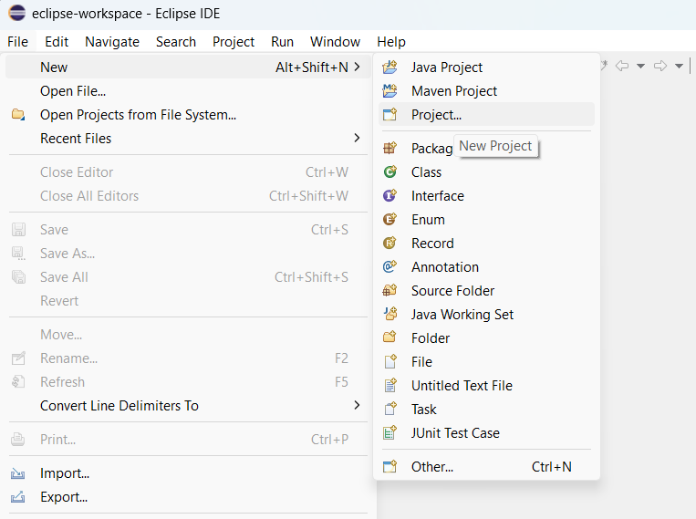

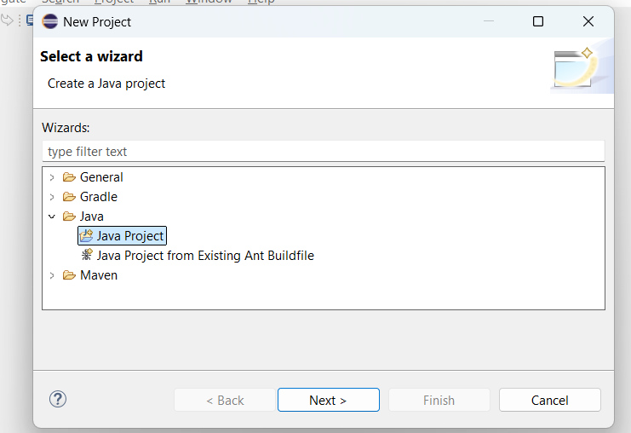

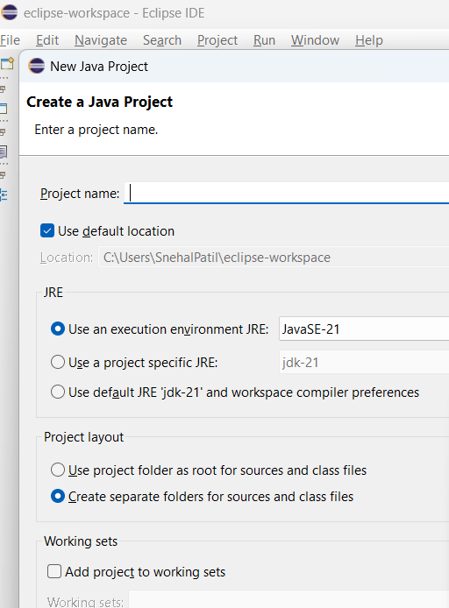

OR

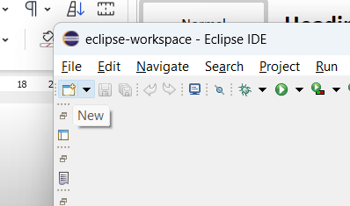

**How to Create a Package:**

Package name should always start with a lowercase letter, the continuation can be camelCase.

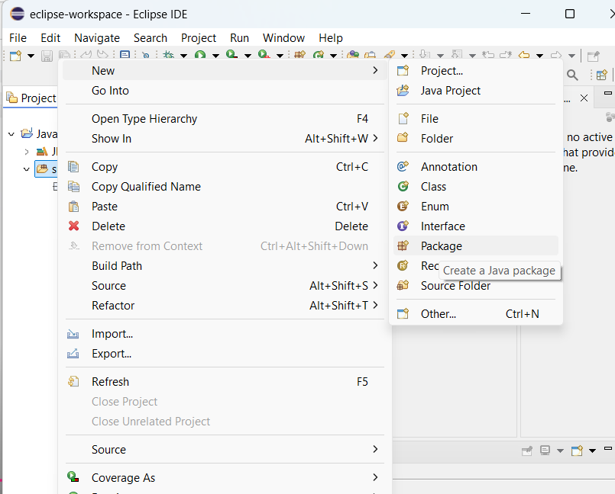

**How to Create a Java Class:**

Class Name always starts with Capital letter, further CamelCase.

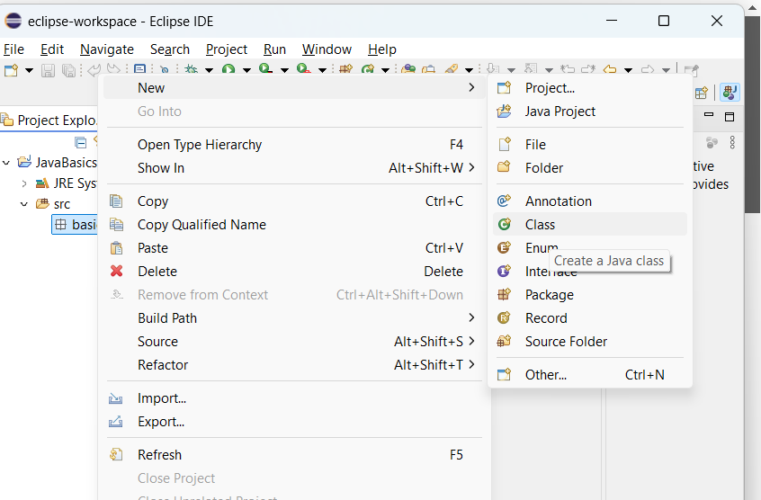

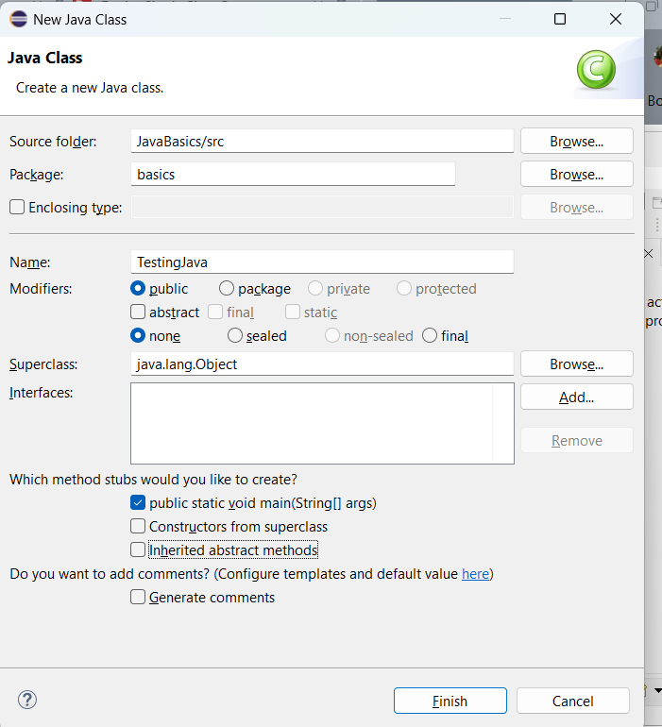

**Class 3 (Day 3)**

**How to execute Java code through terminal / command.  
  
In Note pad > write a code > Save as > FileName.java >Select All files >**

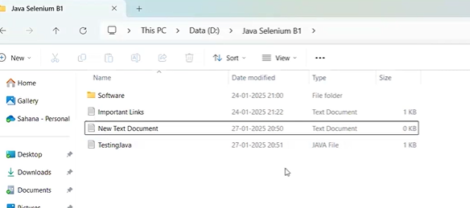  
  
Right click > open in terminal (Open in Windows Powershell) >

Compile >> javac FileName.java

Execute >> java FileName

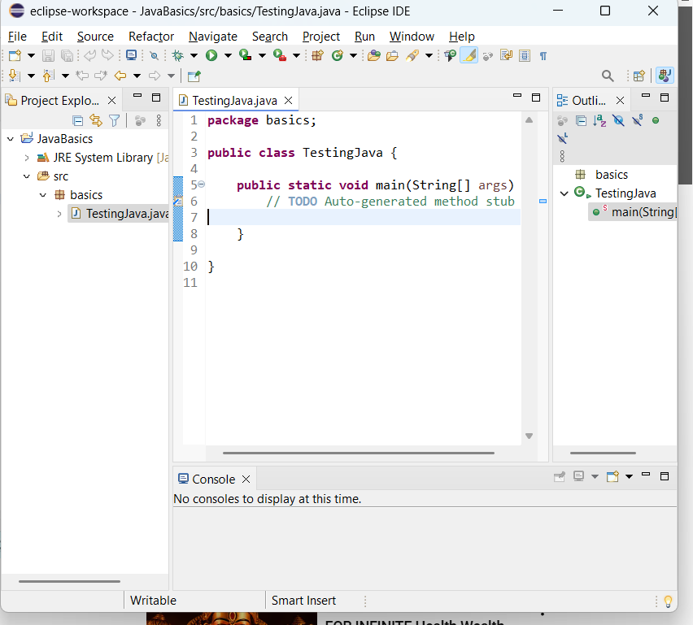

**INTRODUCTION To JAVA:**

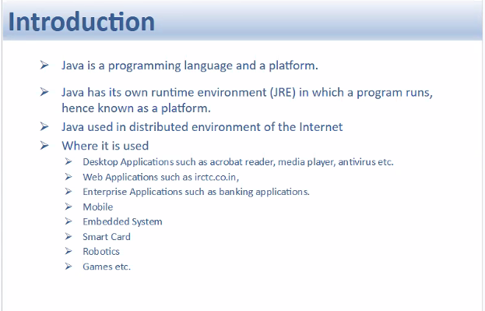

Why is Java platform independent?

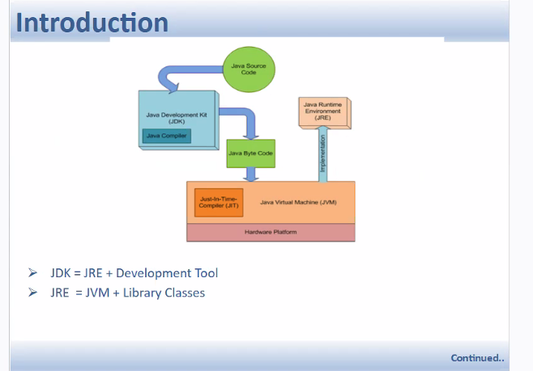

Java Source code is the entry point for the JDK.  
(Eclipse is the mediator between us and Java, it talks to JDK and JRE)  
We provide the SourceCode to the JDK.  
JDK has the Java compiler, which will converts the source code file to the class file (Java Byte Code).

This Java byte code will be executed on Java RunTime Environment.

Each OS have different types of Run time environments.

Compiled Java Byte code can be executed on Any machine.

The same class file if we execute on any of the OS, the code will be executed.

Hence, Java is platform-independent.

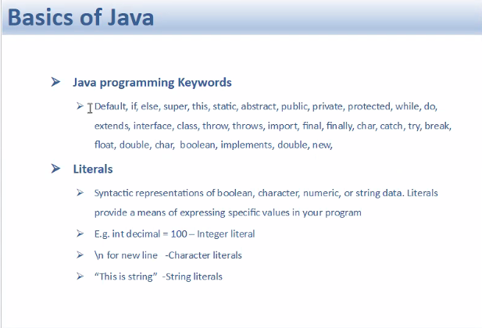

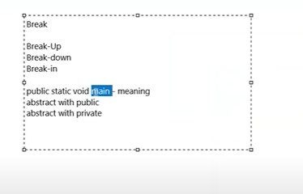

Individual words are called as Keywords  
  
When we combine multiple keywords to form a meaningful statement, that is called “Literals” in Java

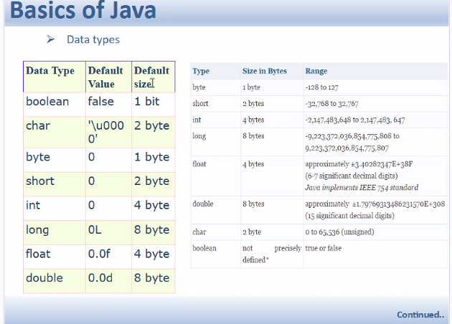

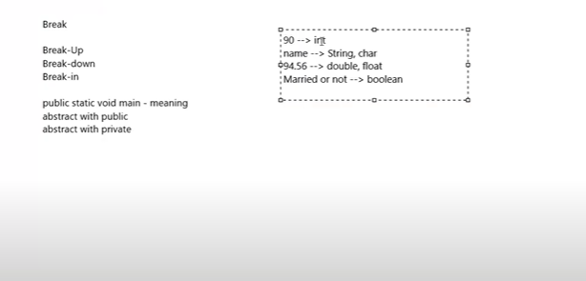

Boolean 1bit

Char 2 byte

Byte 1byte

Short 2 byte

Int 4 byte

Long 8 byte

Float 4 byte

Double 8 byte

**CLASS, METHODS & OBJECTS:**

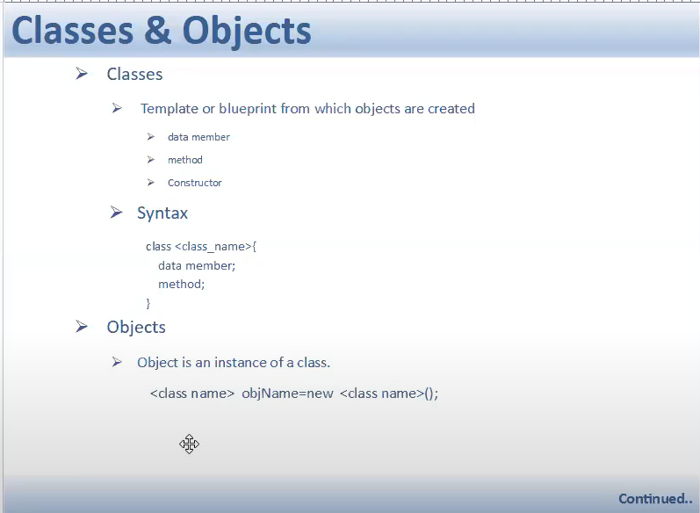

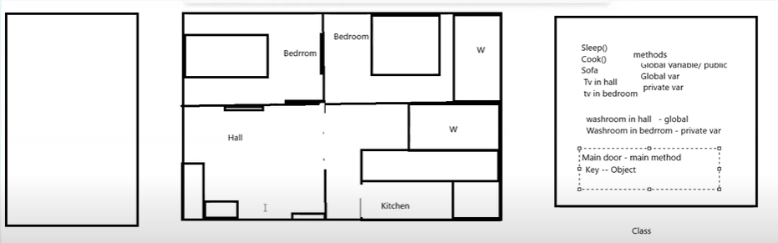

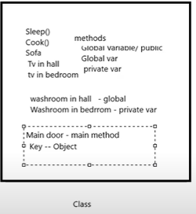

* This entire thing is Class (Flat)
* Functionality is called as Method.
* Main door is -> Main method
* From one class to access another class we need the Object.
* We will create the Object in Main Method.

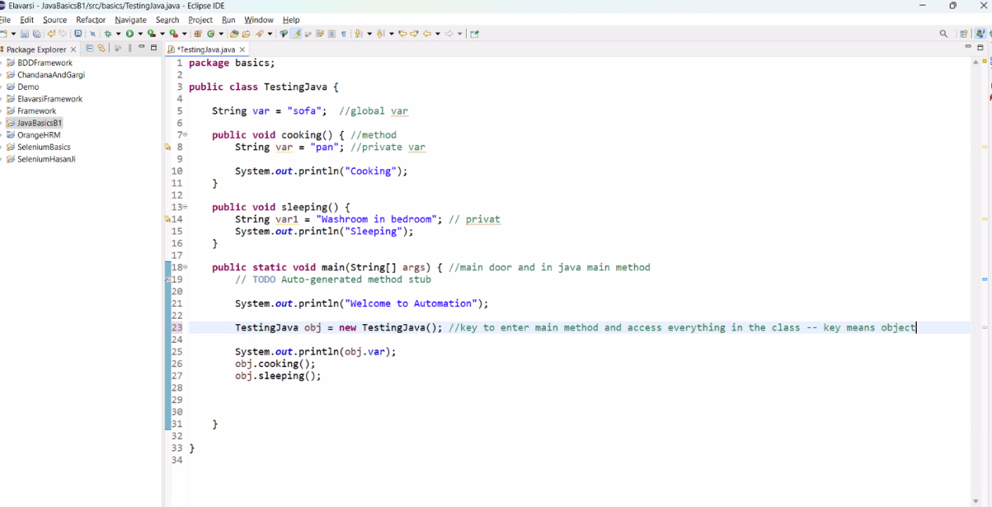

**Access One Class in Another Class using Object**

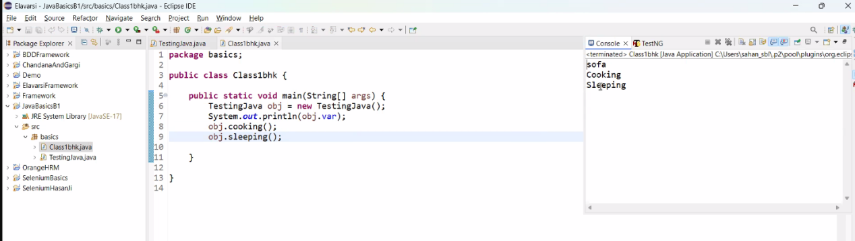

**PACKAGE: (**Folder / **Floor):   
A group of classes**

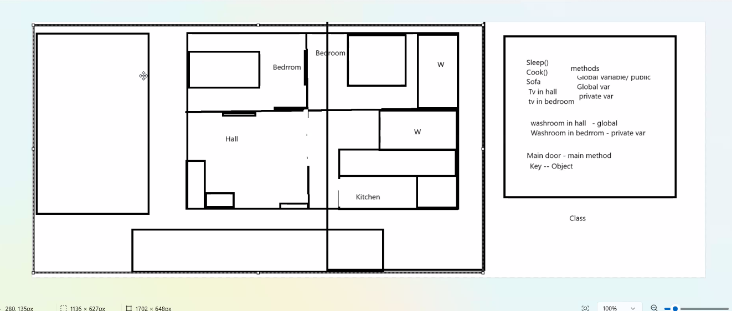

**PACKAGE ->** A group of multiple classes (flats).

**PROJECT ->** Group of Packages (group of Floors - 1 Building)

**Class 4:**

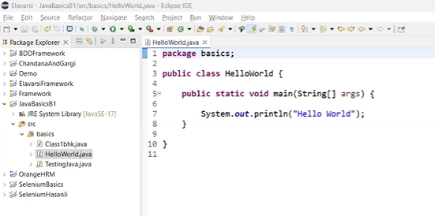

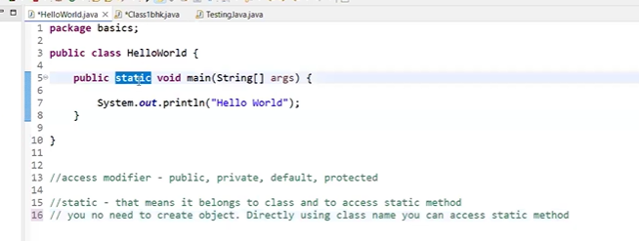

Package name

* Public class CutomisedName{} ->  
   public and class are the keywords
* Public - we can access publically
* Main method is the entry point for a class, from where the execution begins.  
  This main method can be accessed from outside this class as well since it is declared as Public.
* Static - that means it belongs to class and to access this static method no need to create an object.

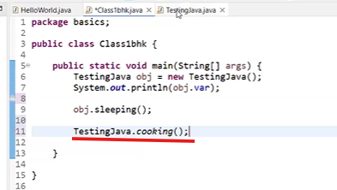

* Void is a return type and when you declare method as void, it will not return anything.
* String[] - String of array
* Args - Variable

Main method accepts the command line arguments as string of array.

Print - Prints in a single line and without space

Println - Prints in next line

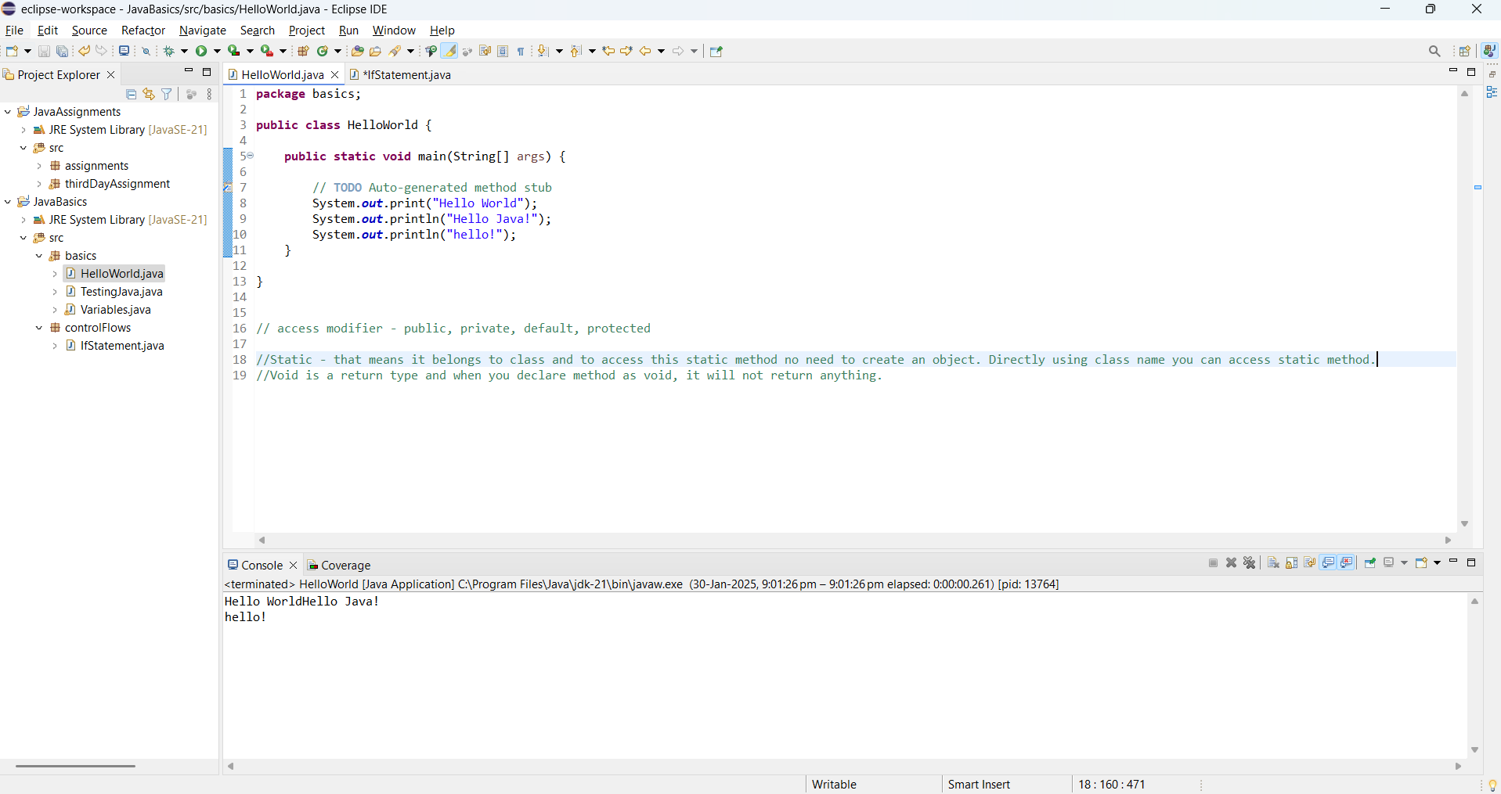

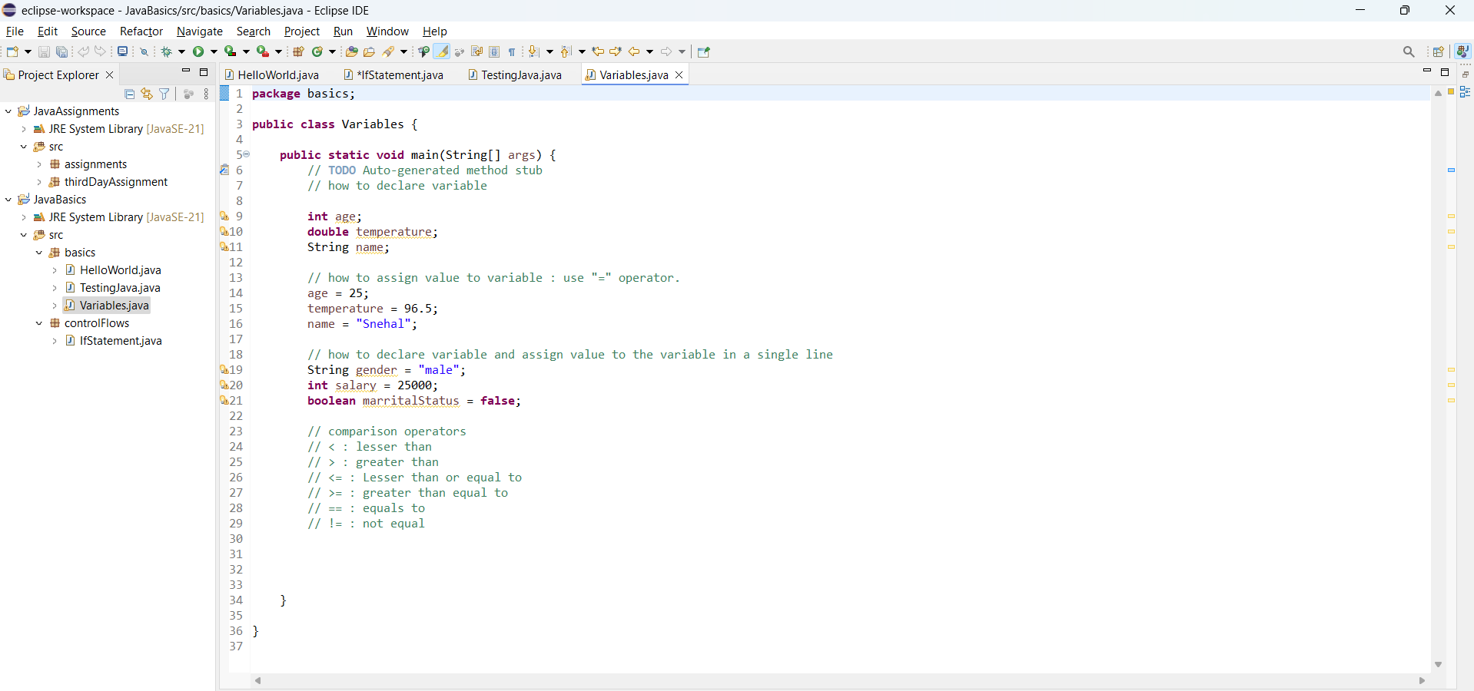

Create a new package and class > **conditional Flows**

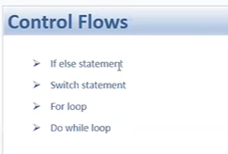

>> If Statement:

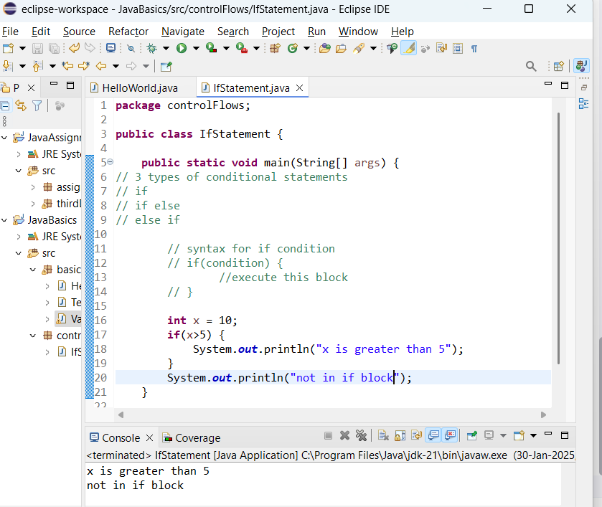

If else statement:

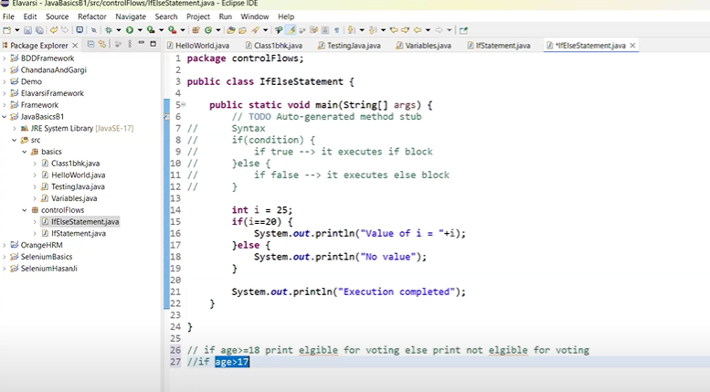

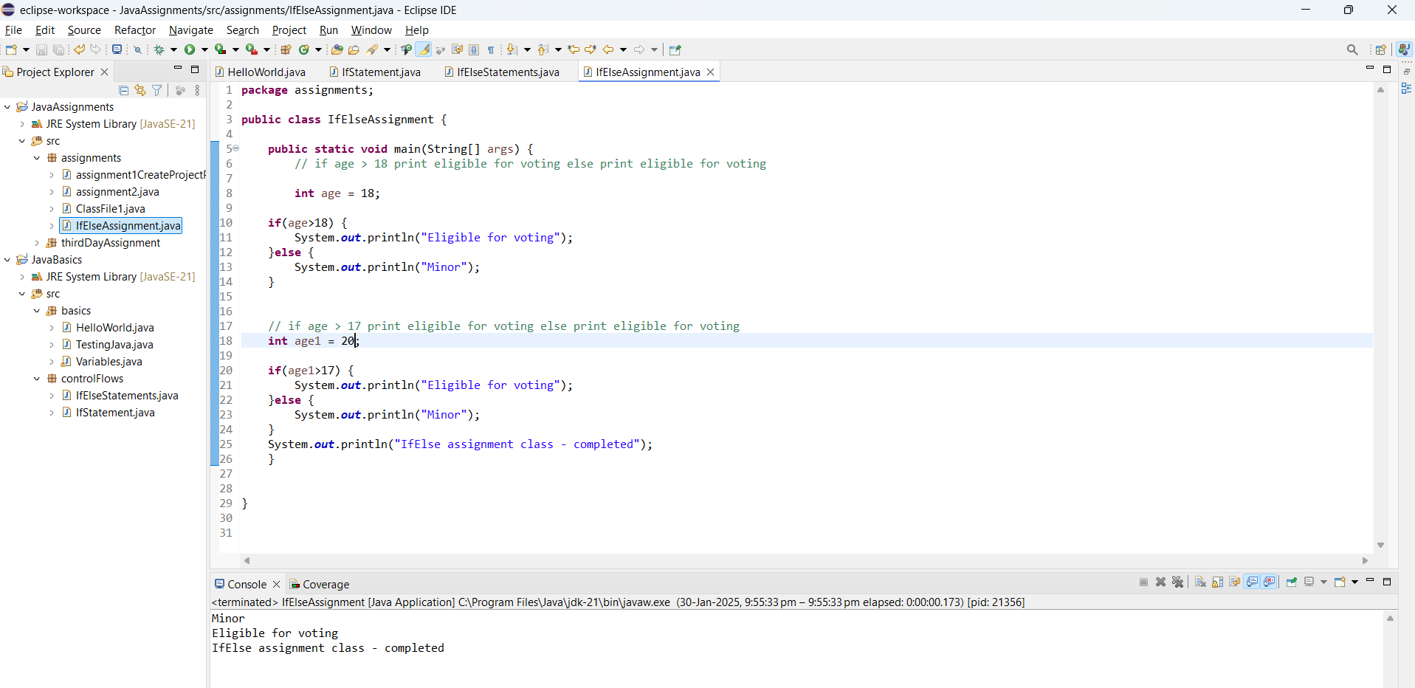

**Class 5:**

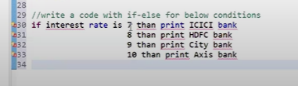  
  
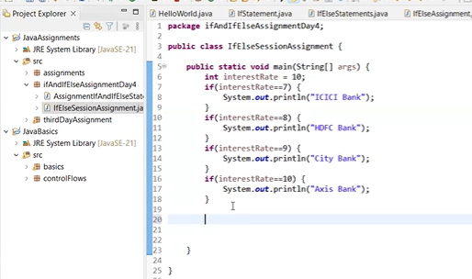

Else If statement:

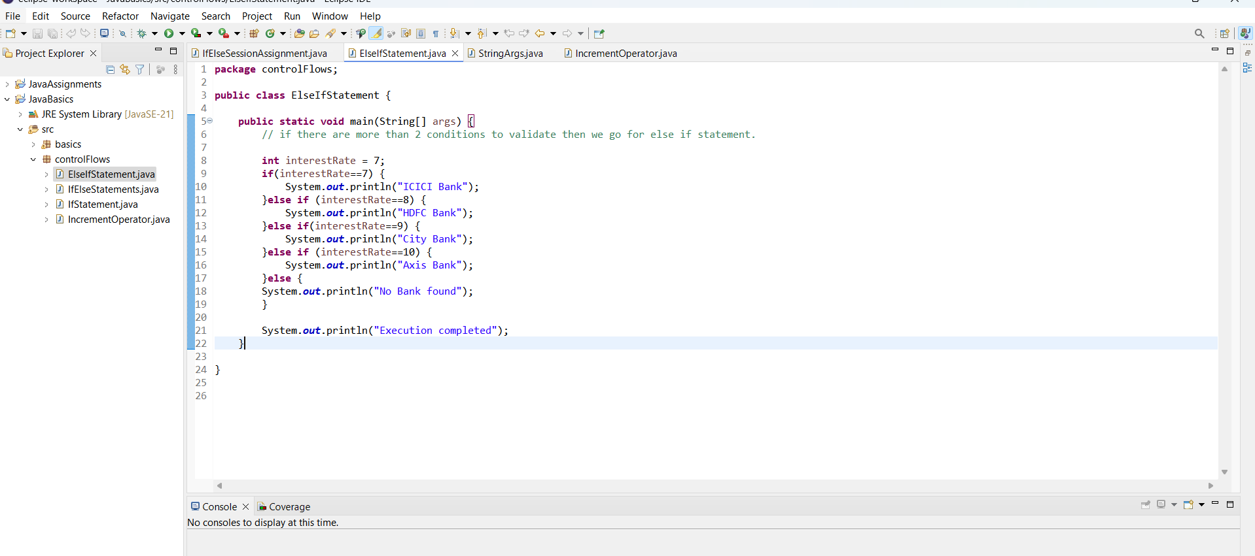

String[] Args :

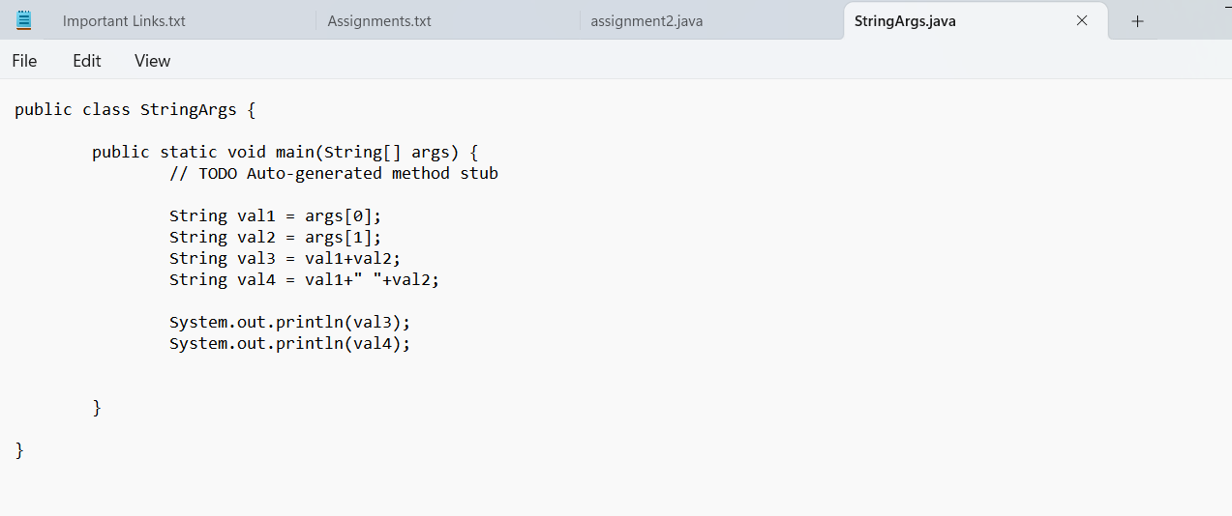

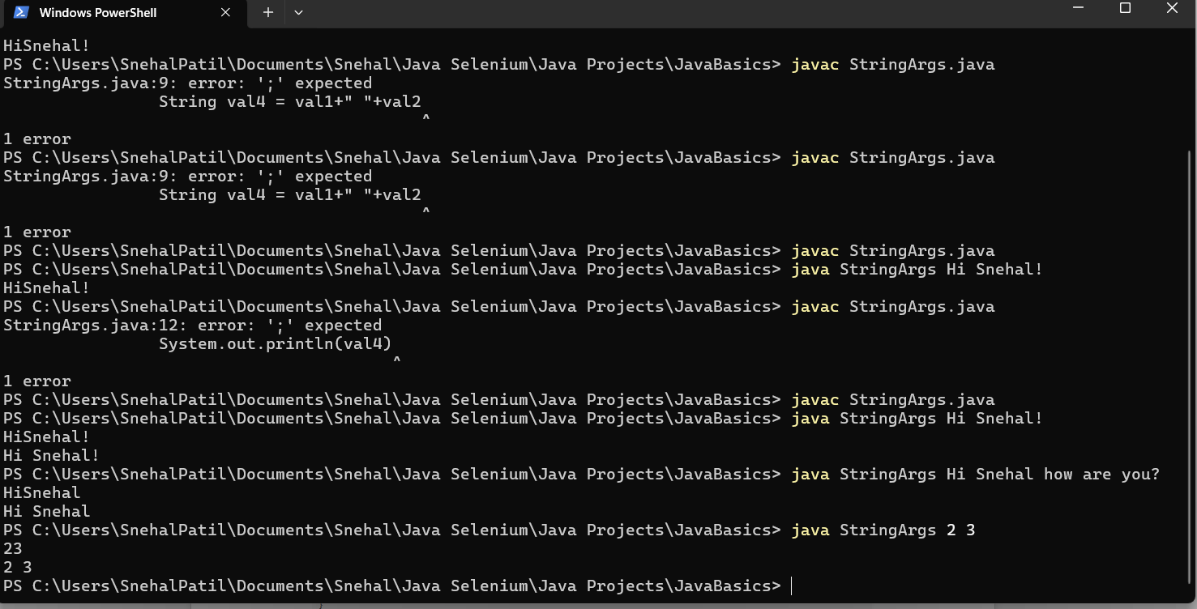

**Increment Operator:**

Pre increment

**int** x = 5;

**int** y = ++x; // x+1

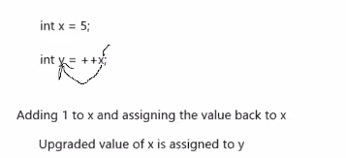

Post increment

**int** a = 5;

**int** b = a++; // a+1

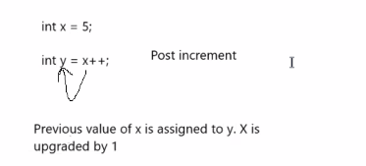

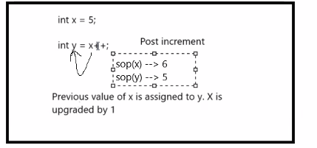

**Class 6:**

**Decrement Operator:**

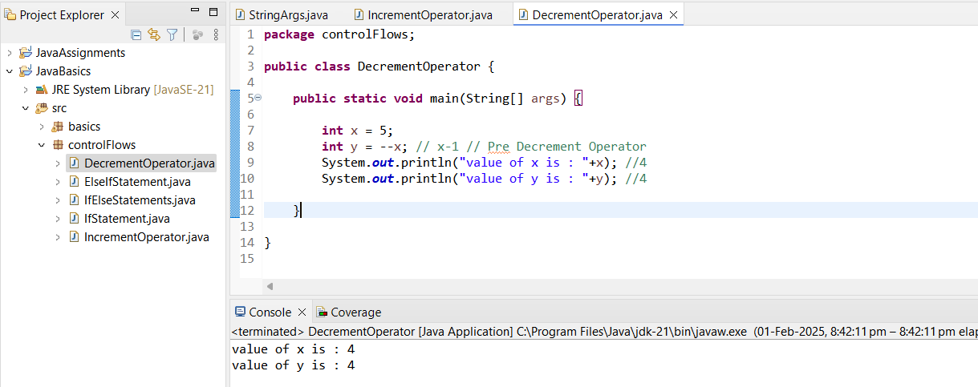

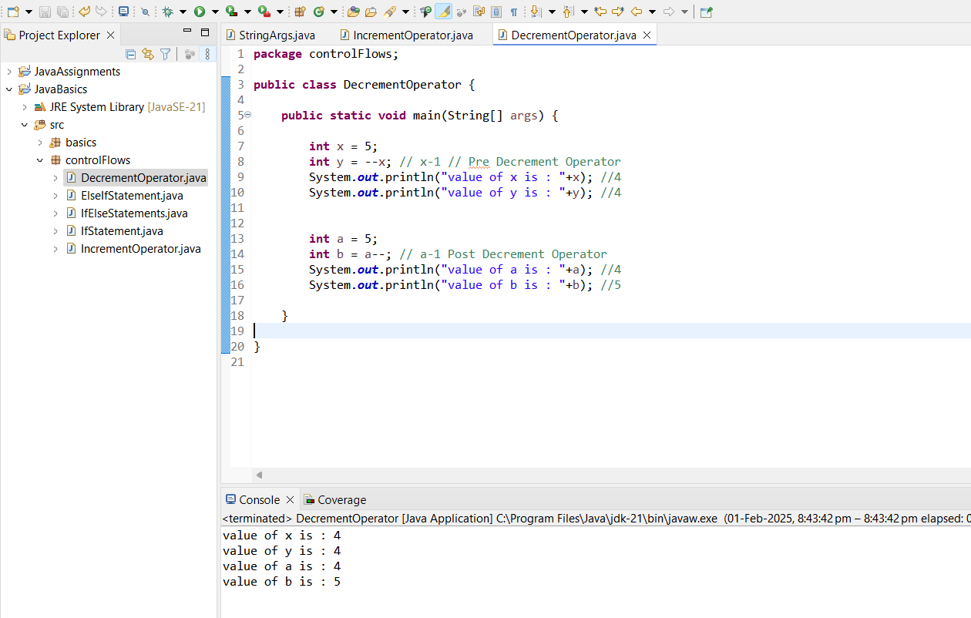

**FOR LOOP :**

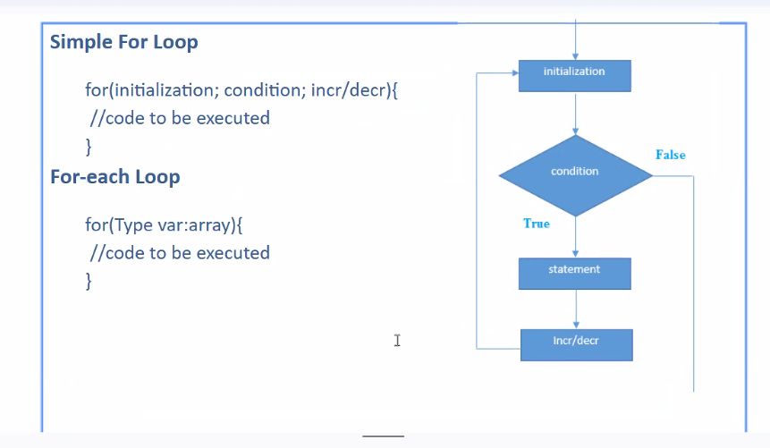

**Initialization** -> Declare a variable and asssign the value to the variable.

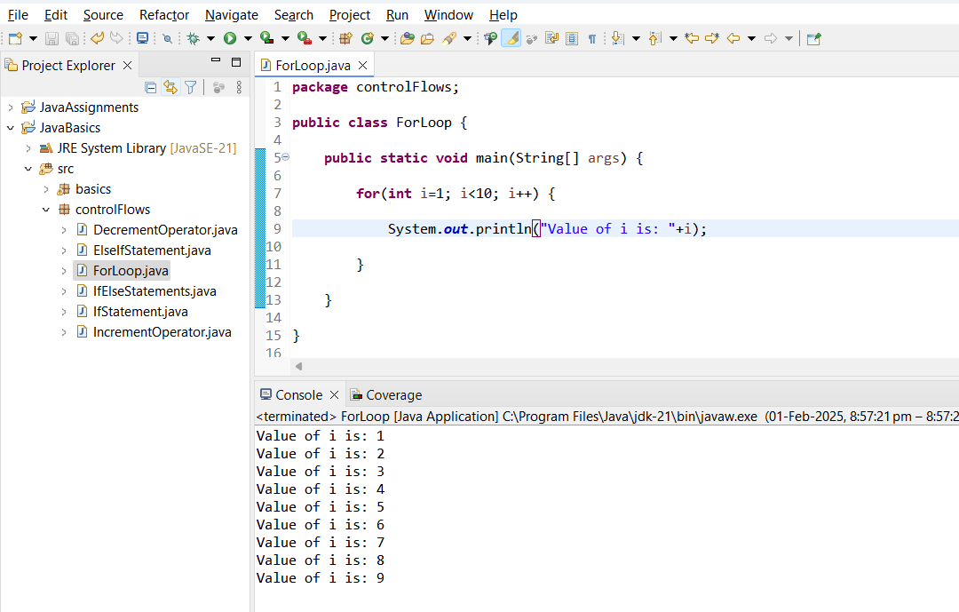

**Debug Mode:**

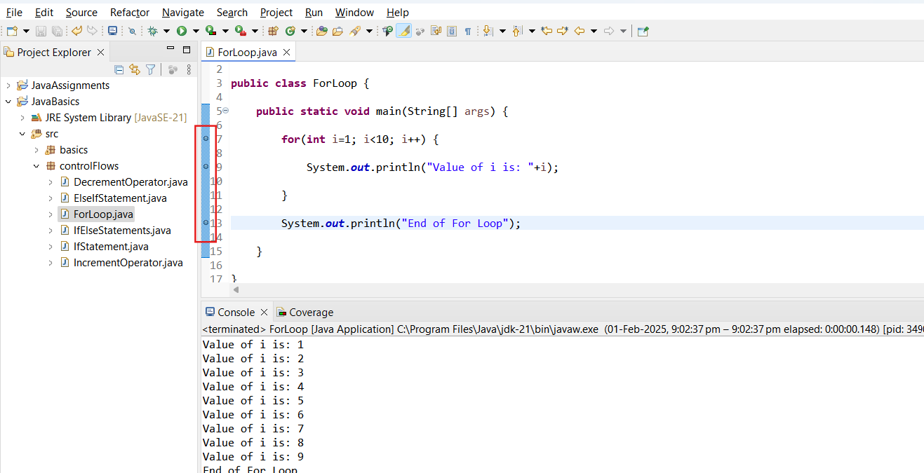

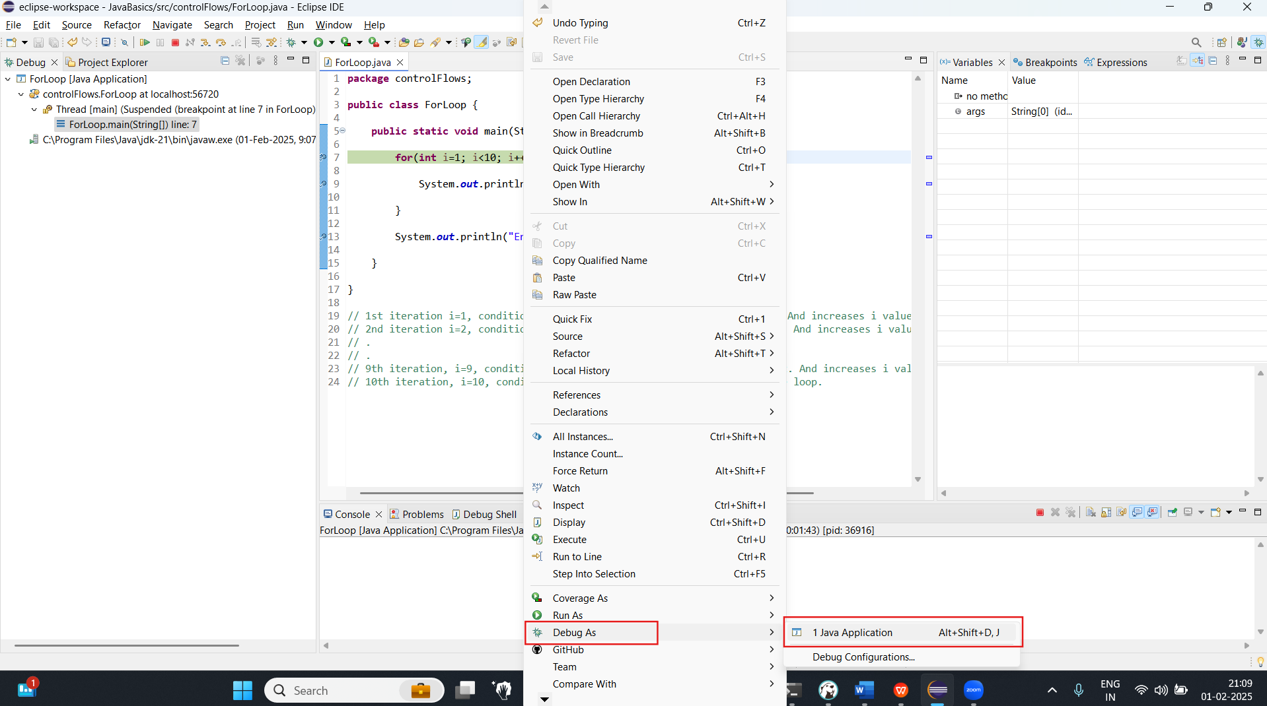

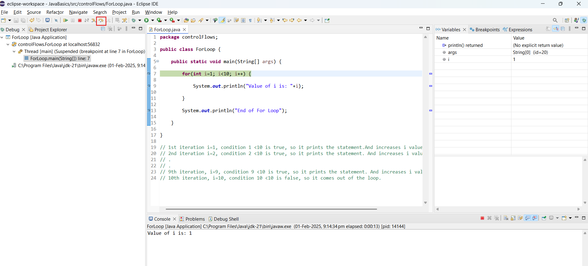

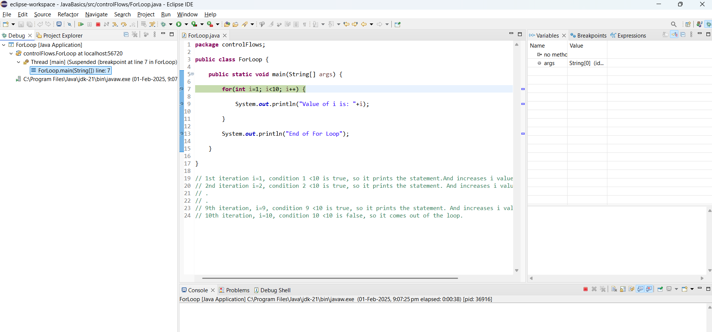

Incrementing and decrementing for loop assignment:

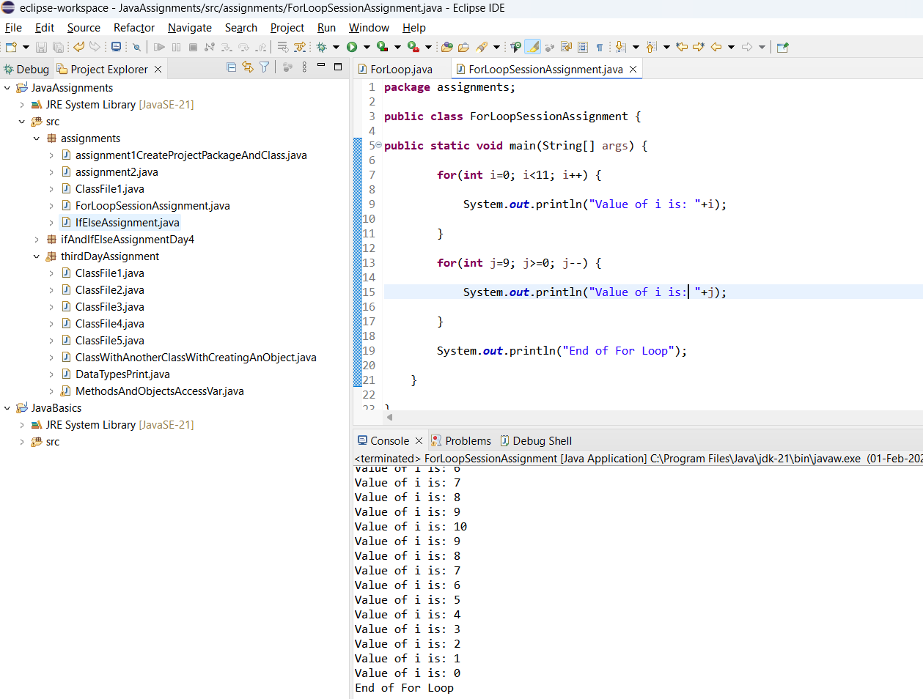

Assignment to print :

0 9

1 8

2 7

3 6

4 5

5 4

6 3

7 2

8 1

9 0

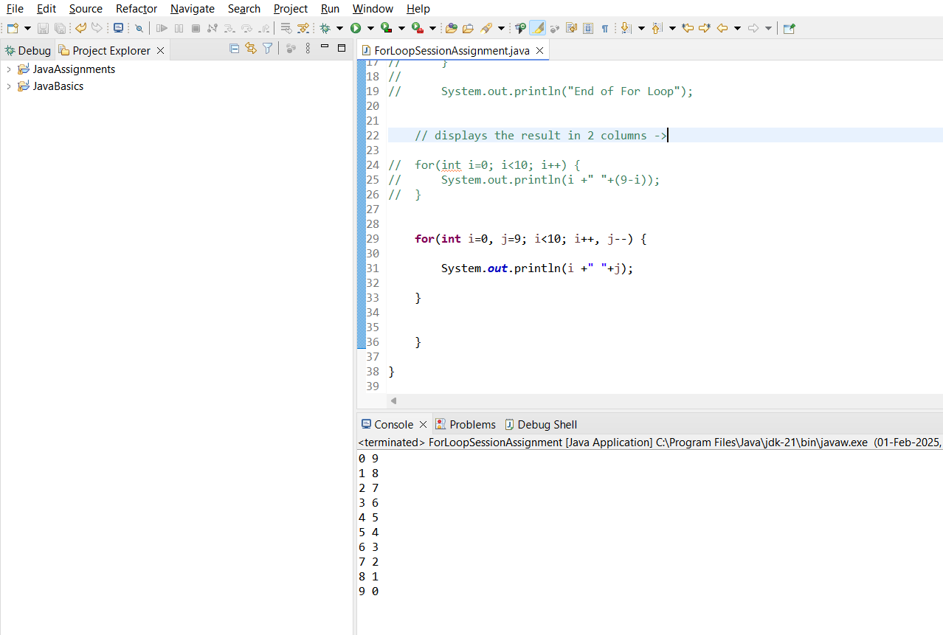

**Class 6:**

Star Patter Assignment using For loop:

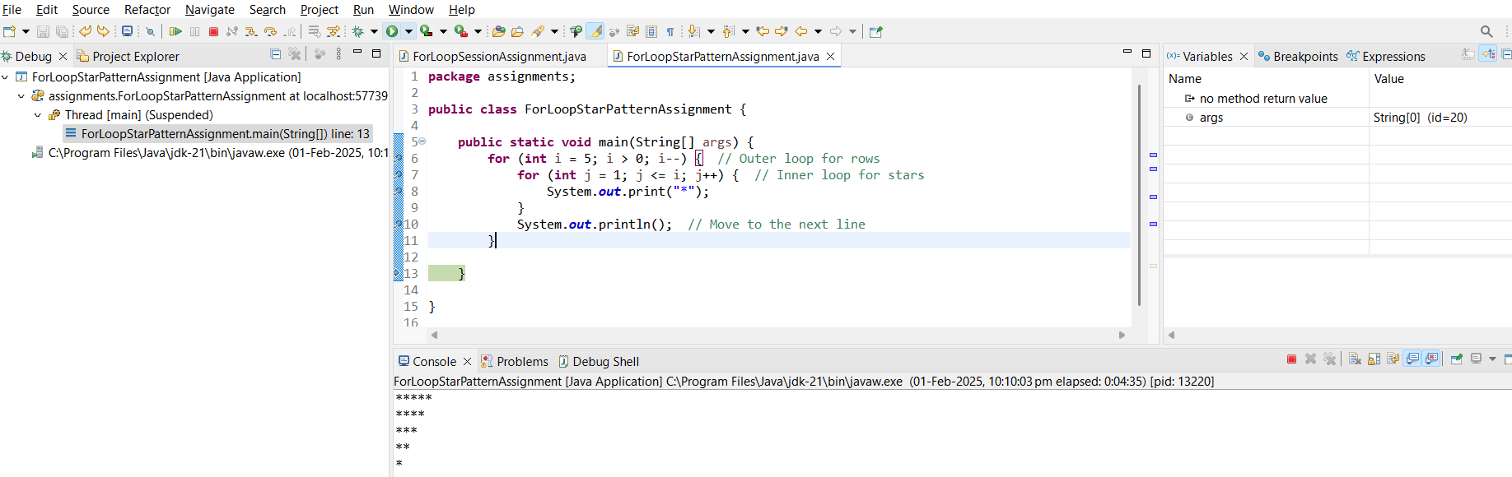

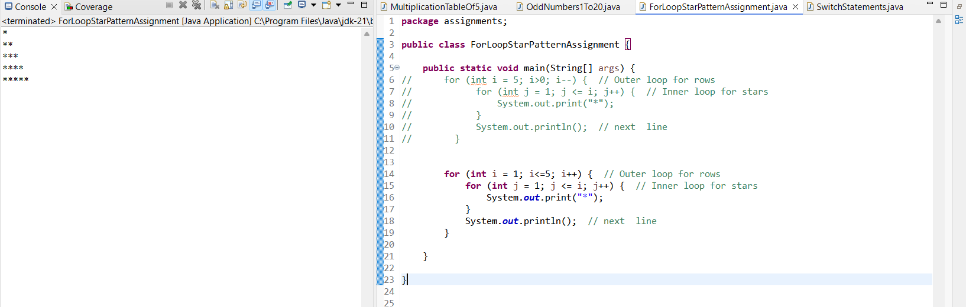

Switch Statements:

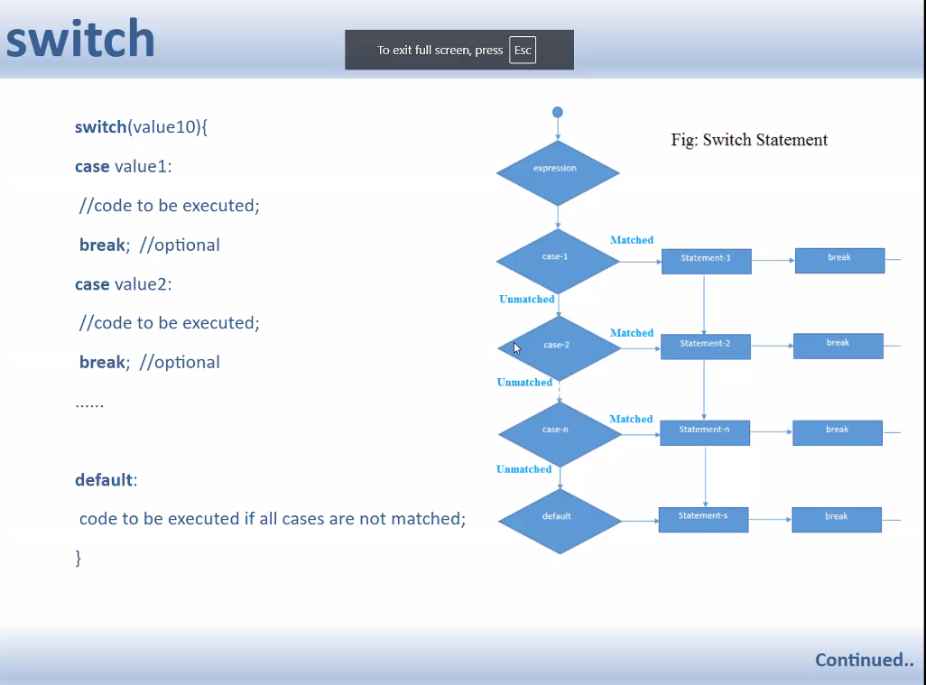

If there is no break, irrespective of the expression matches with the case, all the statements will get executed.

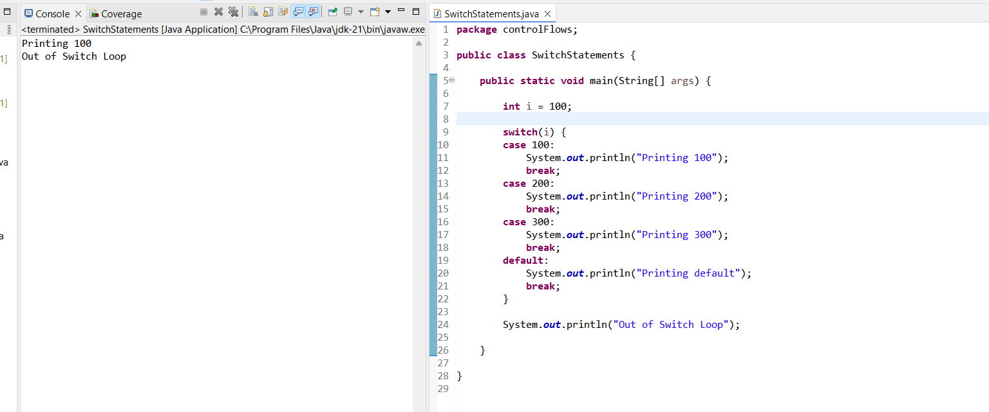

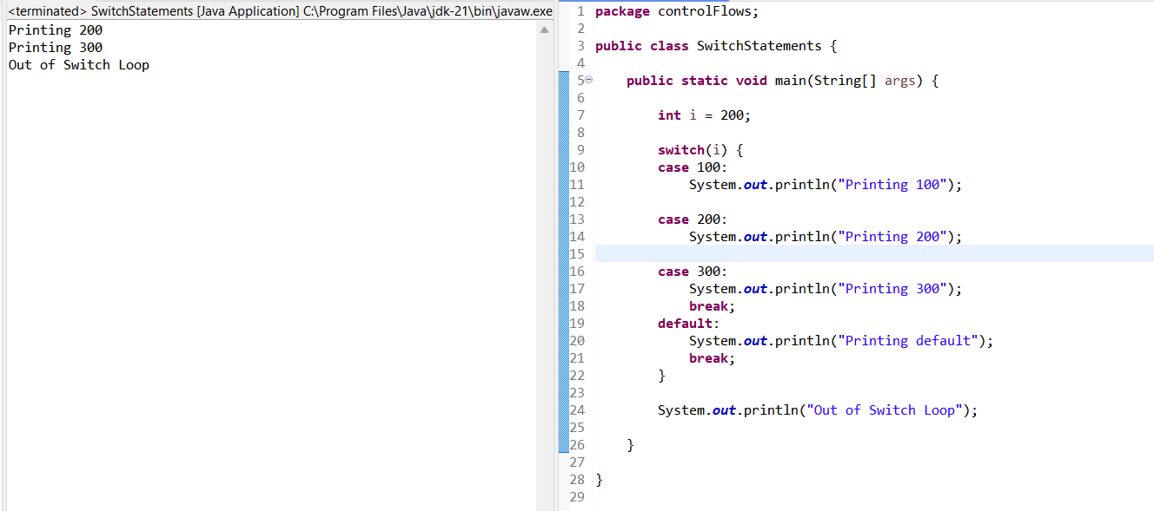

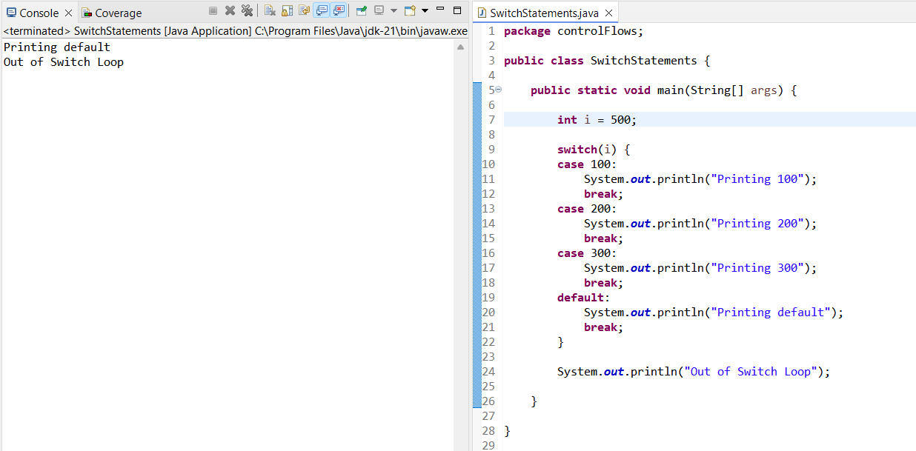

Control+I => Indentation

**Local, Instance & Static Variable:**

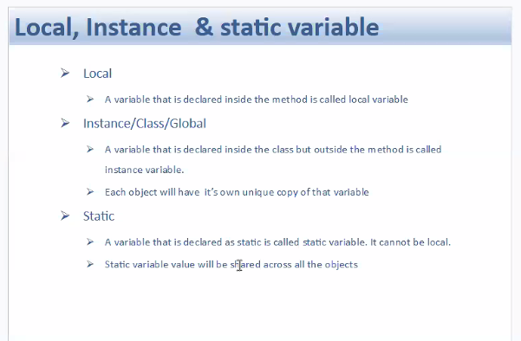

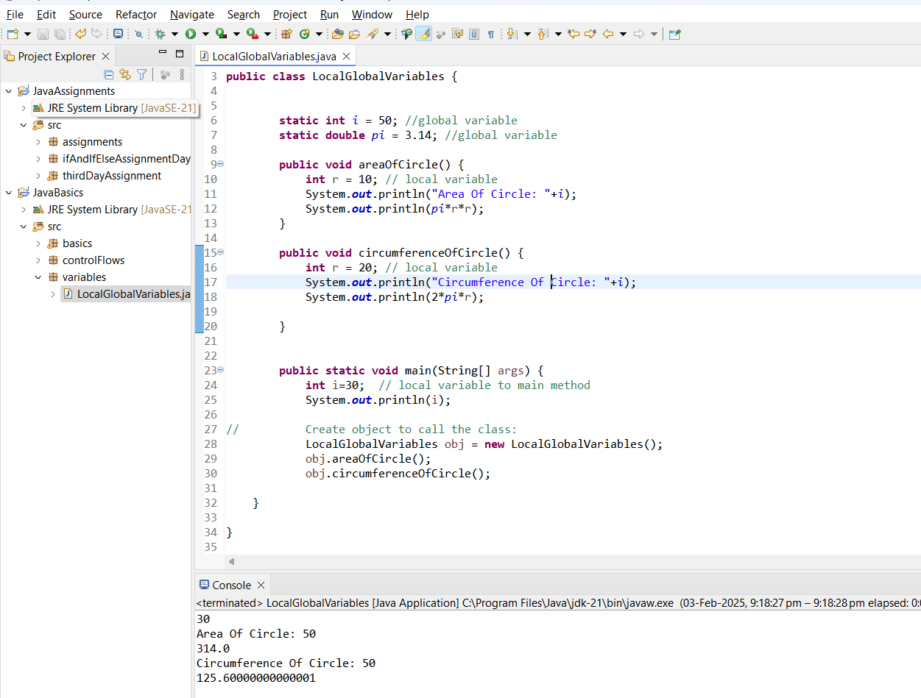

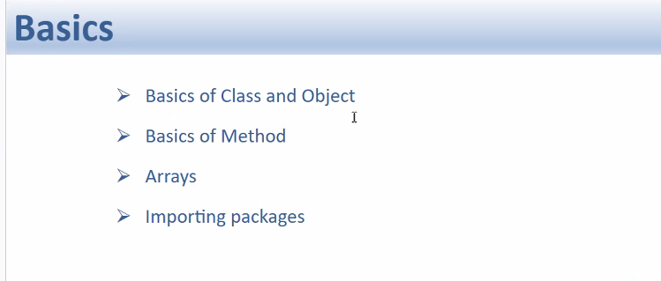

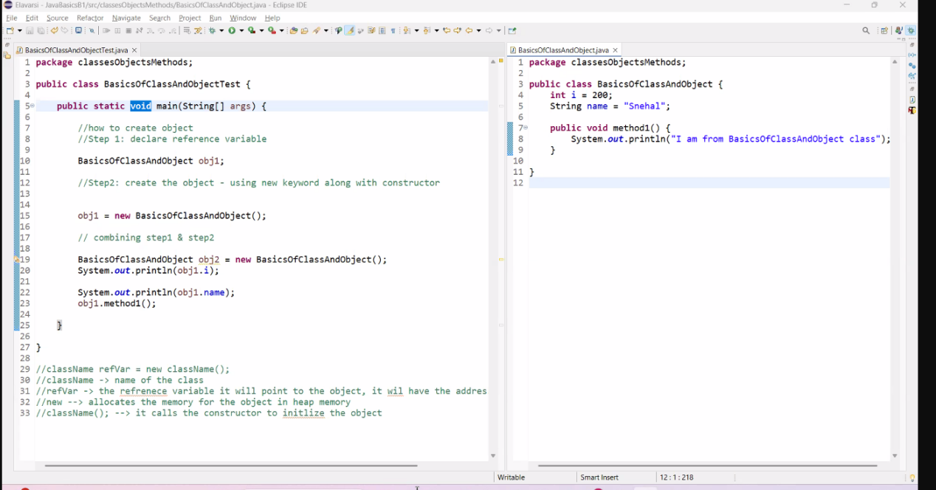

* ClassName refVar = New ClassName();
* ClassName --> Name of the Class
* refVar --> The reference variable that points to the object, it will have the address of the object
* new --> allocates the memory for the object in heap memory
* className(); --> it calls the constructor to initialize the object

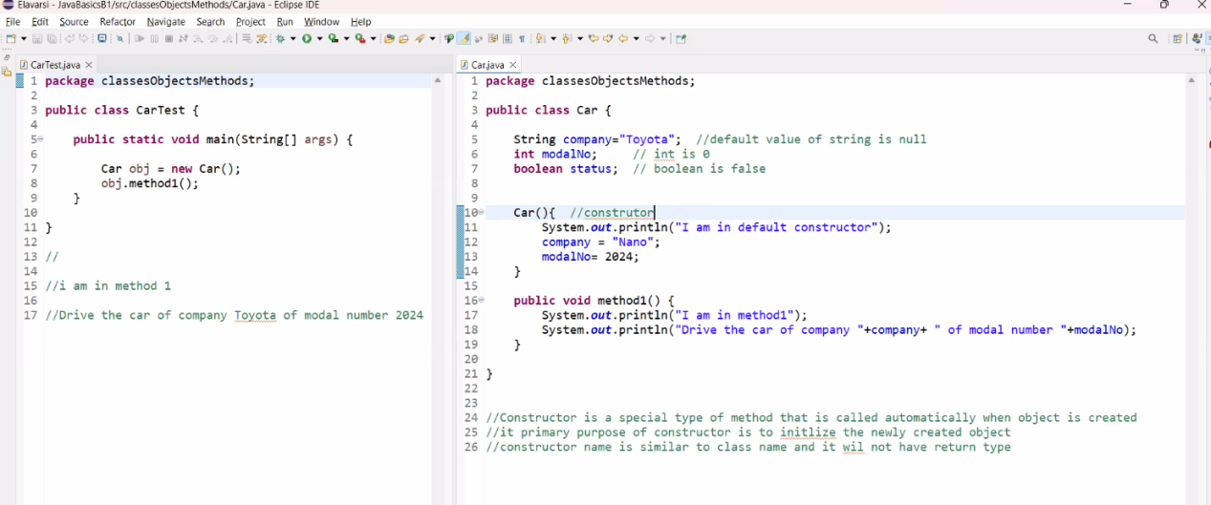

When the object is created the constructor will be called automatically.

**METHODS:**

* All the reusable codes can be combined and kept under method.
* The main use of method is to - Encapsulate the reusable code and call wherever it is required.

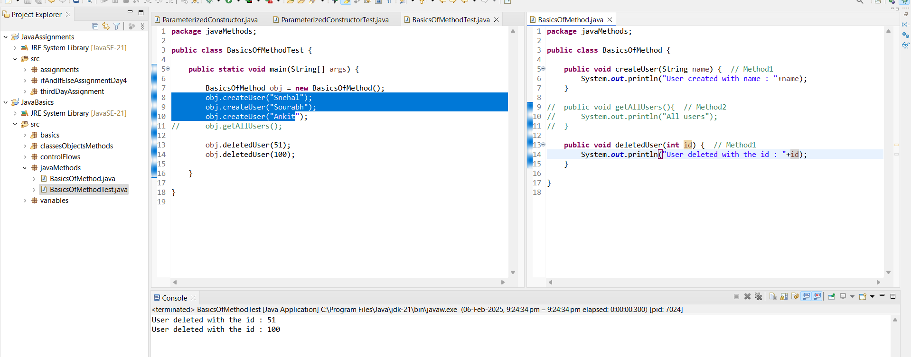

**RETURN TYPE:**

**Examples:** int, boolean, double  
void - is non return type

**String is a class, not a data type. String has multiple methods associated with string class.**

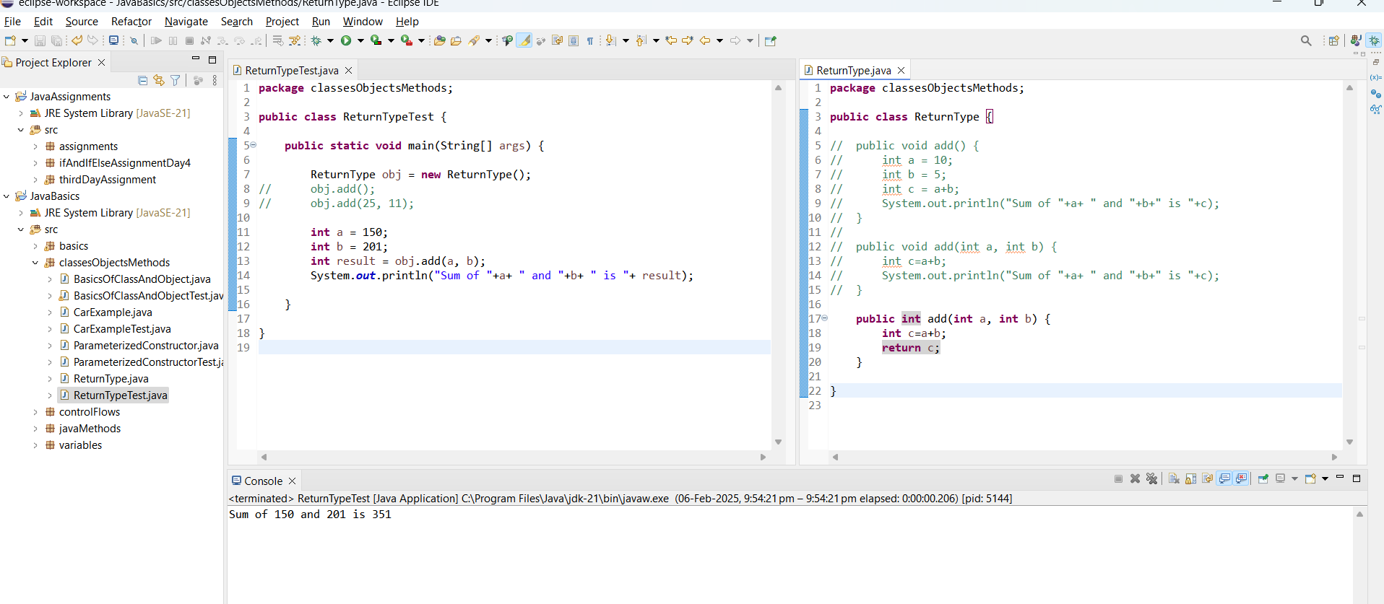

Assignment:

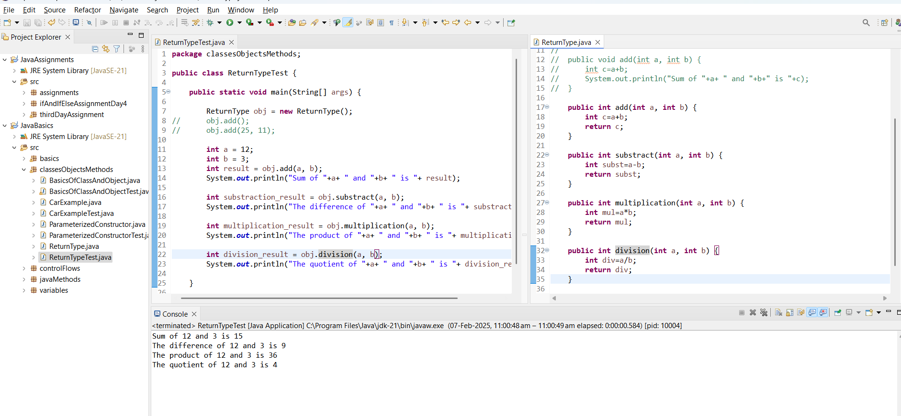

Dynamic methods:

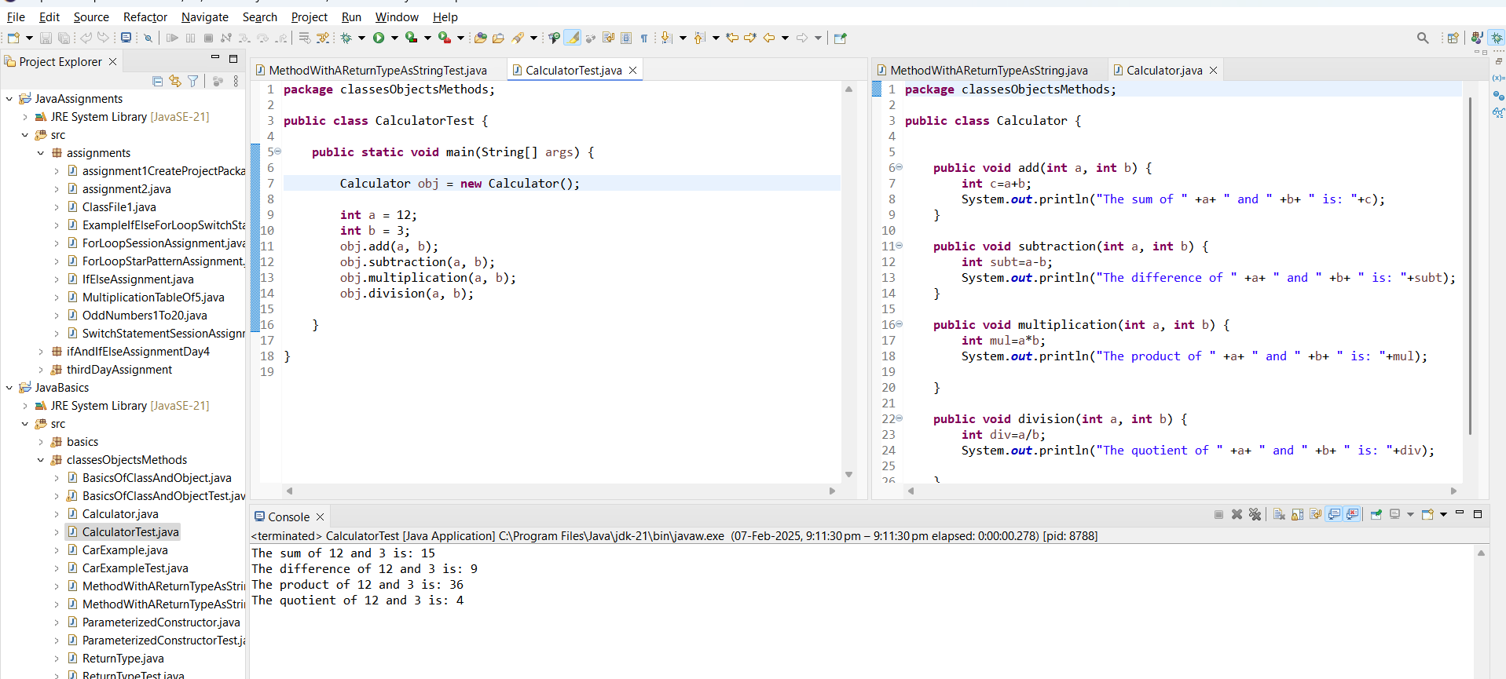

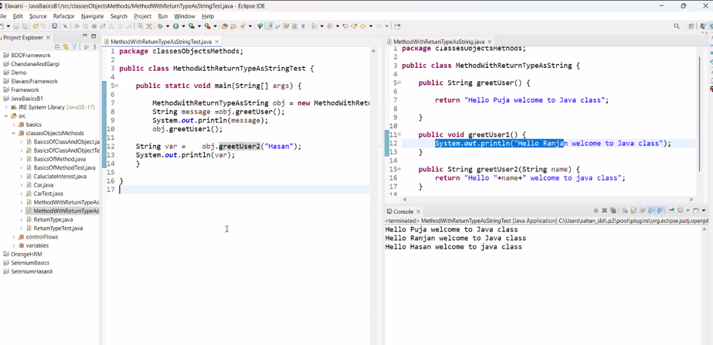

**All Return Types:**

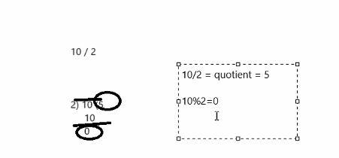

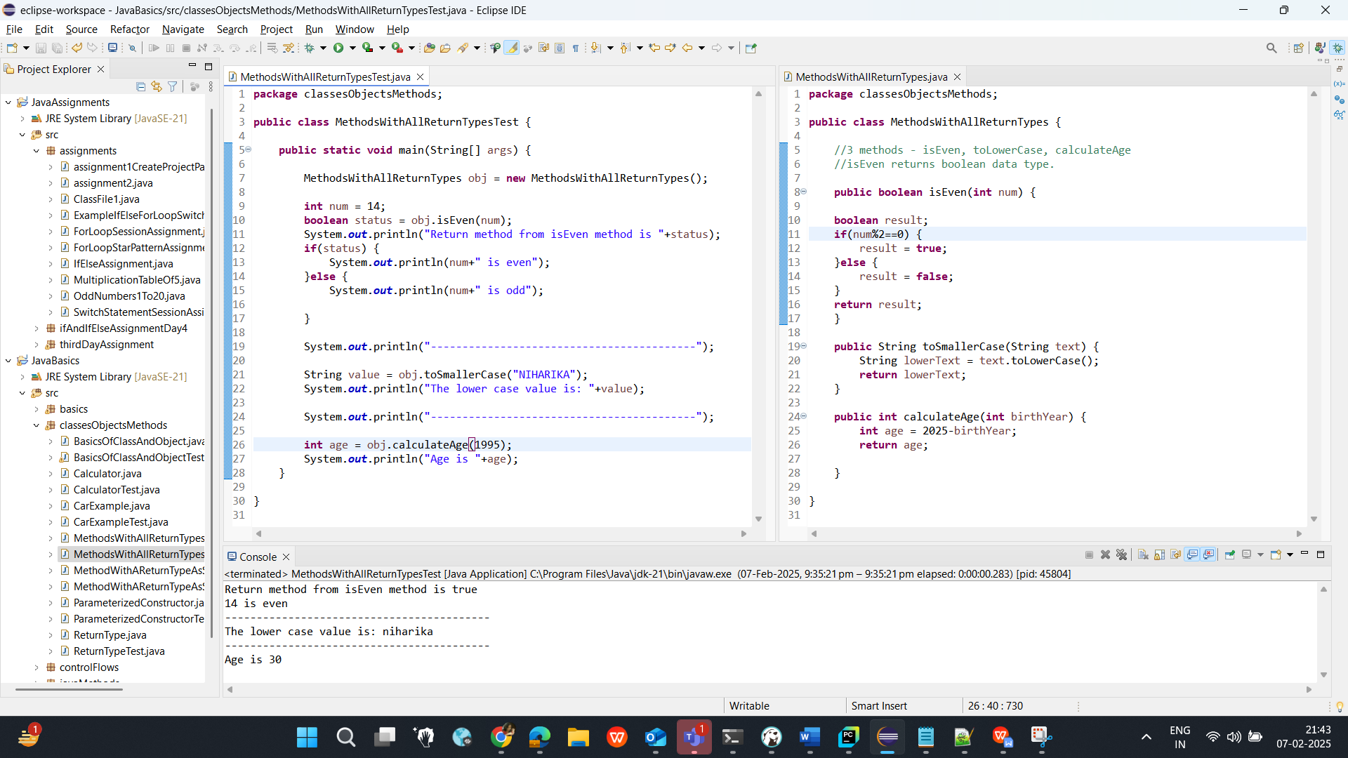

ARRAYS:

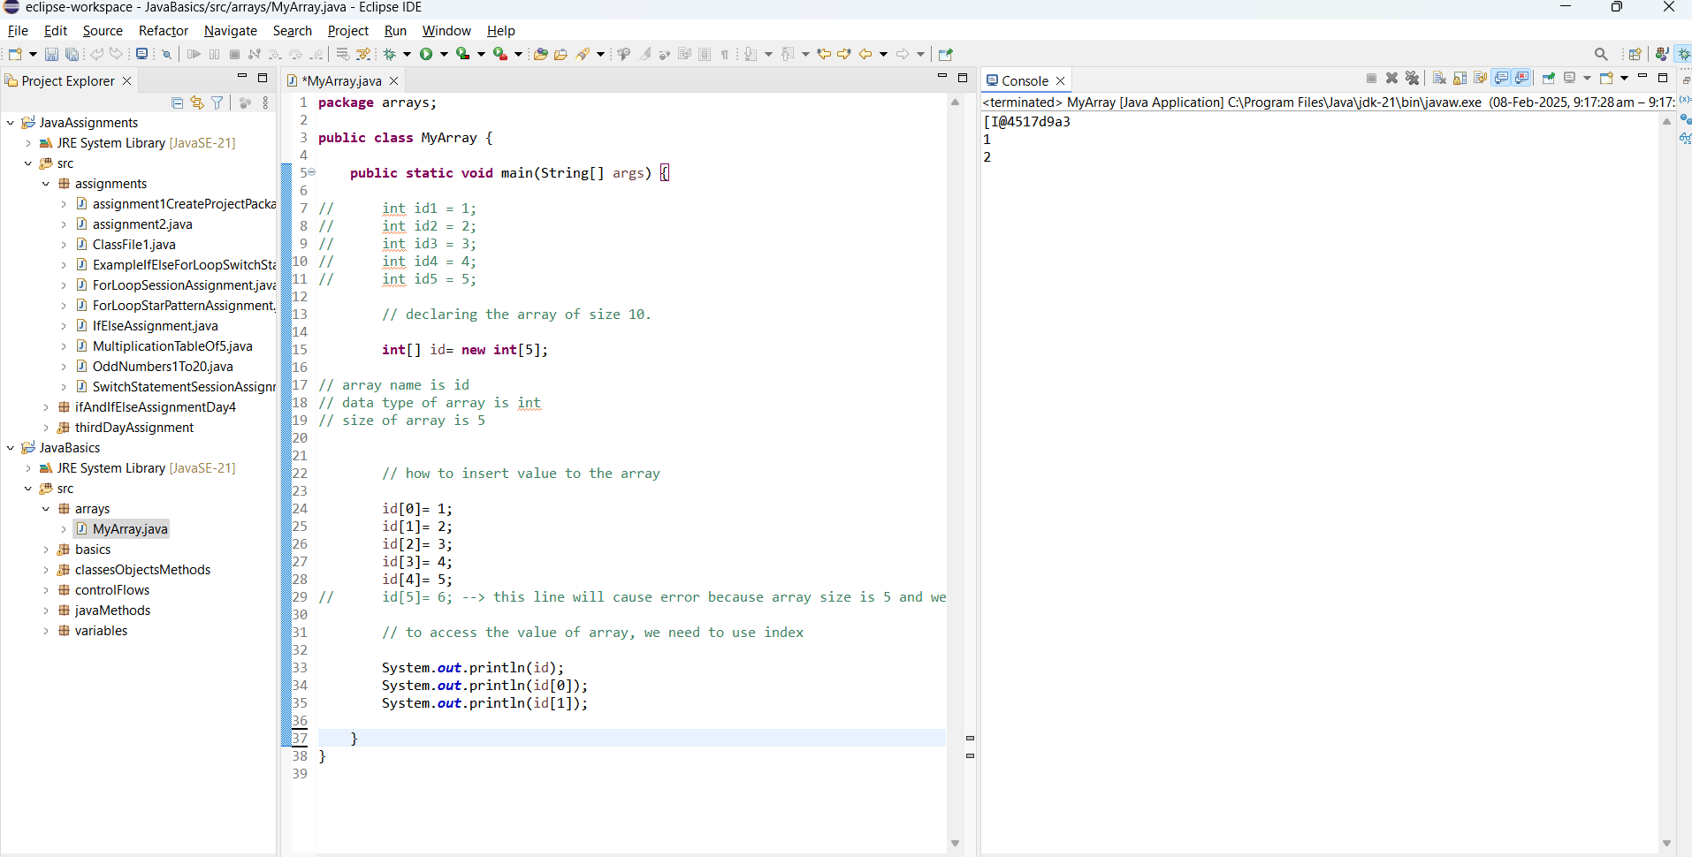

**Advance Array:**

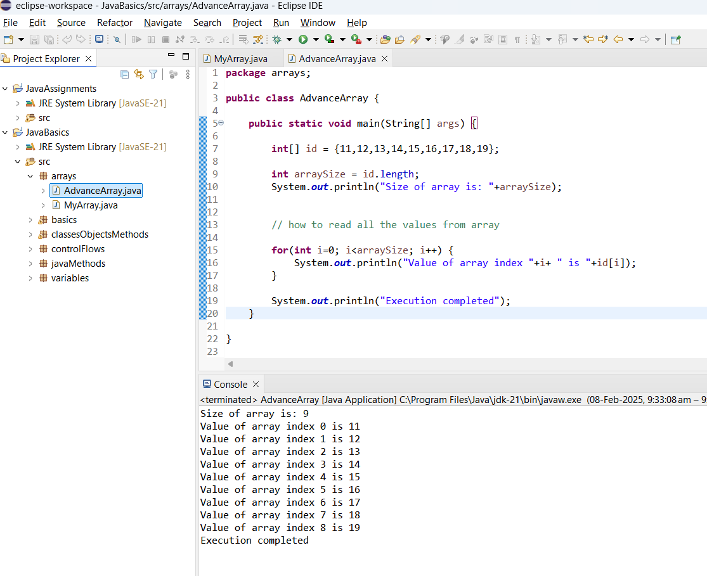

For Each loop:

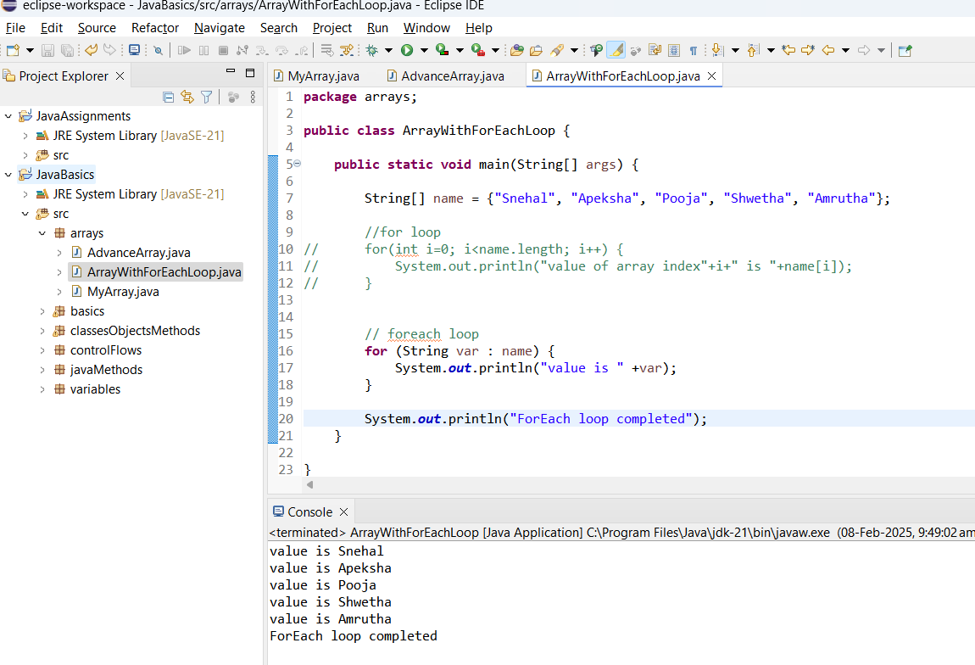

Disadvantages of For Each loop:

1. We can’t append / modify the array when we use For Each loop
2. We can not access the array index

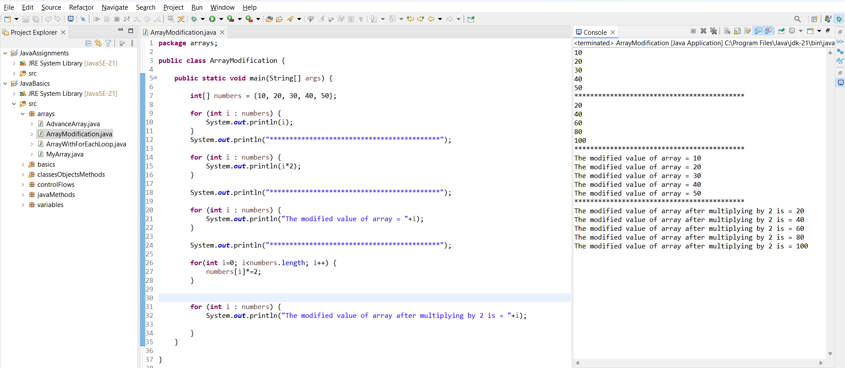

**Access Specifier:**

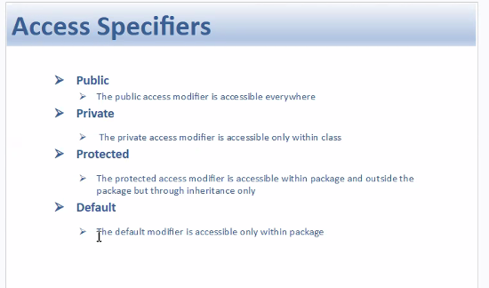

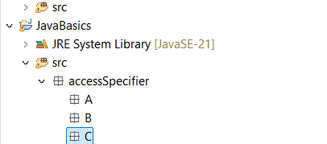

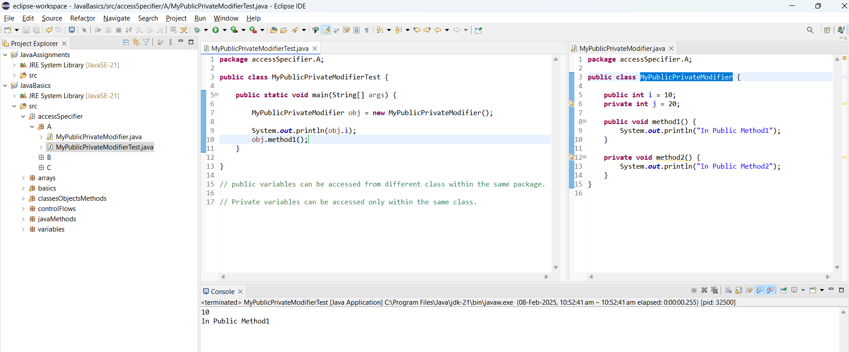

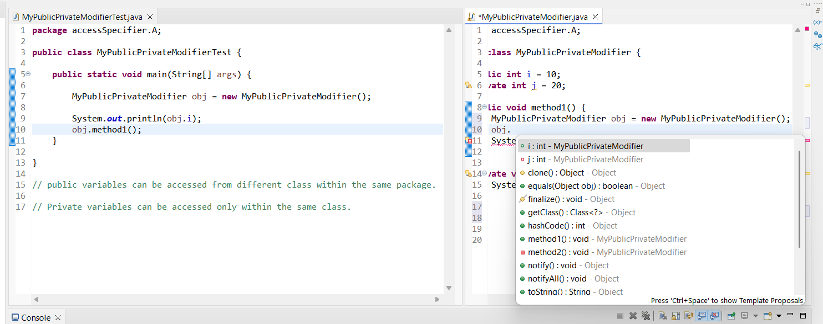

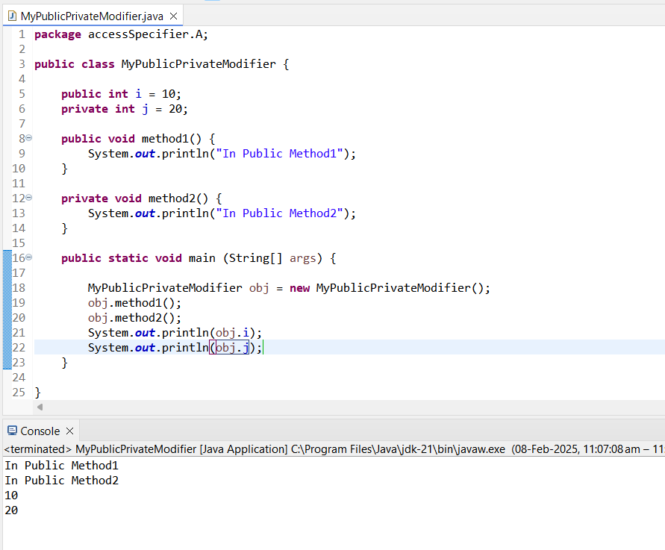  
  
Assignments 5

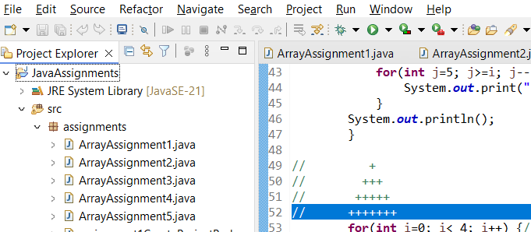

Public Access Modifier:

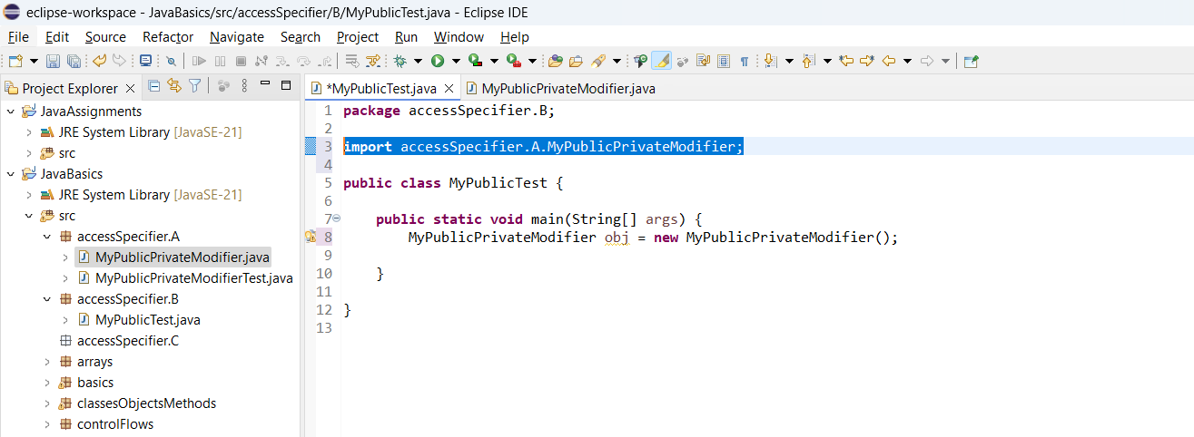

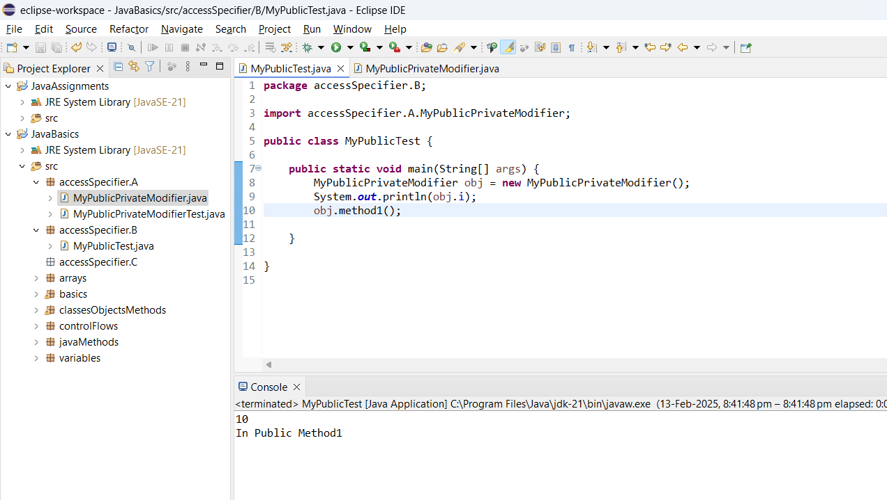

* Private access specifiers are used only in that specific class where the private access specifier is declared.
* Public access specifiers are used in the particular project > under the SRC folder tagged classes > to access in different class under the same project > package > we need to import the specifier

**DEFAULT ACCESS SPECIFIER:**

The Default modifier is used only within a Package.

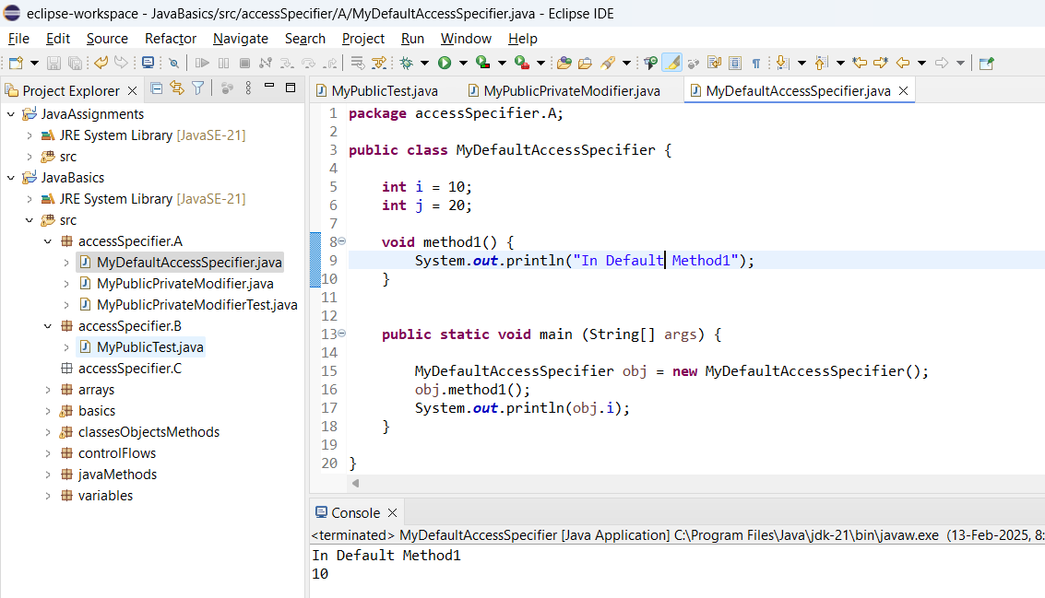

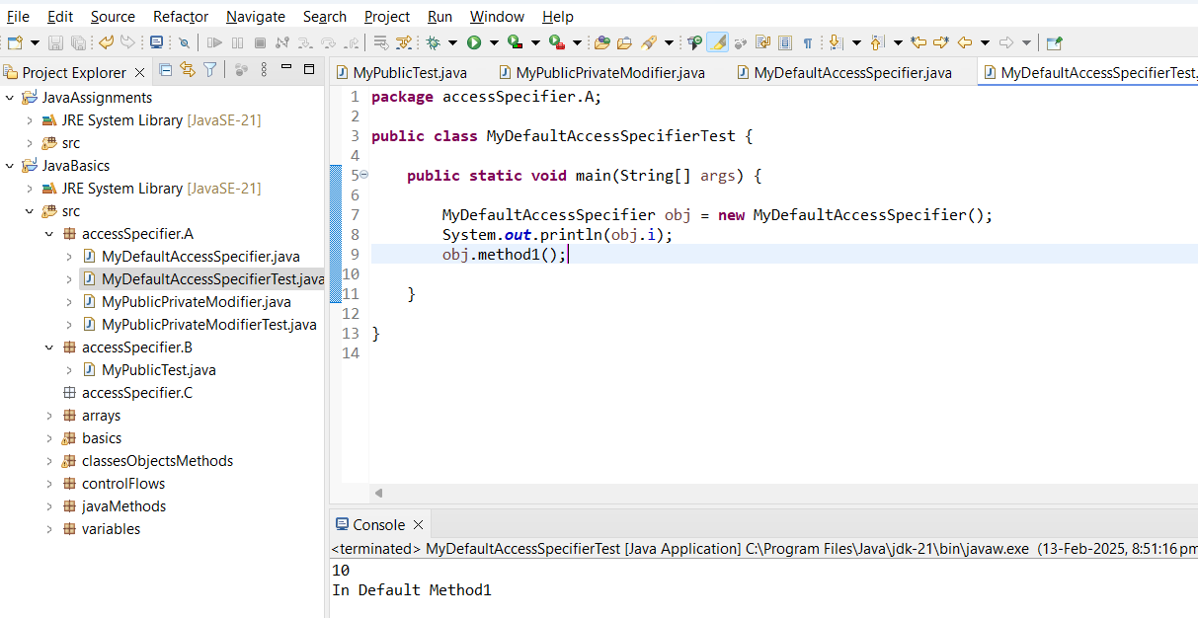

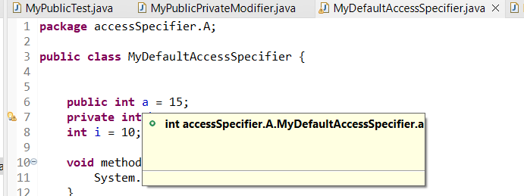

**PROTECTED ACCESS SPECIFIER:**

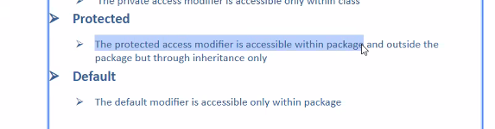

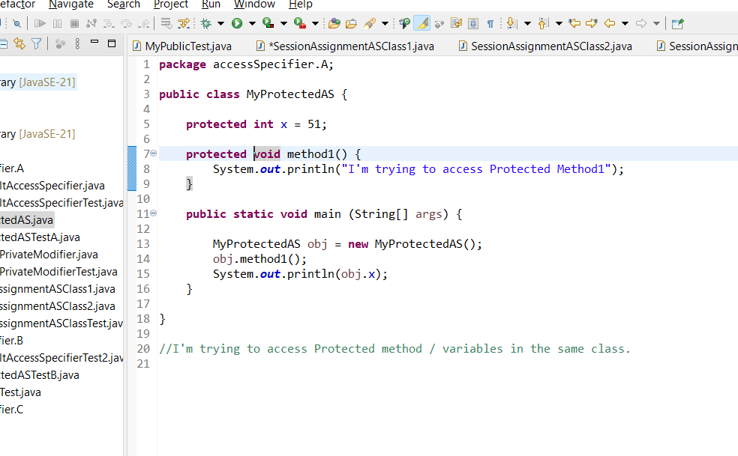

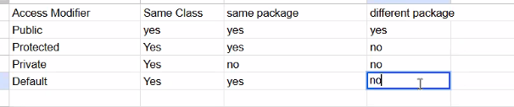

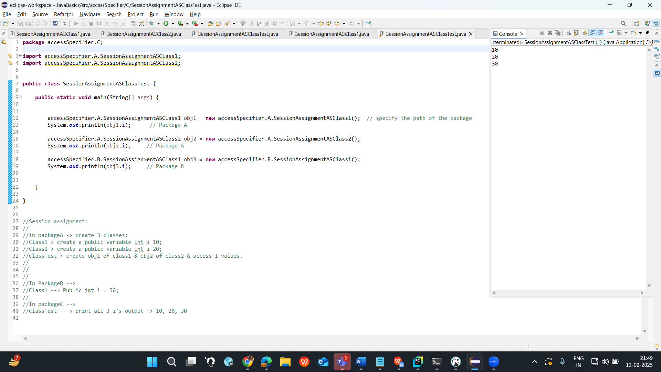

**OOPS Concepts**

Object Oriented programming language.

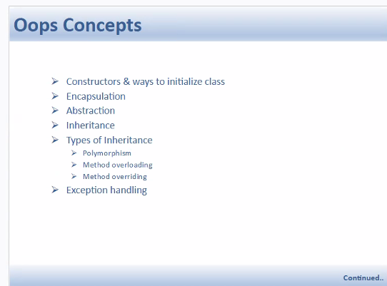

In general -> Oops is nothing but a guideline to follow to write the code.

1. **Constructors :**  
     
   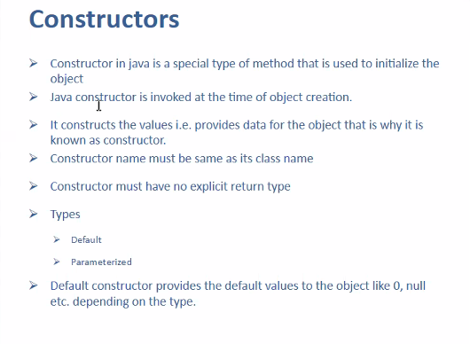

* Constructor in Java is a special type of method used to initialize the object and it invokes at the time of obj creation
* Constructor can be called multiple times by creating object.
* ClassName refVar = New ClassName();
* ClassName --> Name of the Class
* refVar --> The reference variable that points to the object, it will have the address of the object
* new --> allocates the memory for the object in heap memory
* className(); --> it calls the constructor to initialize the object

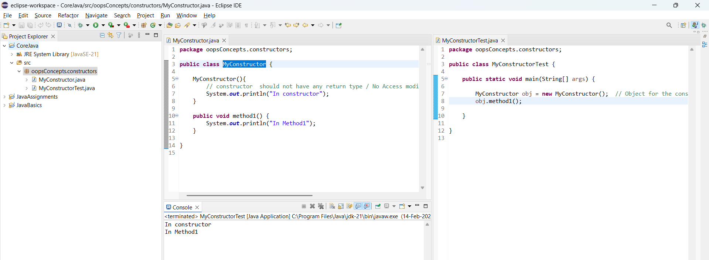

We can write like this as well but constructor is not designed for the same,  
Purpose of Constructor is to construct the values  
  
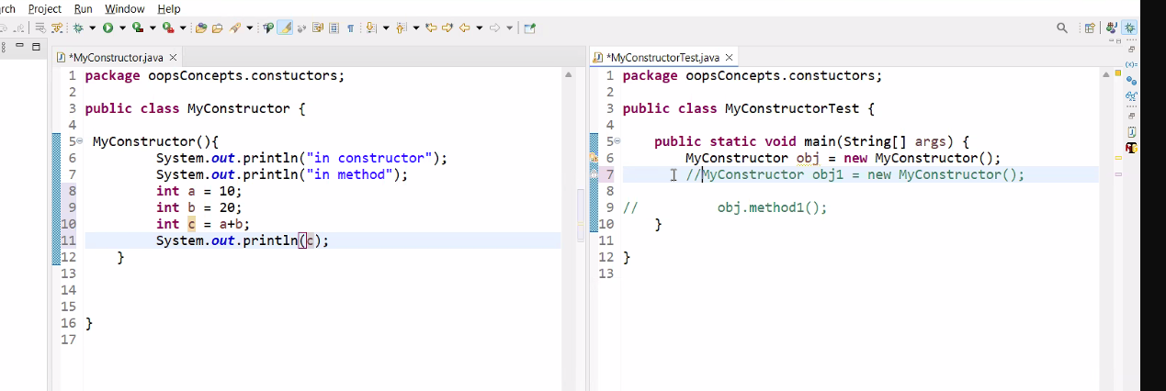

It is not the organized code though!

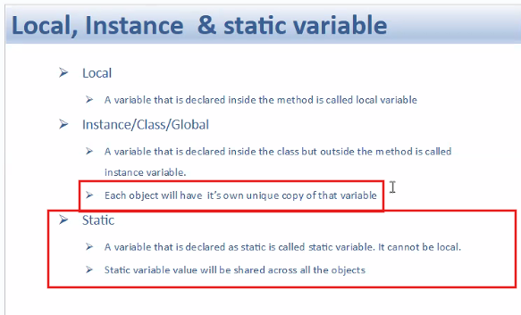

**Instance Variable:**

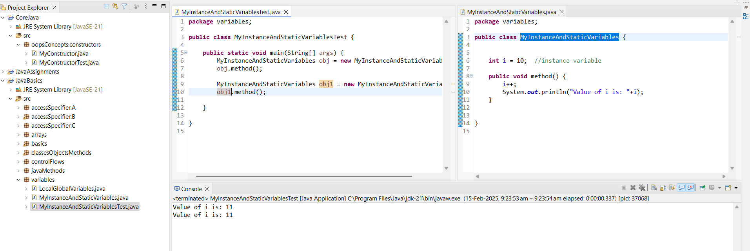

Java creates object in the Heap Memory

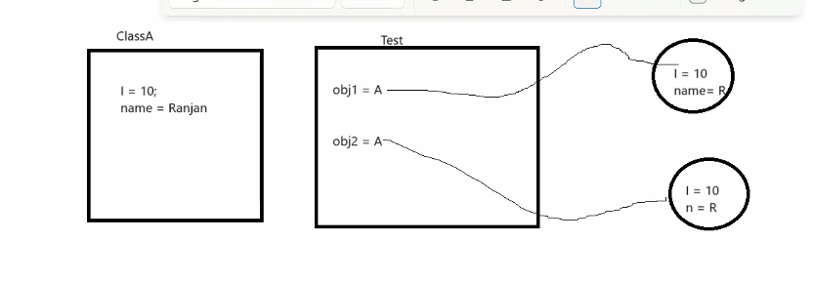

**Static Variable:**

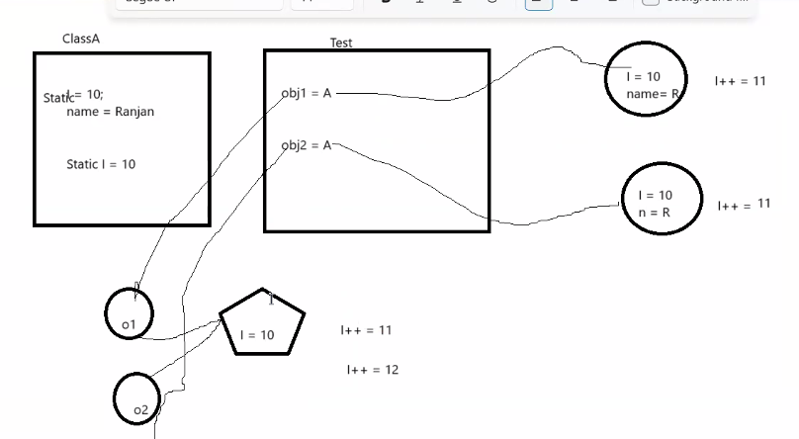

* Instance variable is a unique variable
* Static variable is the Shared variable (Sharing common value across the class code).
* Static variable can’t be declared under the method (locally) though it can be accessed under method. It is declared under the class.
* While accessing static variable / method, we have to use class name instead of creating object. --> Static way.

Example-> classname.variable

In any package we can access the static variable in static way

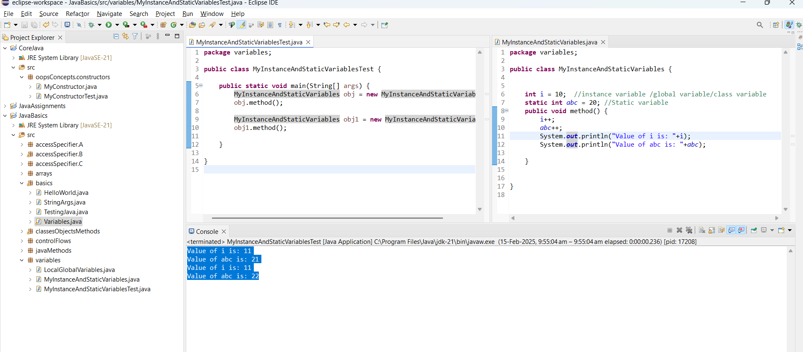

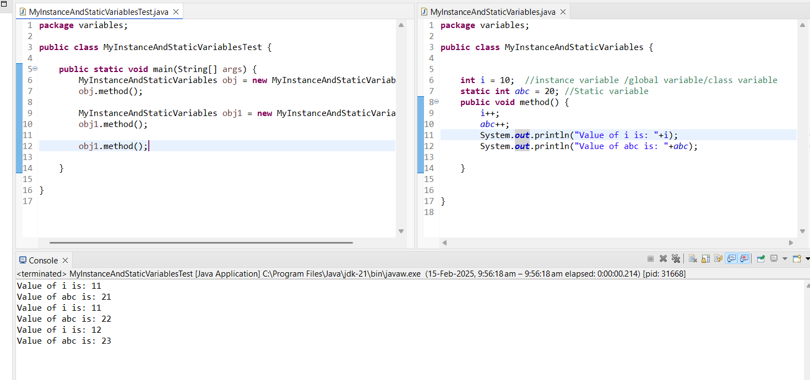

Constructor….

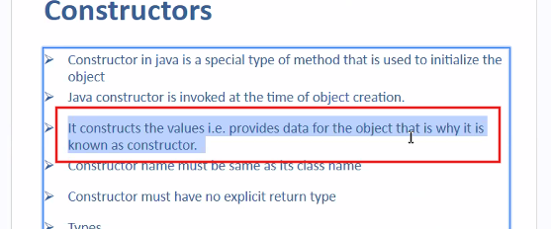

Still accessing the same data->  
  
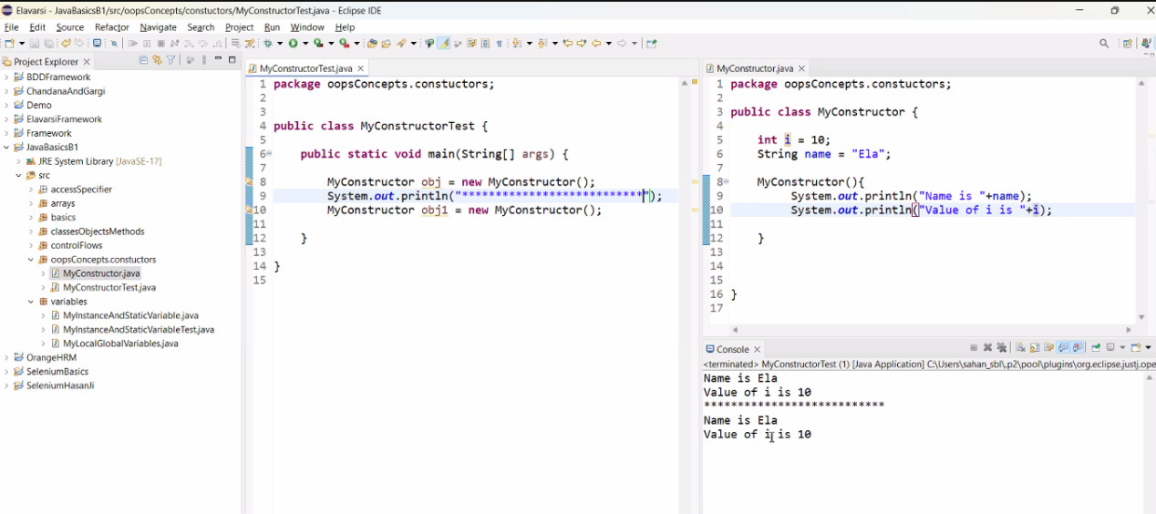

**How to overcome to avoid the data duplication** -->  
(by Parameterize we can avoid the data duplication when we call the constructor multiple time)

The main purpose of the constructor is to construct the values to the object.

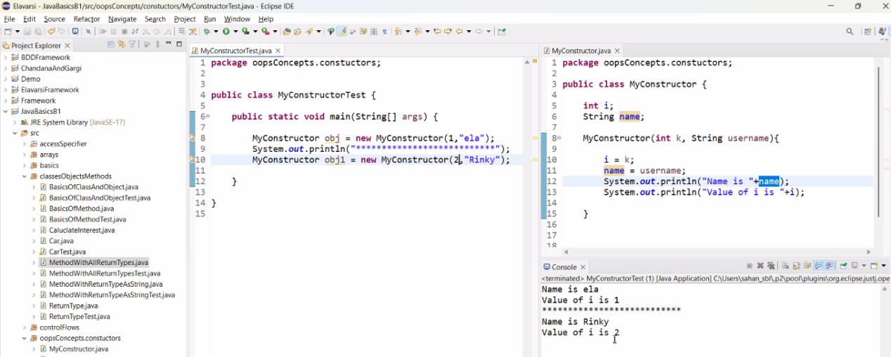

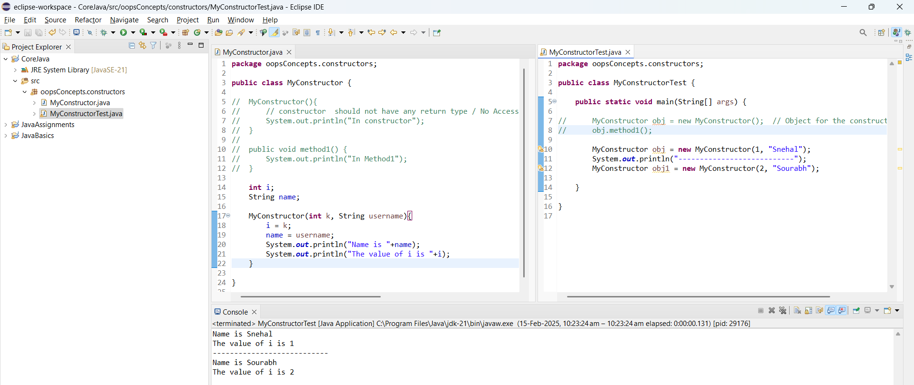

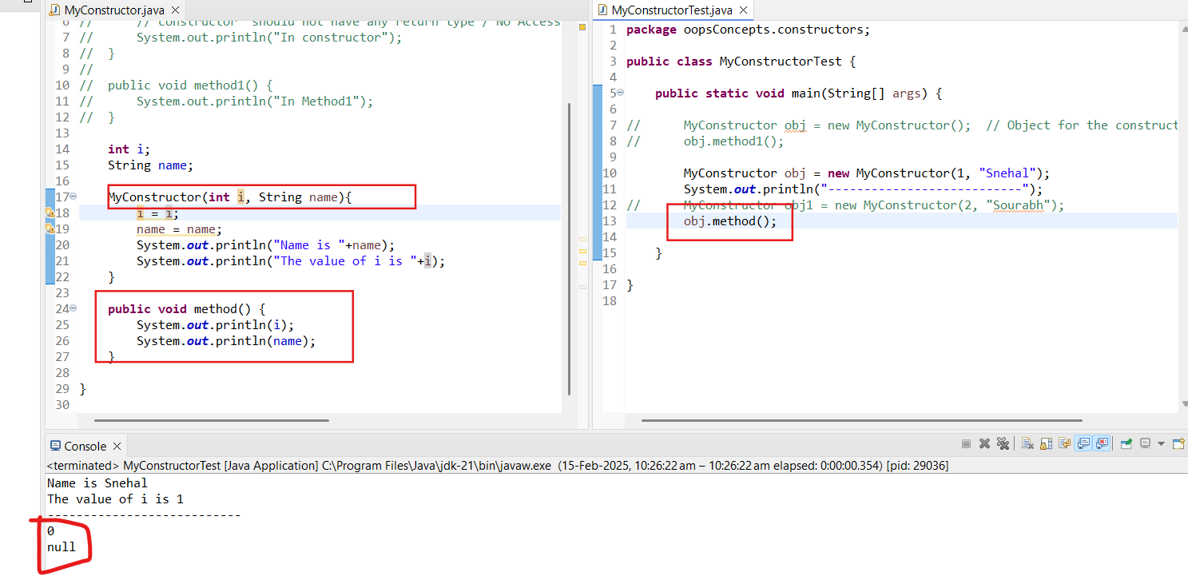

**Parameterized Constructor and the Default Constructor:**

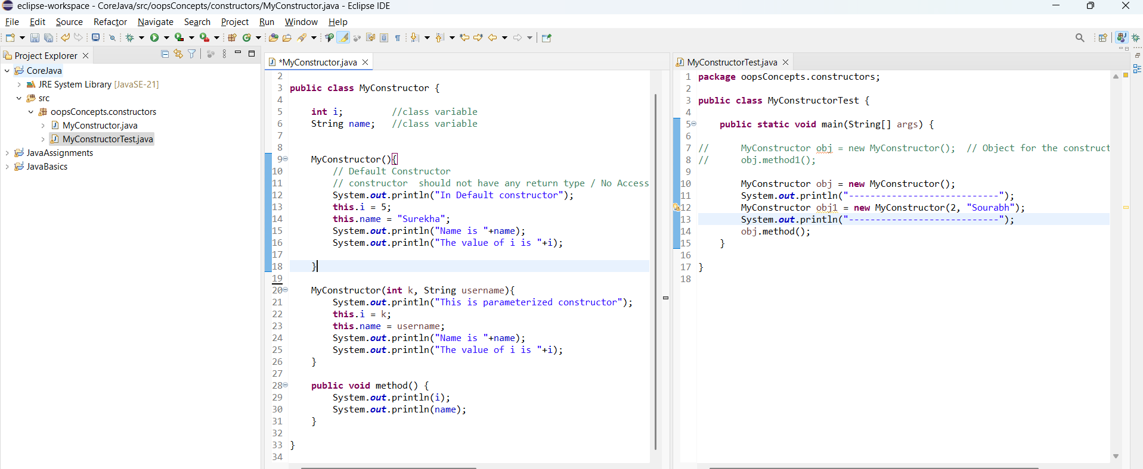

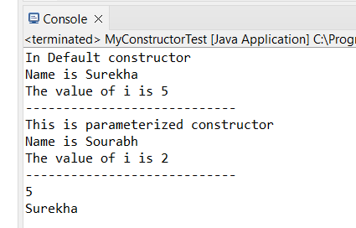

* We can not create the constructor of same name / same signature multiple times in a class.

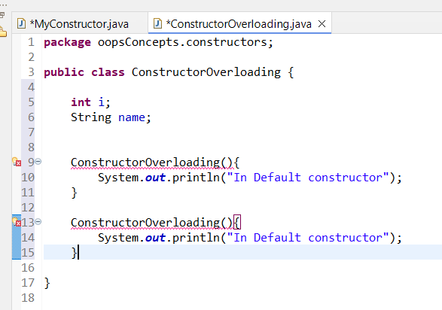

* **We can create N number of the constructor with the same name but with the different number of parameters and with the different signature (datatype used).**

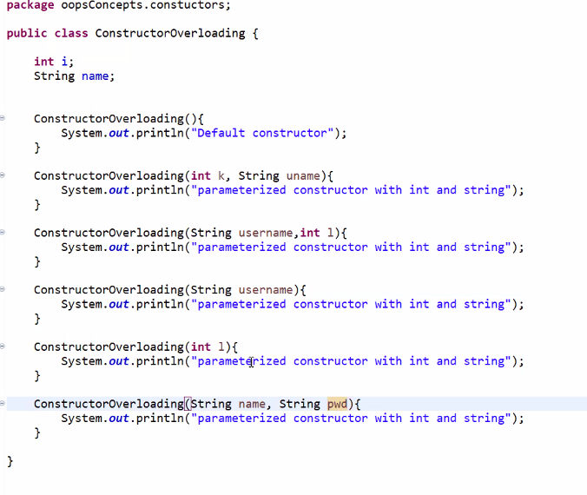

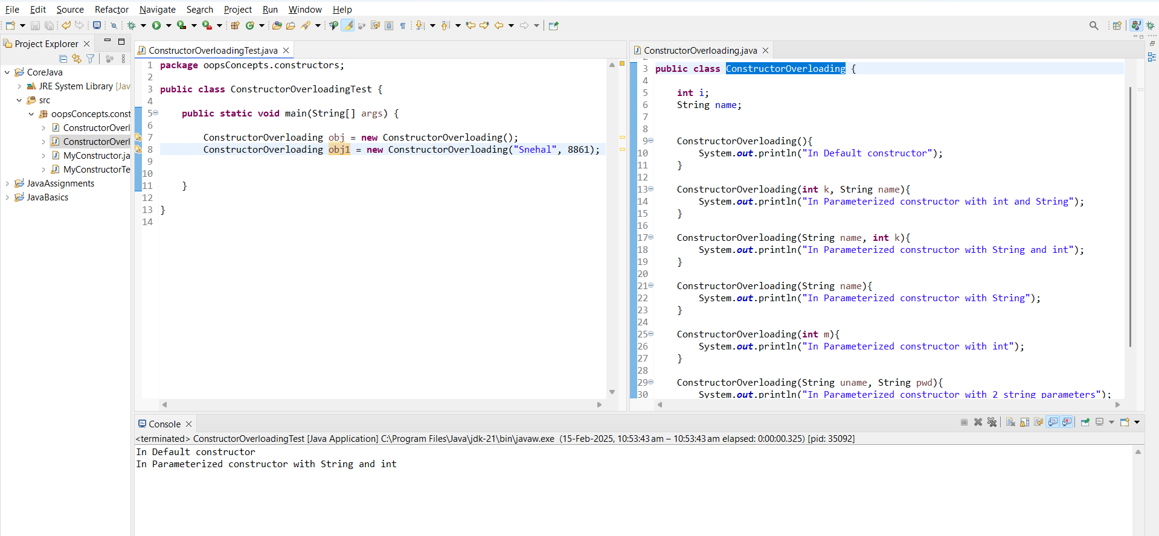

**Accessing Static Method/ Variable in a Static Way:**

* Accessing the static method/variable using class name in a static way,
* Static Method and variable belongs to class, no need to create an object for the Static variable/method.

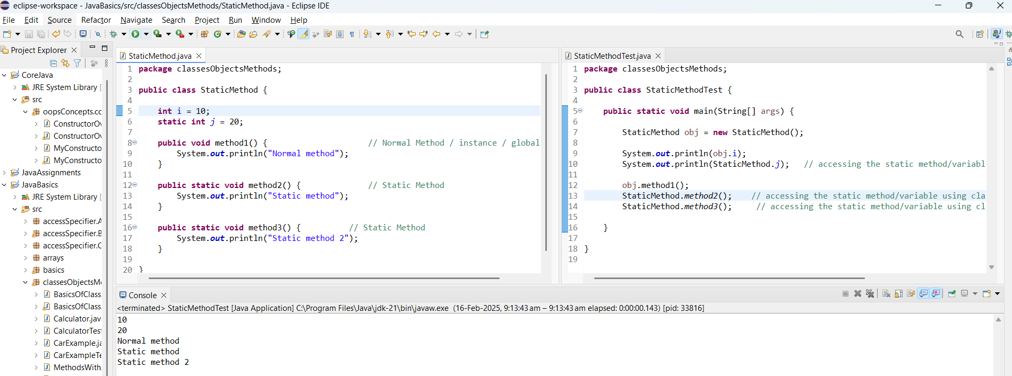

**String Methods:**

**Concatenation Operator -**

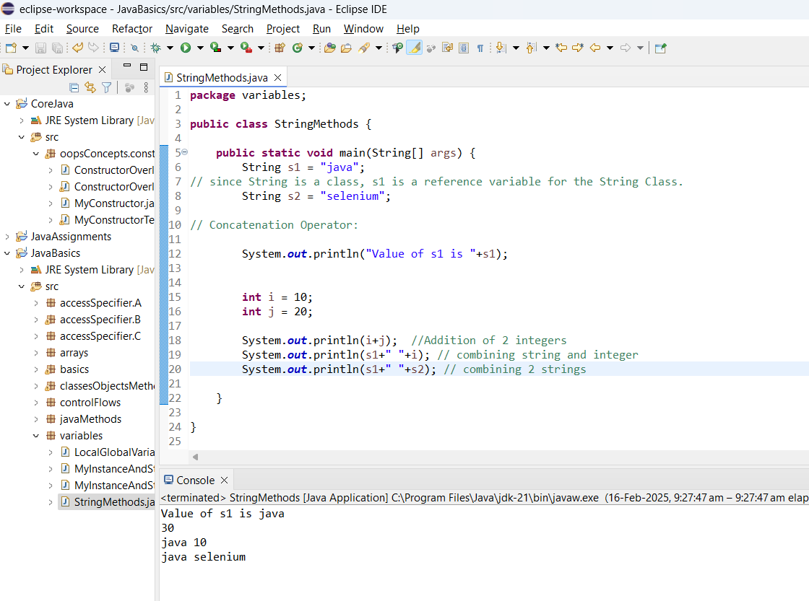

Green -> public  
Red -> Private

Gree circle -> Public Variable

Red circle -> Private Variable

Yellow -> Protected

Blue triangle -> Default

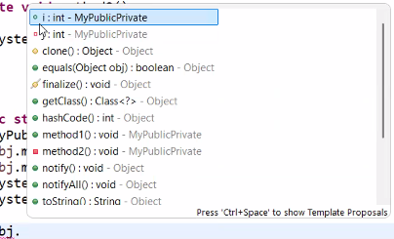

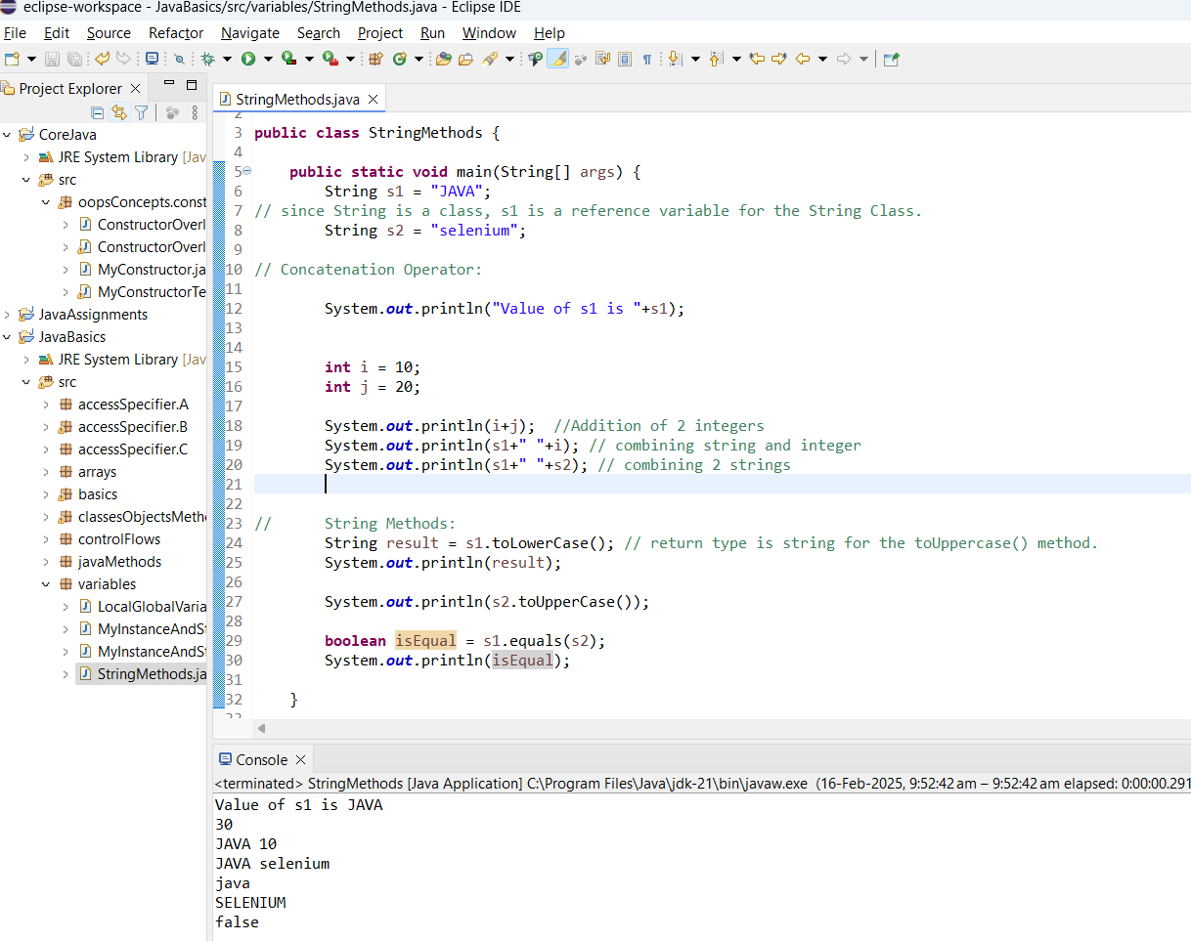

* In case of the similar String variable values, the system do not allocate a new memory location in the heap Memory,   
  Rather both the variables points at the same memory location in the heap memory.

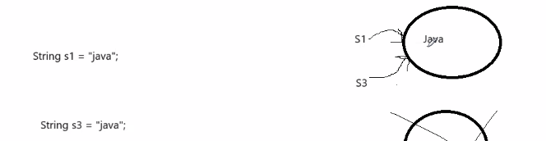

* If we want the java to allocate a new memory location even if the variables are same, we need to declare as follows:

**String var = new String(“ “);**

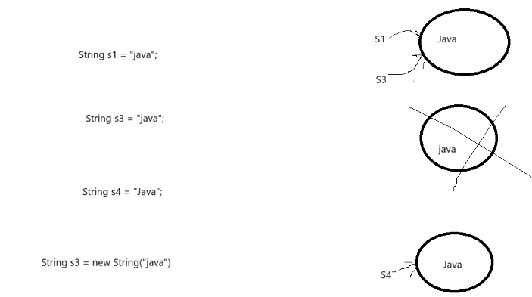

* **==** -> operator verifies if both the strings referring to the same memory location
* **equals()** -> it will check if both string has same value.

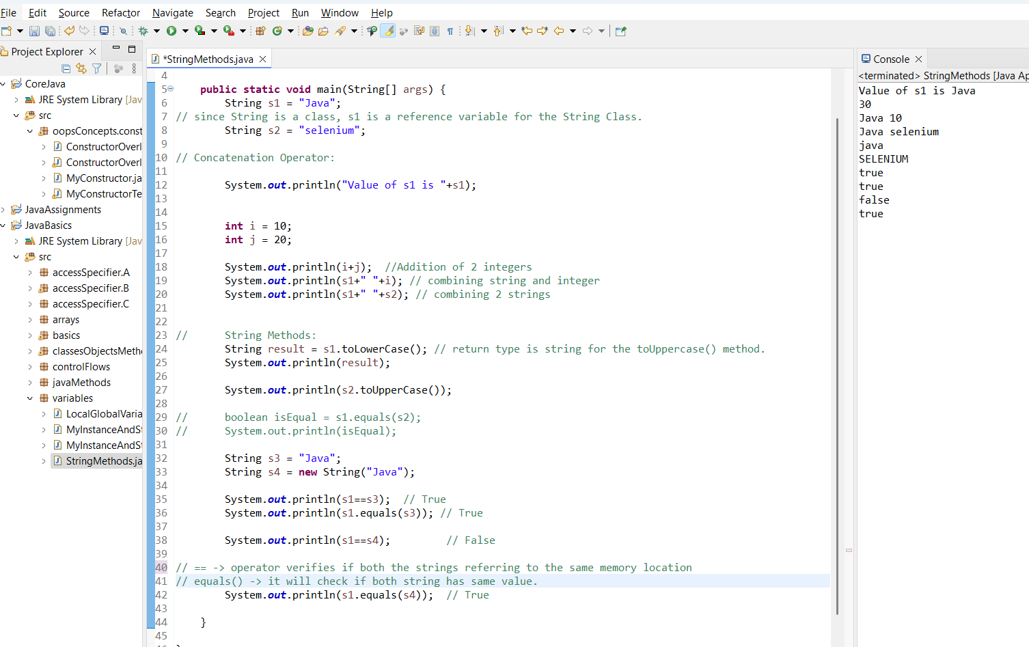

**Split()**

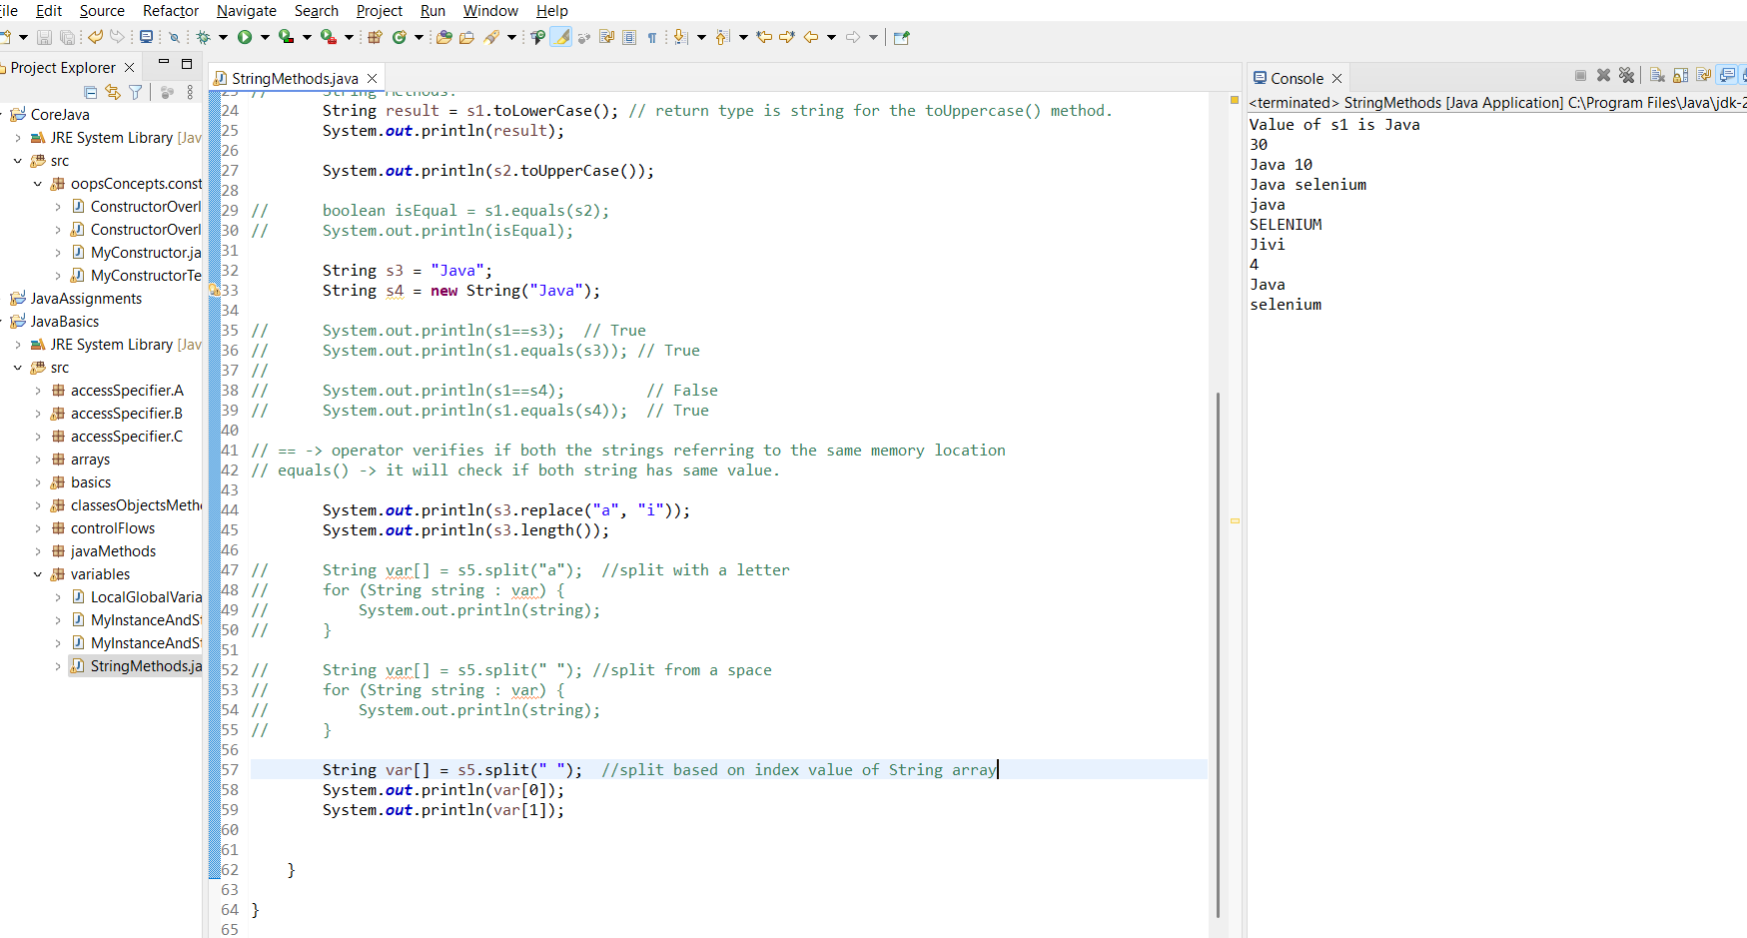

**Inheritance**:

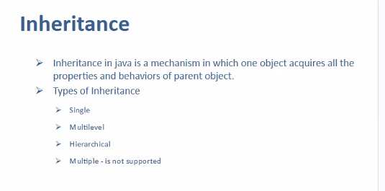

Variables in a class --> Properties

Methods / functionalities /implementation --> Behaviors

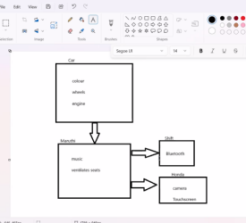

**Single Level Inheritance:**

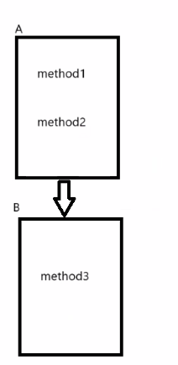

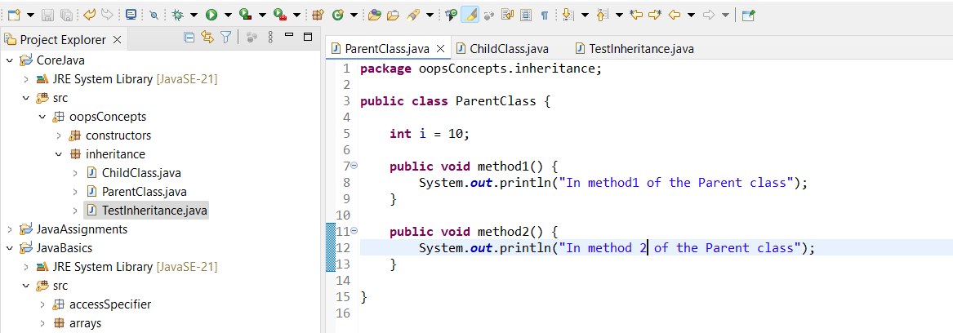

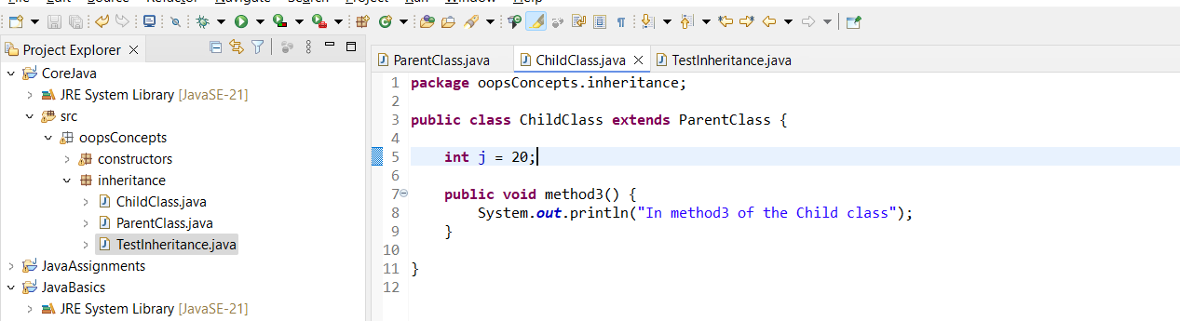

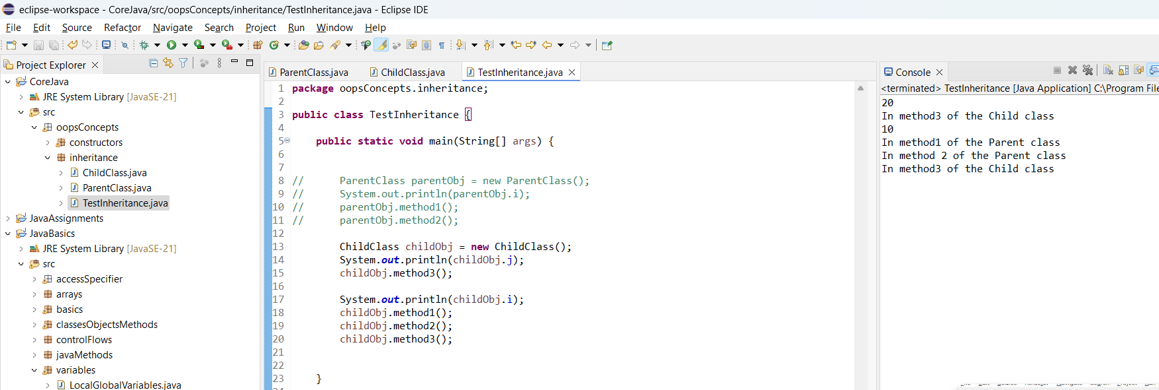

**Multi-Level Inheritance:**

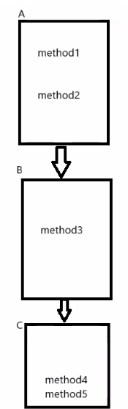

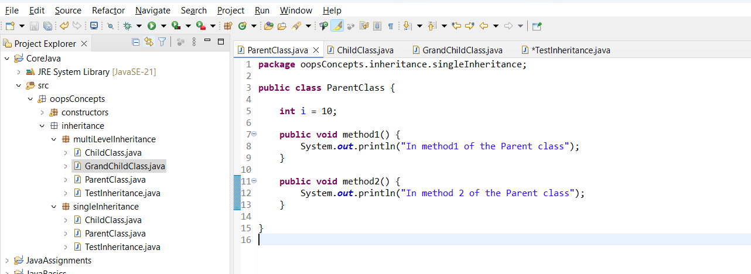

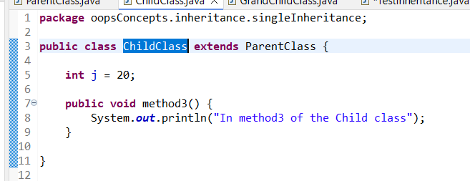

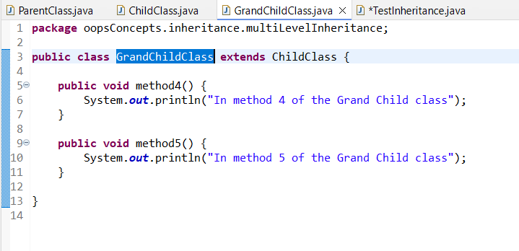

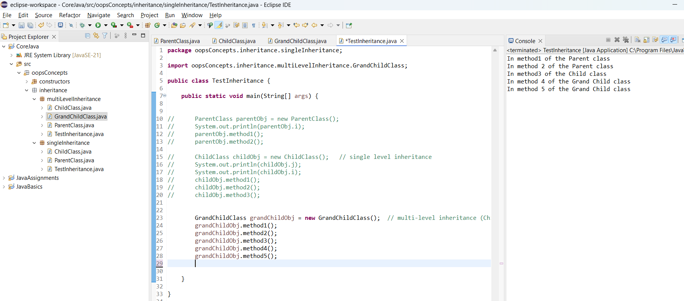

**Hierarchical Inheritance:**

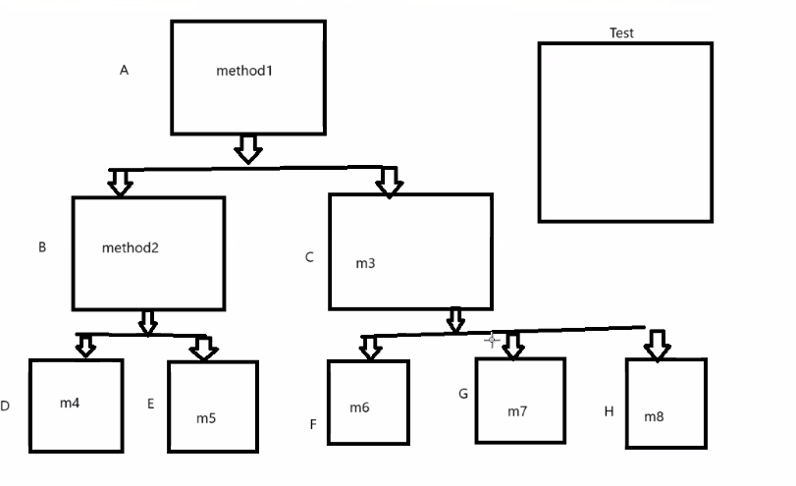

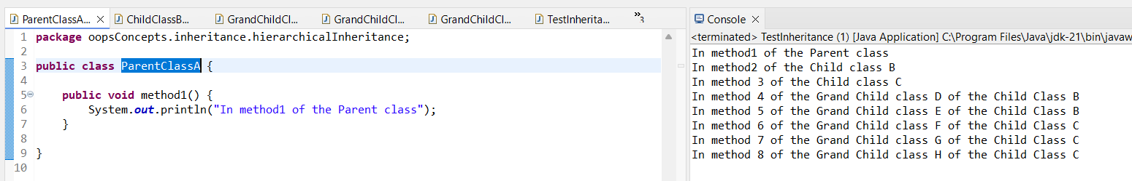

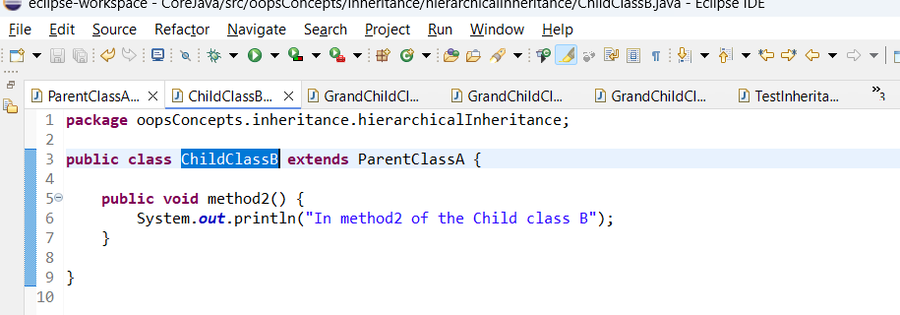

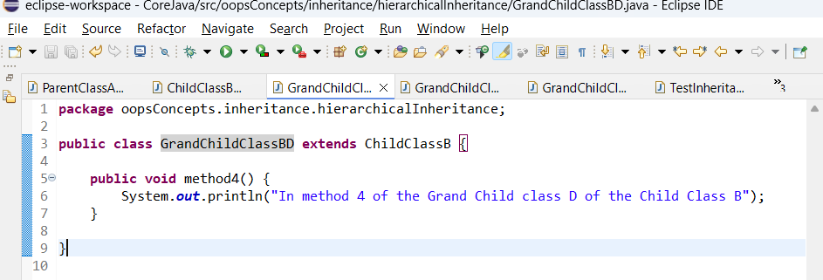

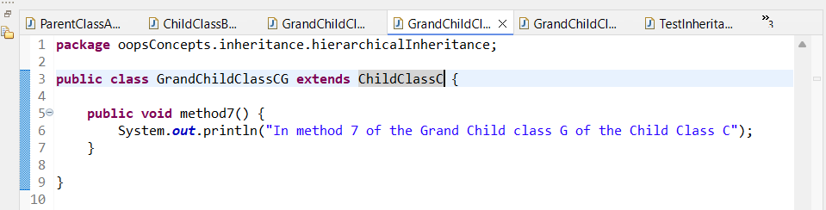

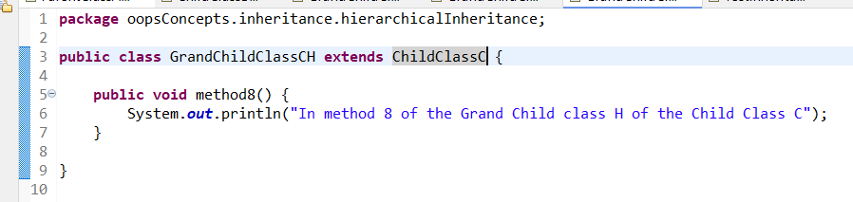

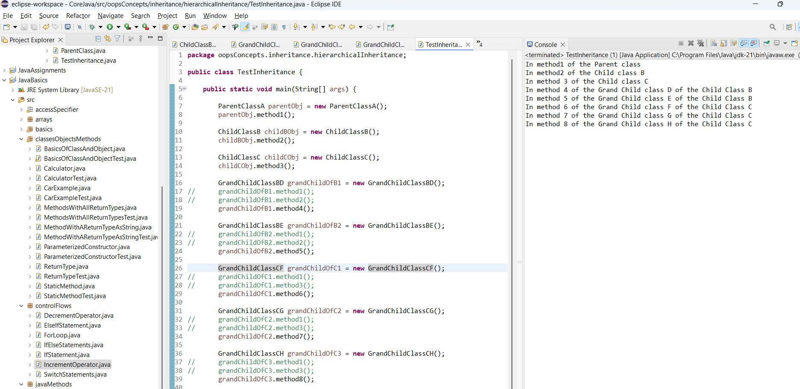

**Multiple Inheritance:**

(Not supported)

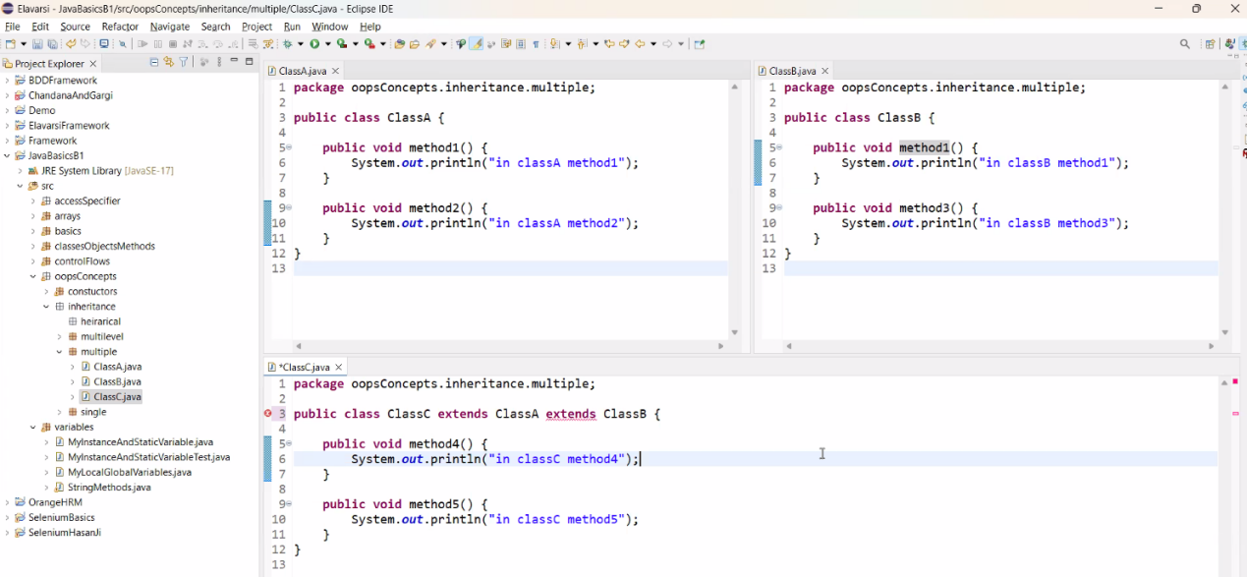

**POLYMORPHISM:**

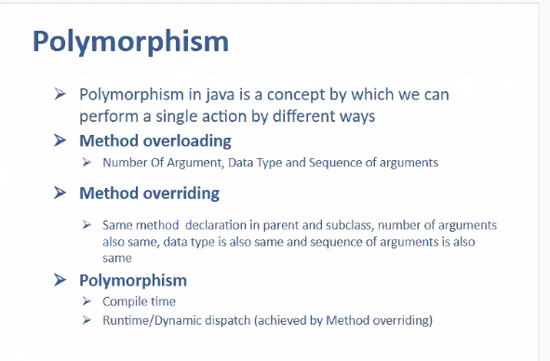

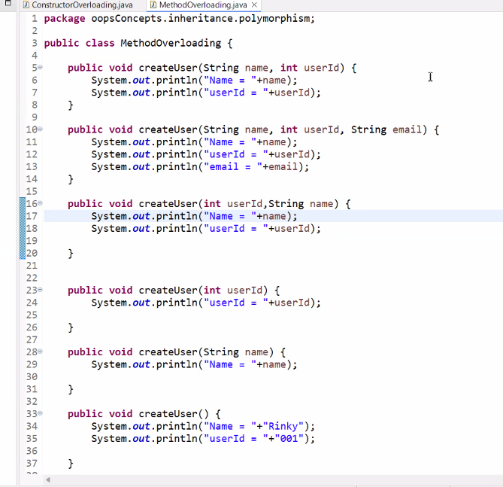

Method Overloading depends on 4 factors:

//1. datatype

//2. Number of parameters

//3. signature (Sequence of parameters)

//4. Method Overloading is not dependent on return type.

* when to use Method Overloading:

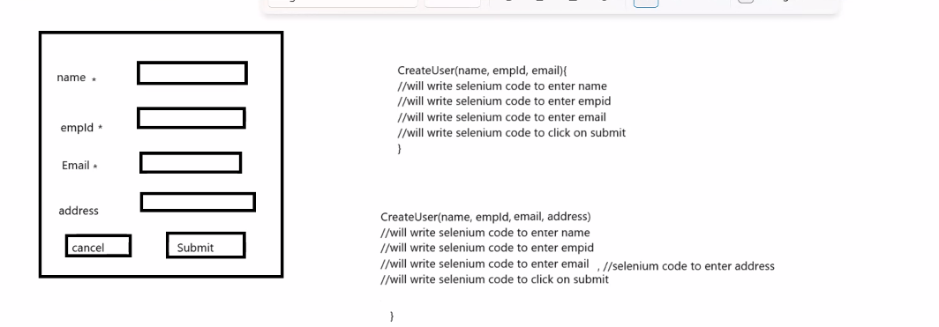

**Method Overriding:**

In parent and child class method name is same, data type is same, signature is also same.

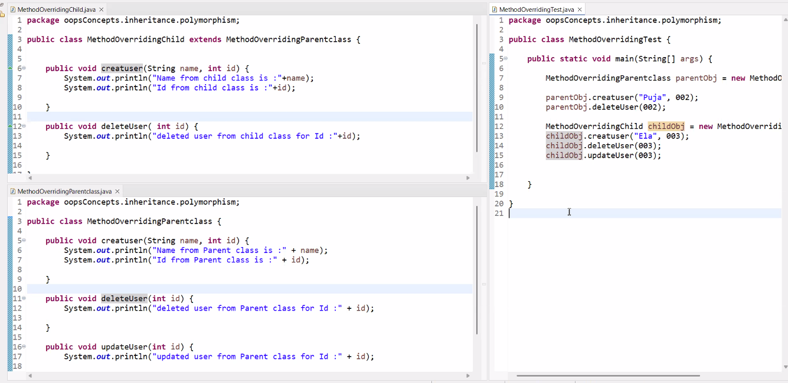

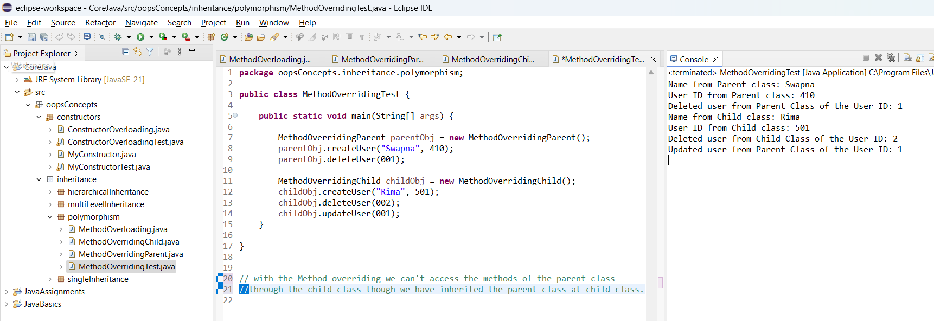

Inheritance Example:  
(Multilevel)

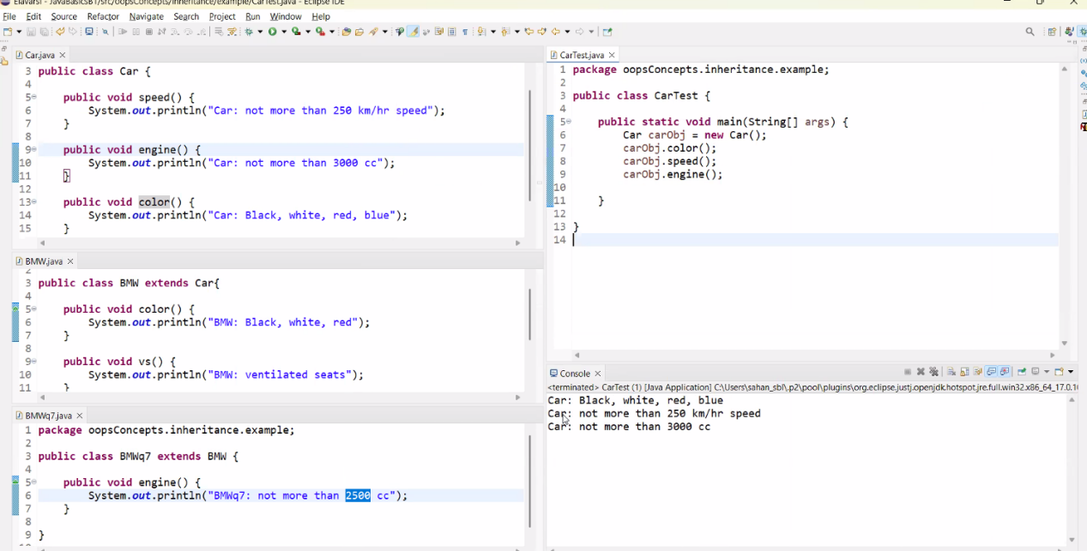

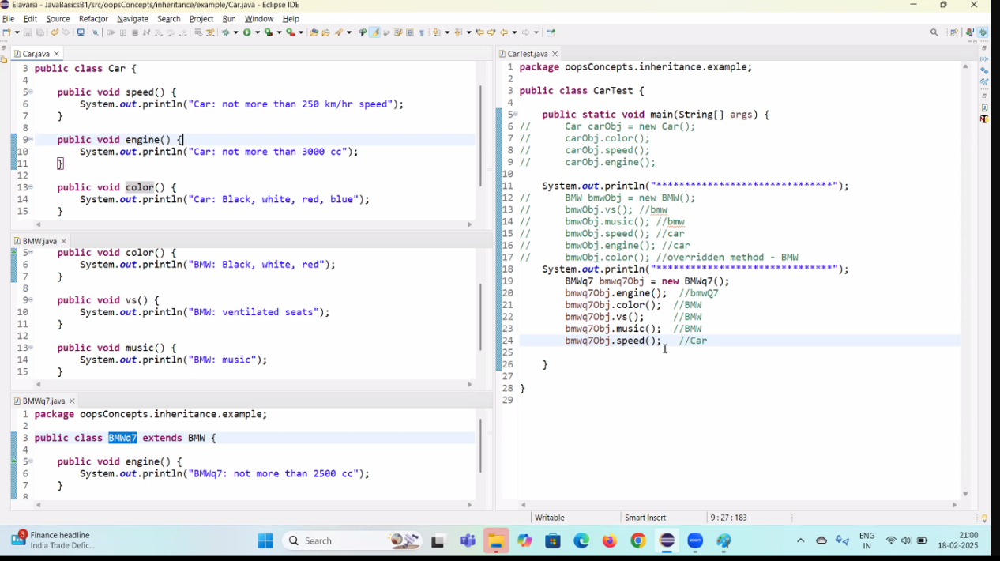

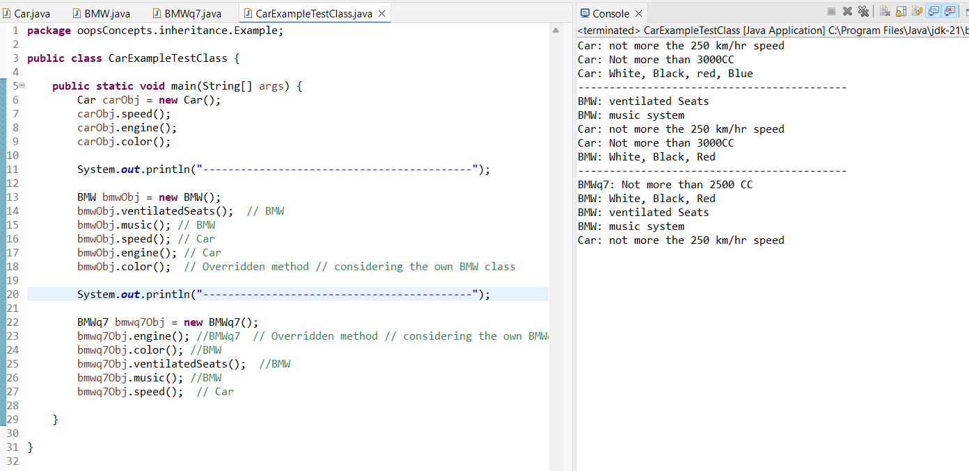

**Car Obj1 = new BMW();**

// Creating the object of the BMW class and assigning it in the reference variable carObj or the Car class.

// we can keep any child object in the reference variable of the parent class.

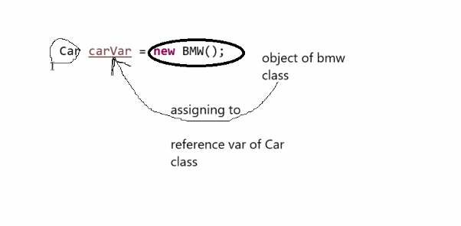

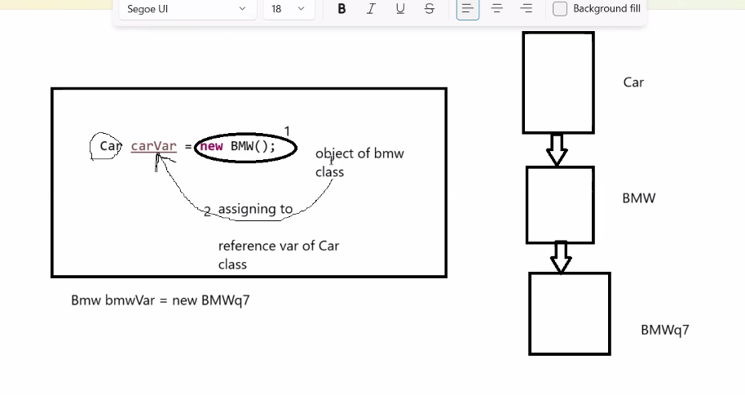

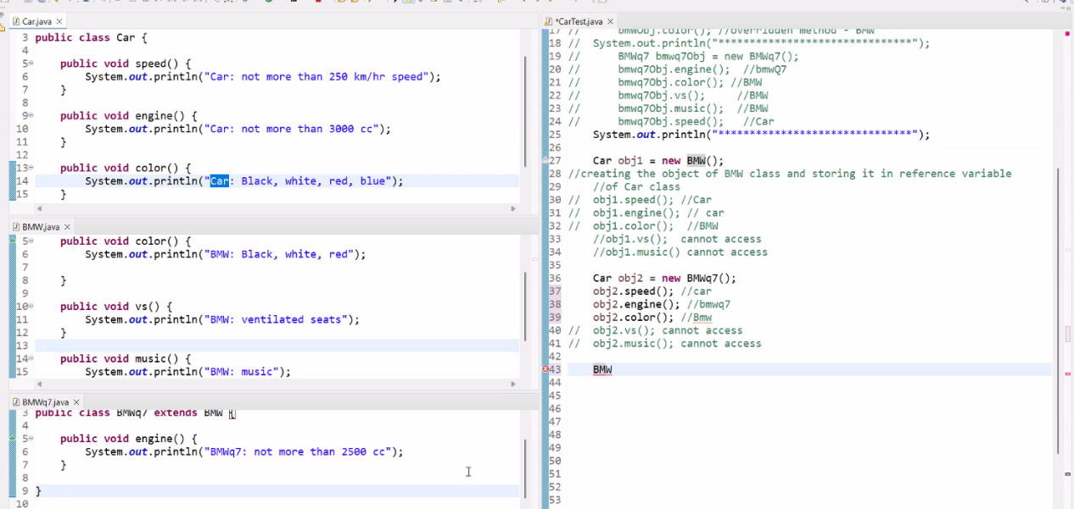

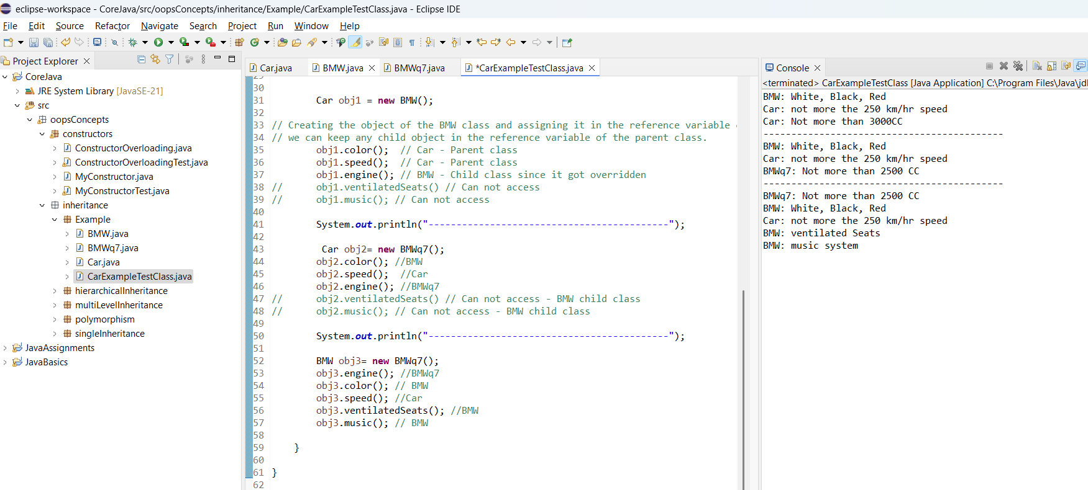

**CLASS 17:   
  
 Exception Handling**

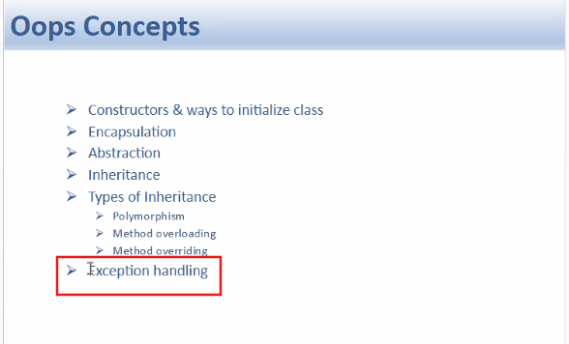

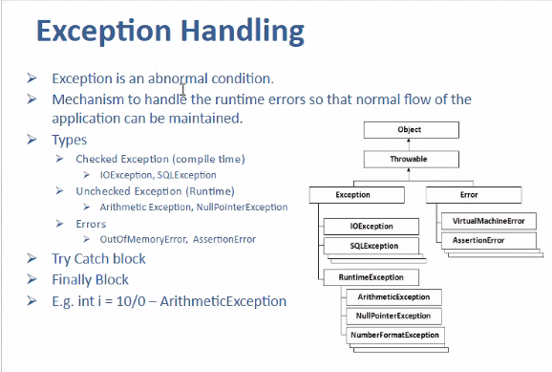

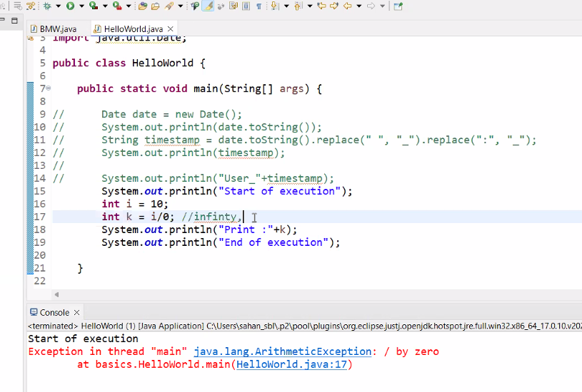

* If we handle the run time errors properly so that next remaining lines should get executed => Exception Handling

**Checked Exception :** While typing the code itself Java will check the code and shows the error - pops up at Compile time

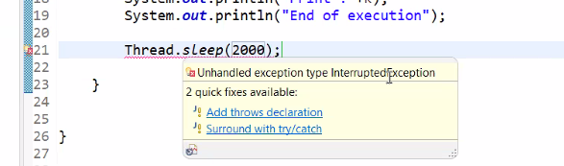

While writing code we can get a syntactical error.

**Un-Checked Exception :**

After the execution of the code / at run time only this will occur.

Arithmetic Exception (Unchecked Exception) example:

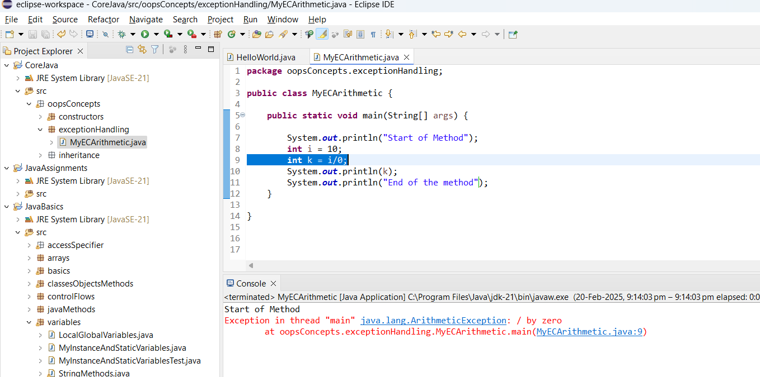

**Assertion error :** Whenever there is a mismatch between the expected value and the actual value.

**Index Out Of Bound: Array Index Out of Bound exception**

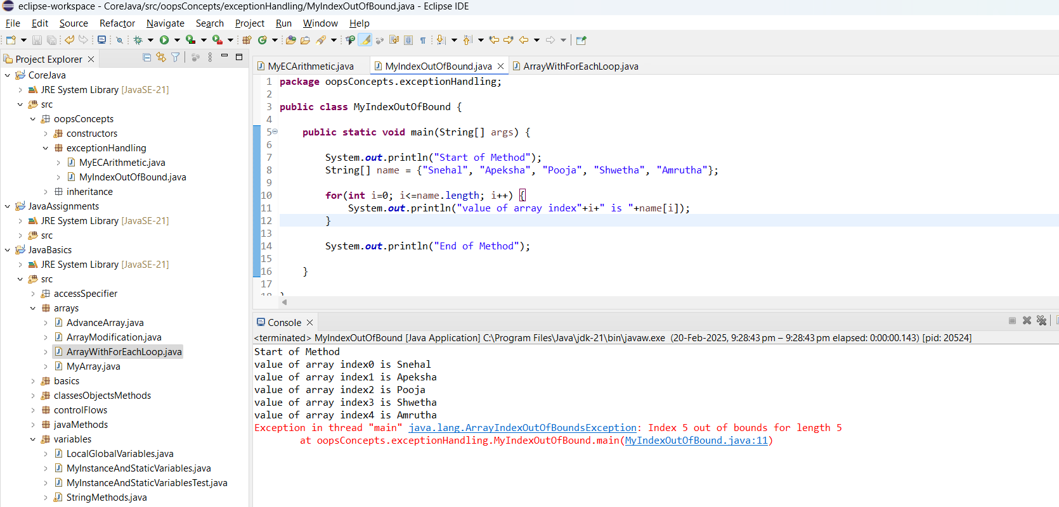

**Exception Handling -  
TRY CATCH BLOCK:**

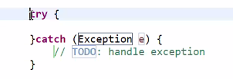

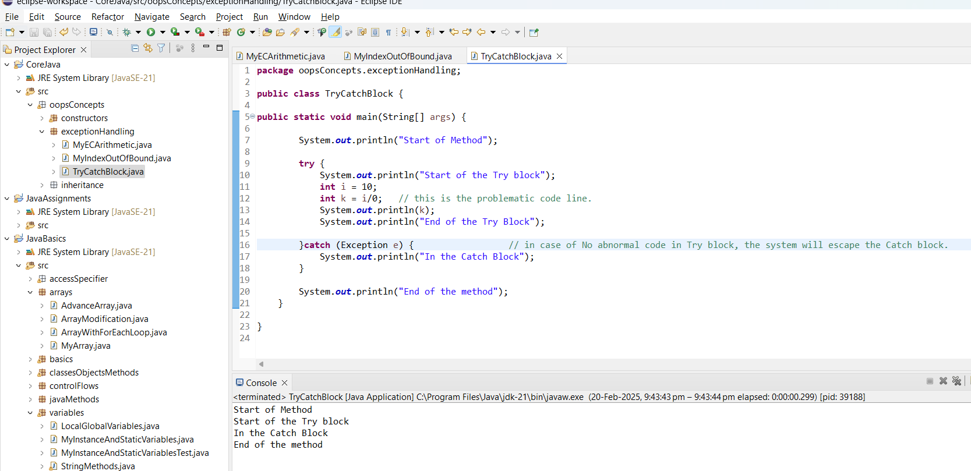

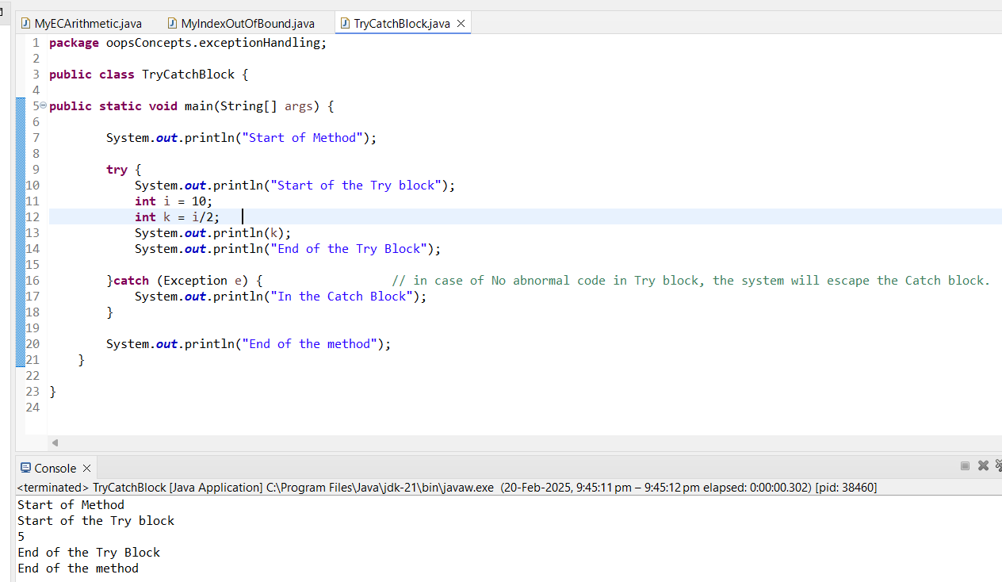

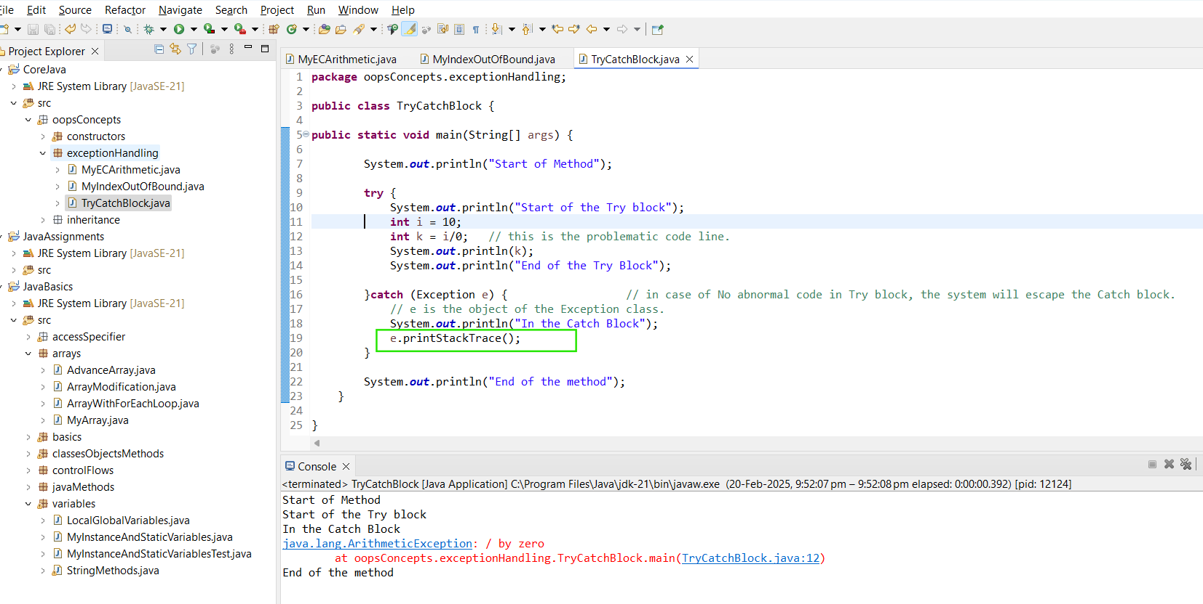

Assignment:  
  
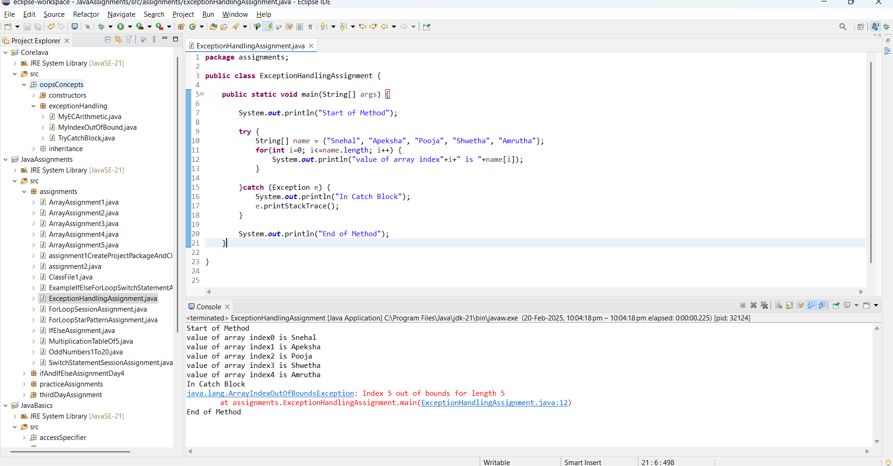

**CLASS 18:**

whenever the exception occurs. It Creates the object of the Child class - ArrayIndexOutOfBox() and assigning it in the reference variable 'e' of the Exception (parent class).

**Exception e = new ArrayIndexOutOfBound();**

* **Exception name is itself a class name too**

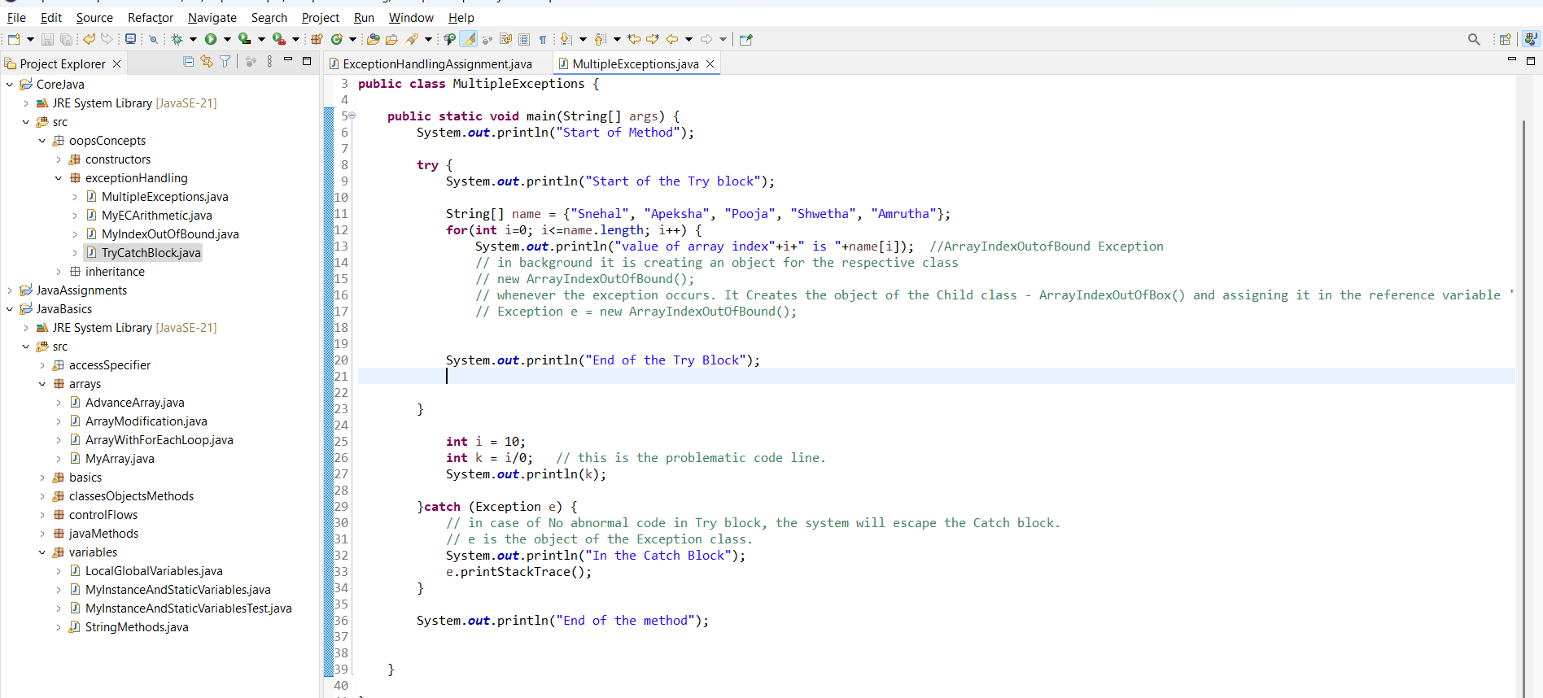

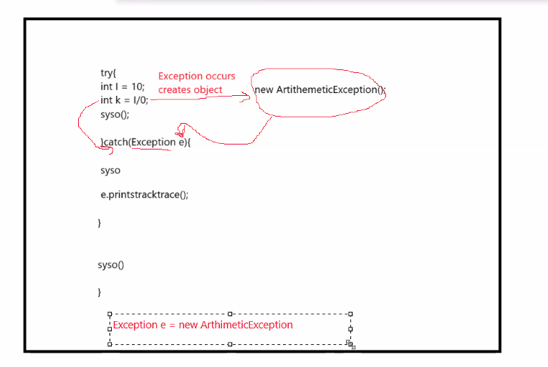

This is also allowed:  
  
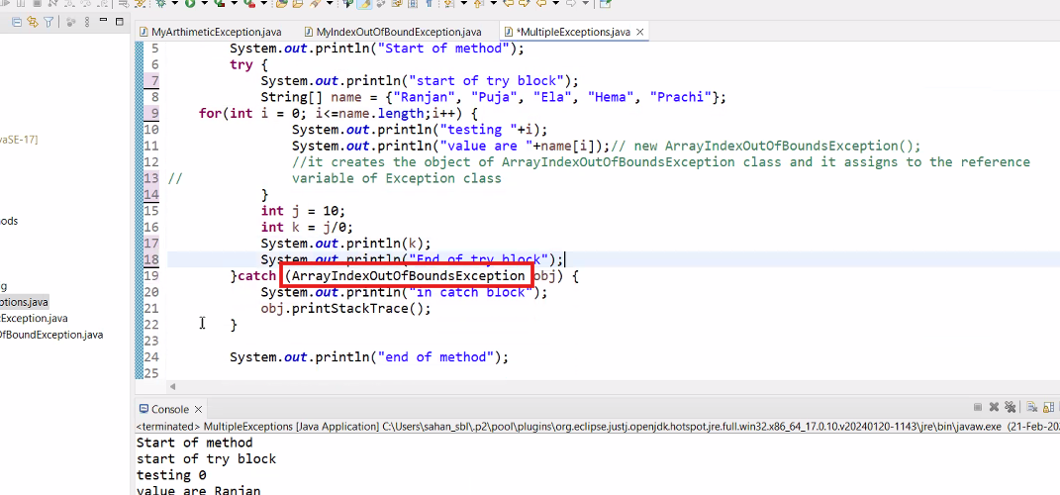

**CLASS 19:**

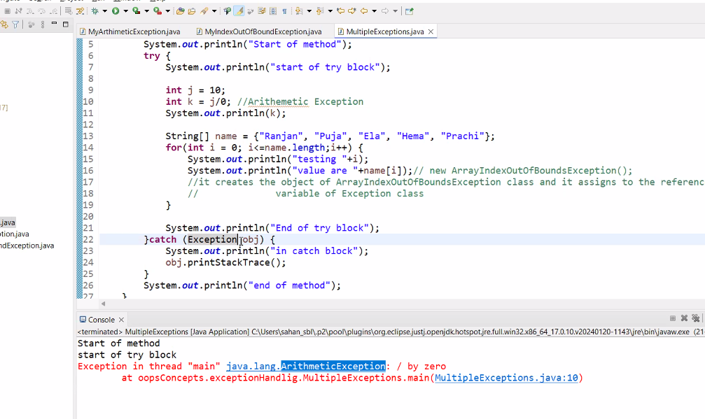

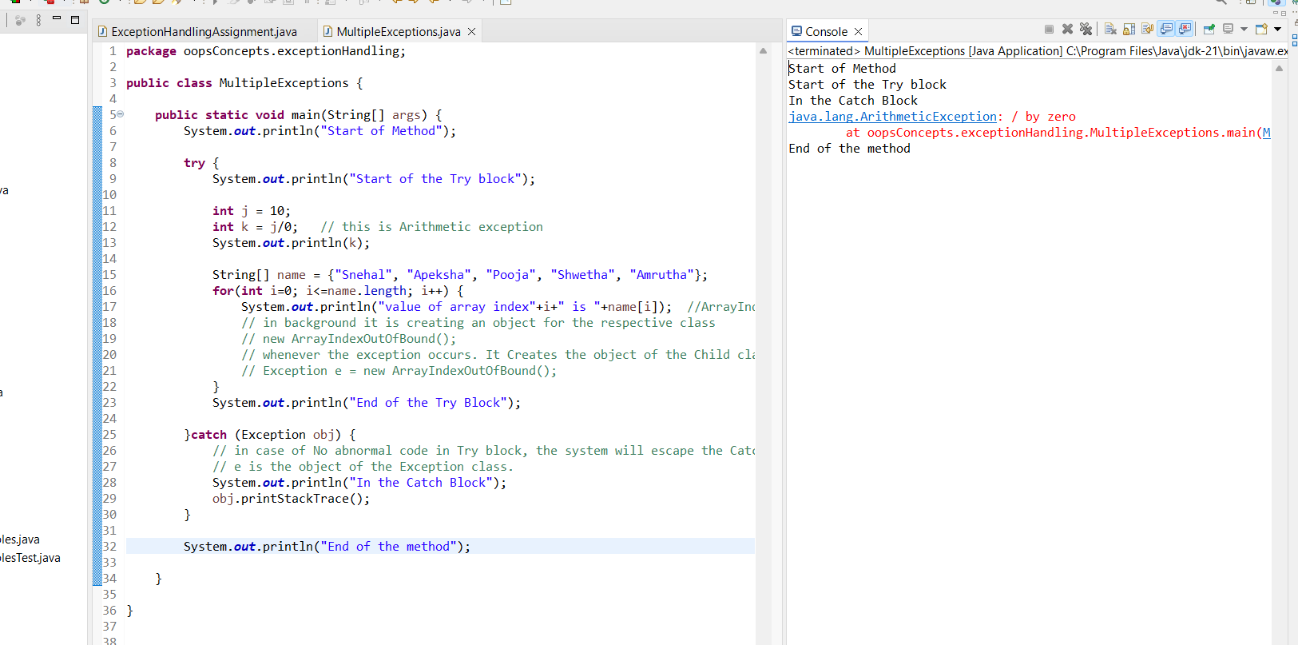

* If we add wrong exception class name, and the try block throws some other exception, the system will not execute the catch block. It just terminated at the try block's problematic code line.  
  Hence it is better to use the parent class Exception which will handle all type of exception.

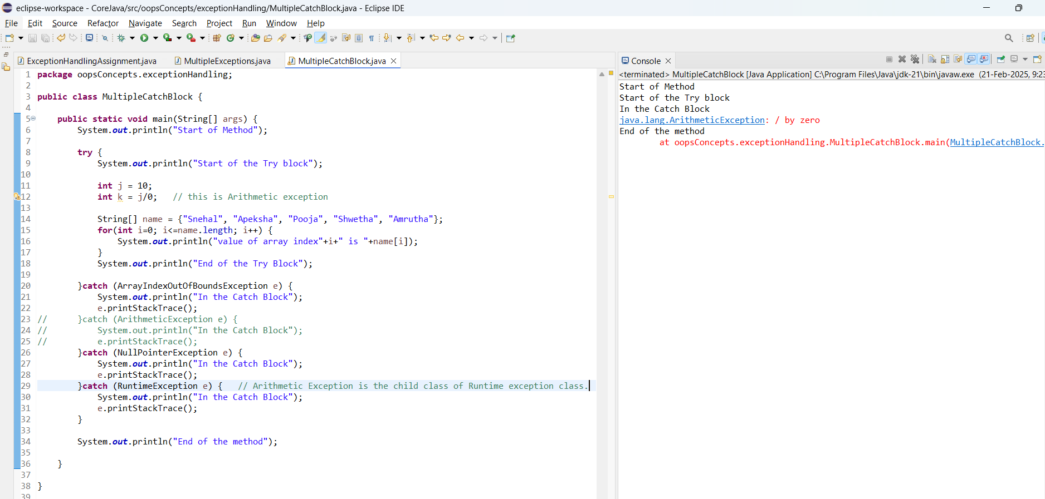

If we add Garndparent Exception class catch block at the top and rest all exception below, then the java throws an **Compile error since the below mentioned is an unreachable code.**

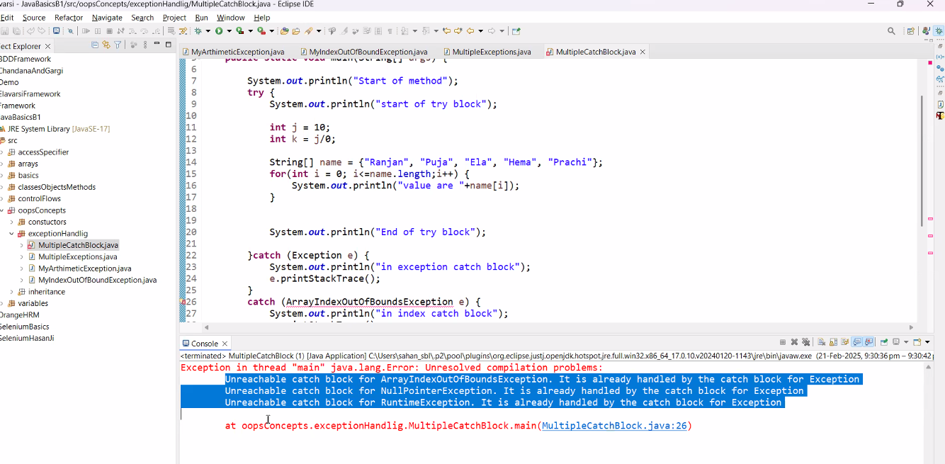

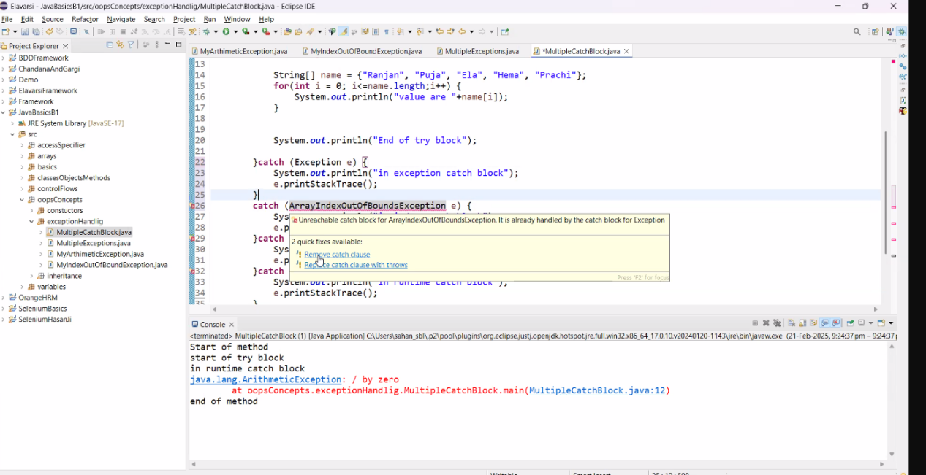

The hierarchy should be ->>  
Grand Child  
Child

Parent  
GrandParent

**Finally block will always gets** executed irrespective of exception’s occurrence.

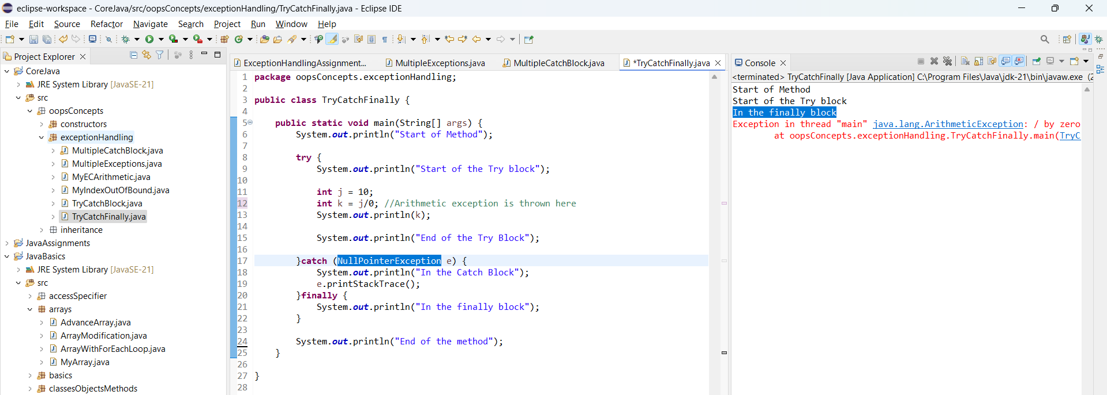

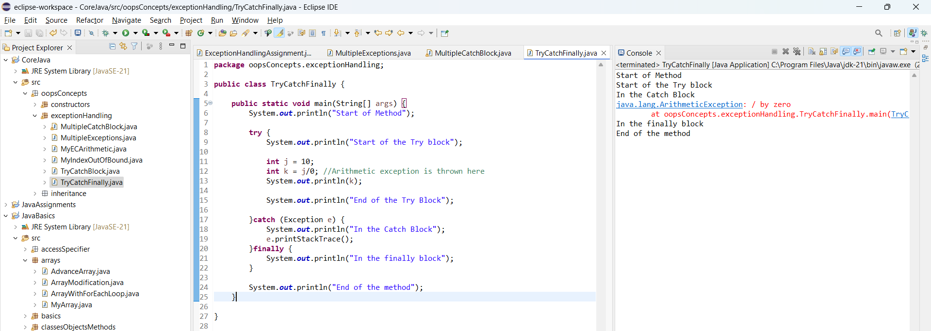

**CLASS 20: (Day 27)**

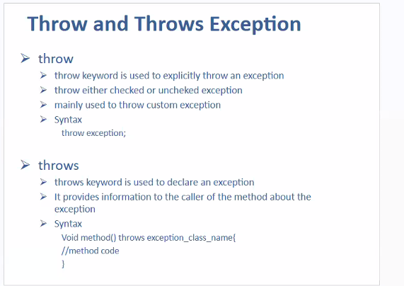

Syntax:

**throw** **new** ArithmeticException("Login Failed!”);

* Here “ArithmeticException” is just taken as one of the exception for an instance.

// Throw keyword is used to throw exception explicitly.When you want to stop your code execution

* Post this line, further code will be unreachable.
* Example Scenario - whenever login fails further user don’t want the code executed.

**Throw:**

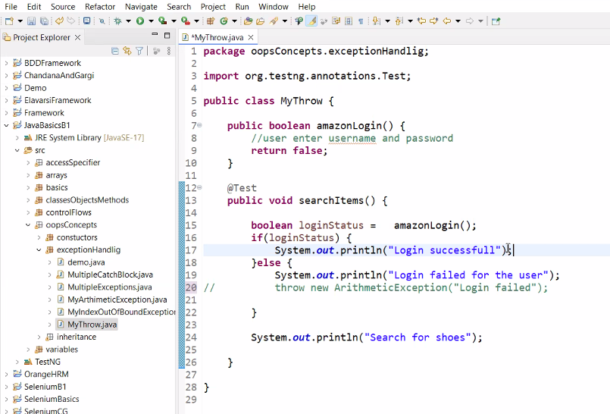

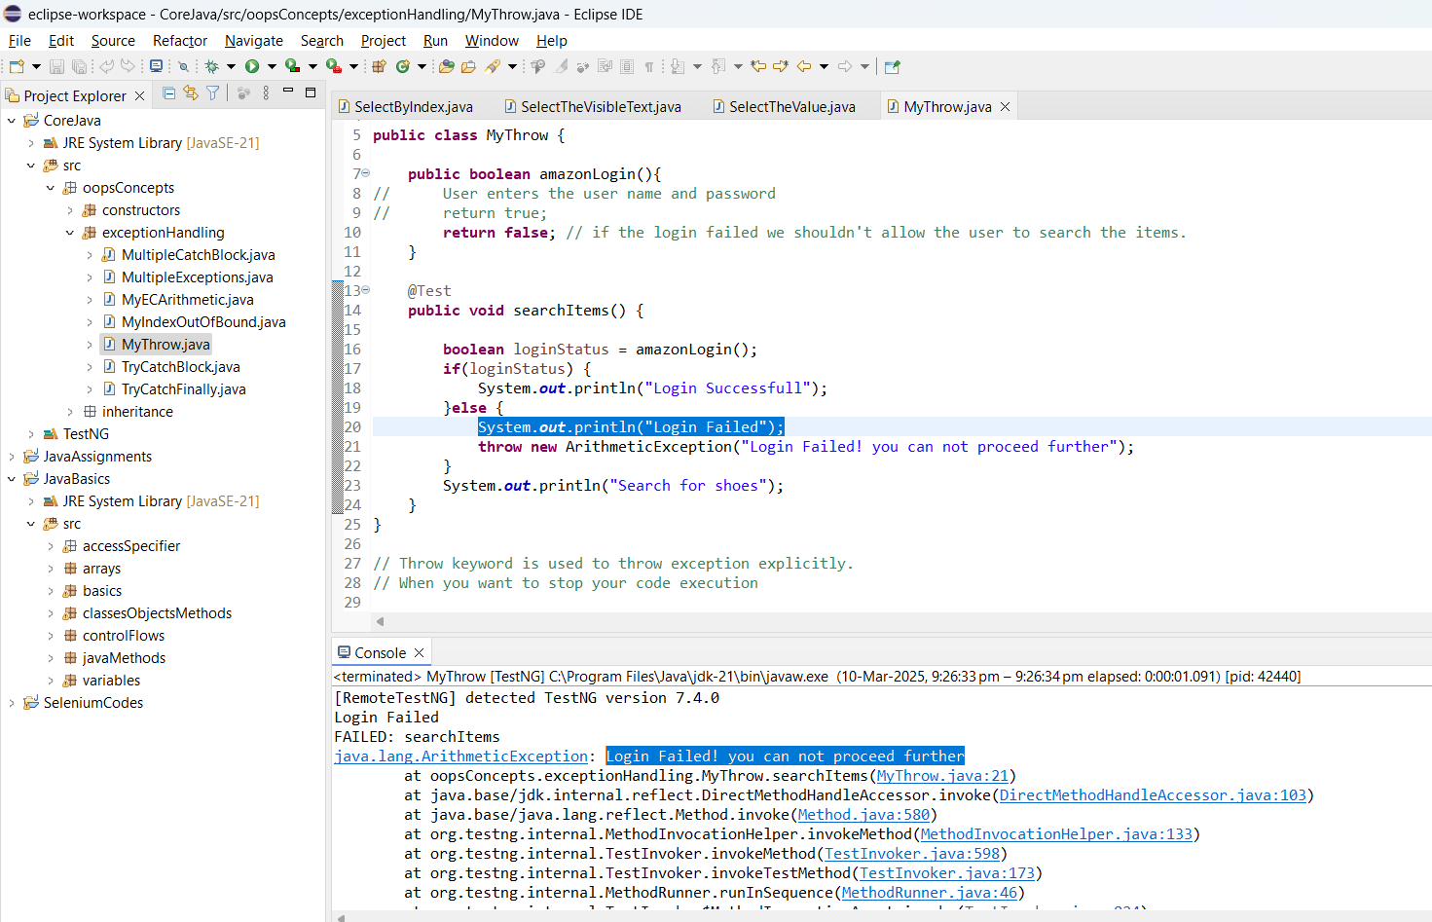

**MyThrowsException():**

// throws works like if any calls the method if the same method want to handle the exception, it will handle using throws,

If not it wishes to pass on to next method.

Hence, Throws is like Passing the Parcel Game.

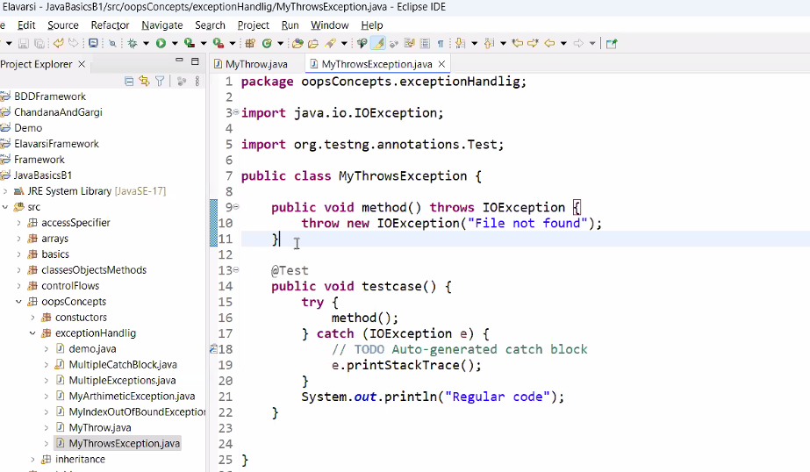

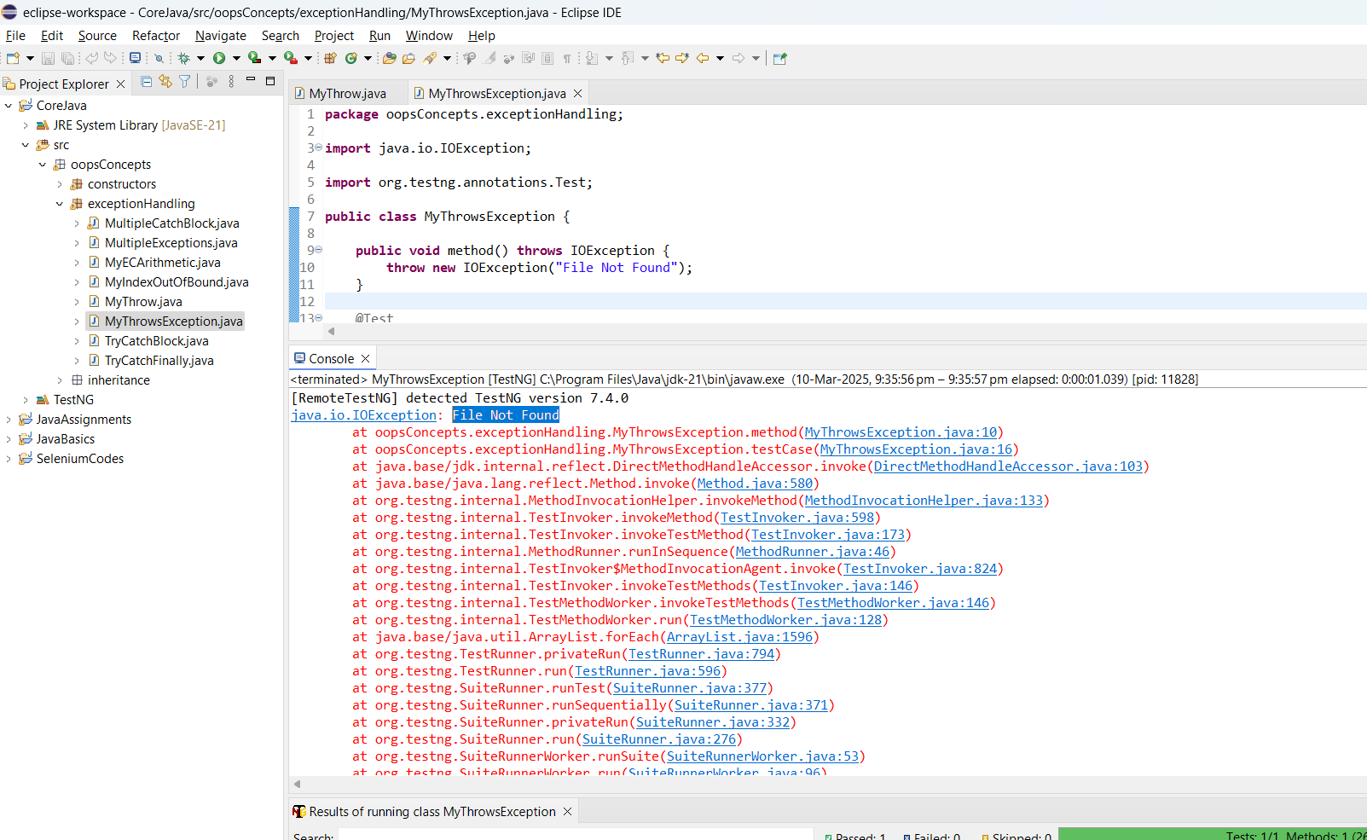

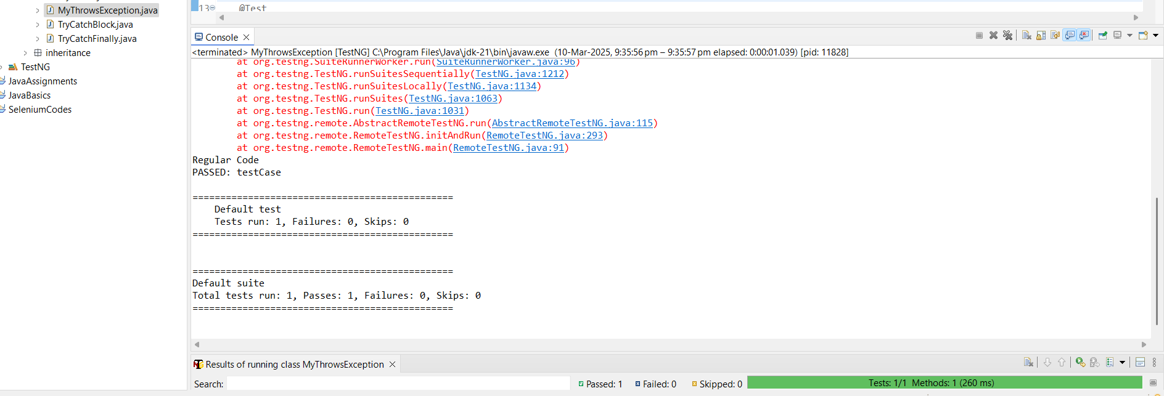

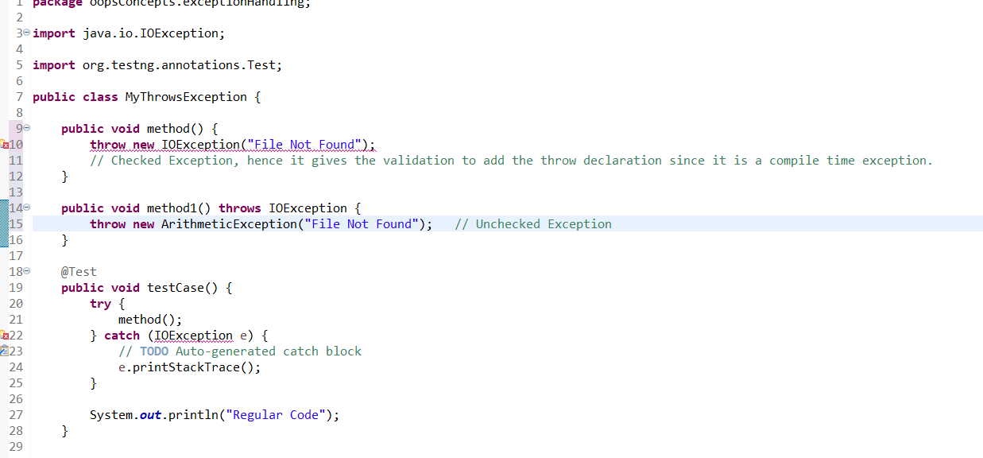

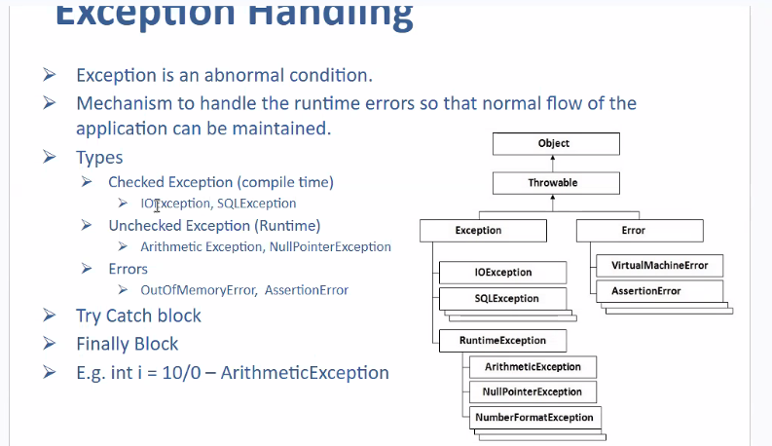

1. When we are not aware what to write in Catch Block, in this case we can throw the exception using Throw/Throws

Then whoever calls the method, they may handle the exception they also can pass on the exception to the next method.

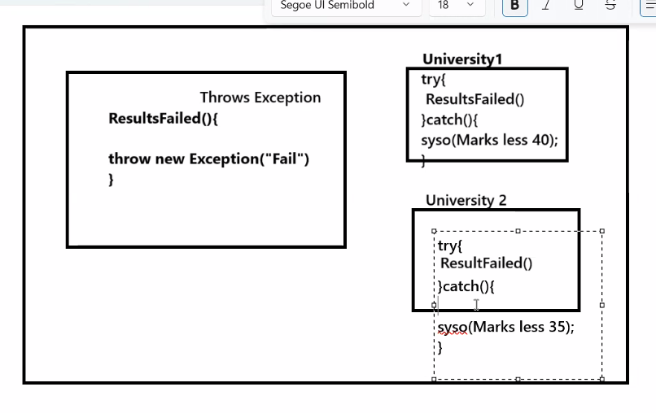

**Interview Quest:** What is the difference between Throw and Throws?

Examples:

**MyThrowsException():**

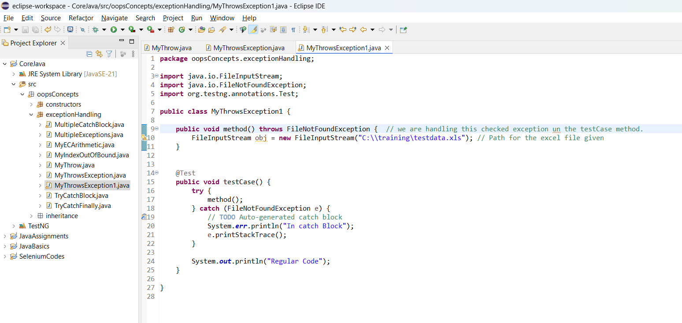

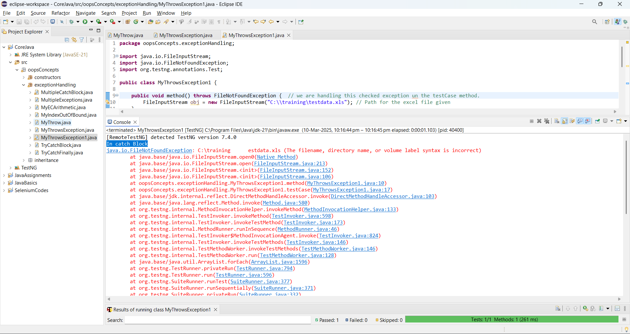

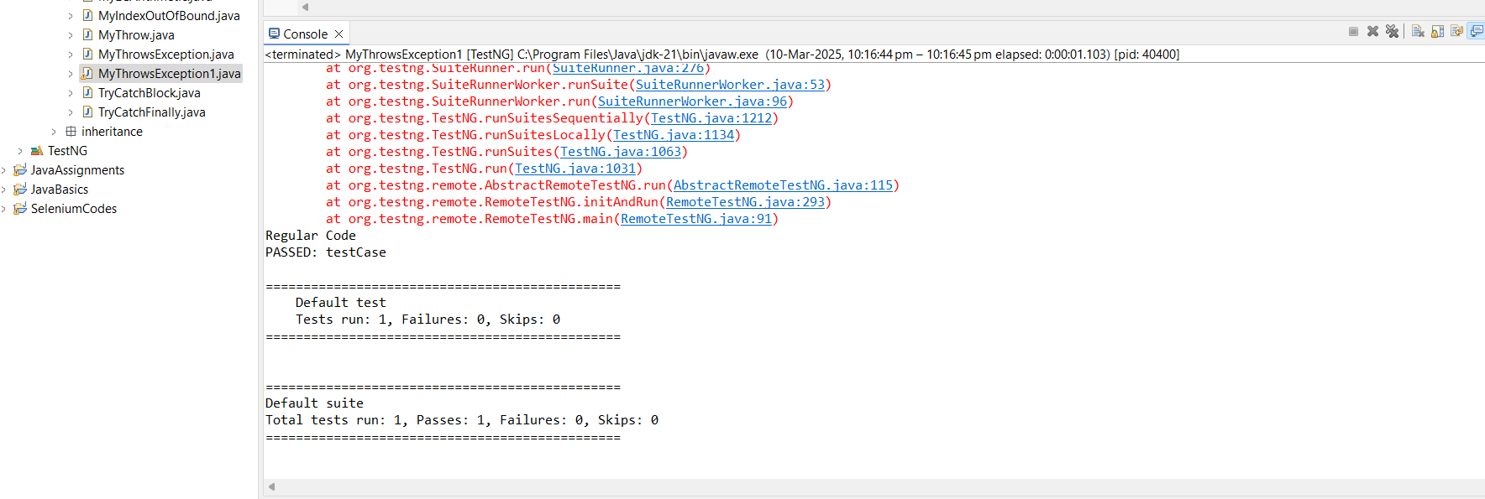

**CLASS 21: (Day 28)**

We can throw multiple exceptions

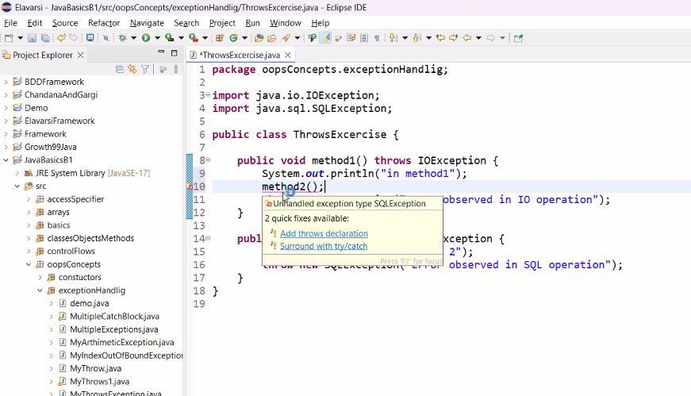

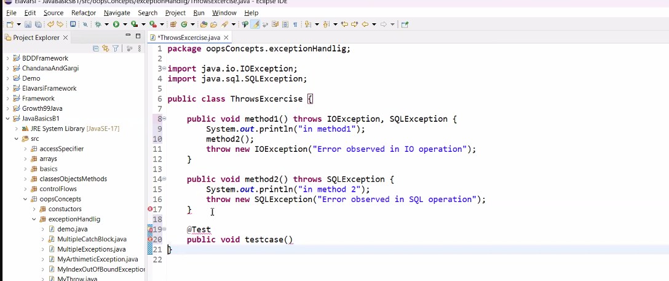

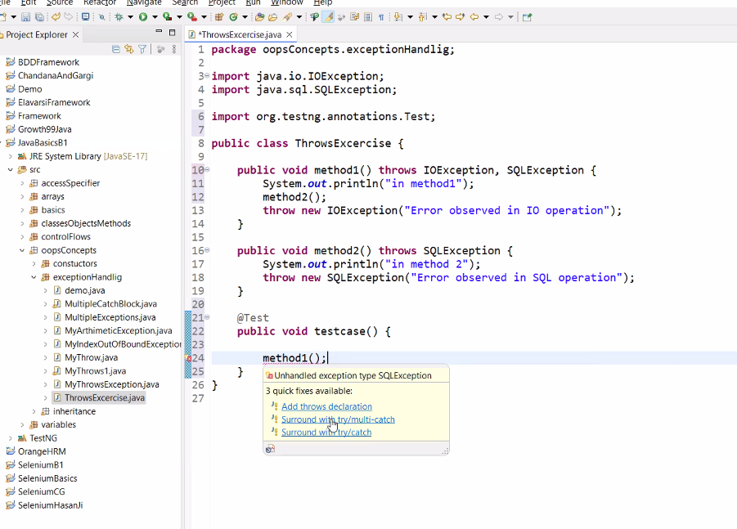

Using Multiple Catch blocks:

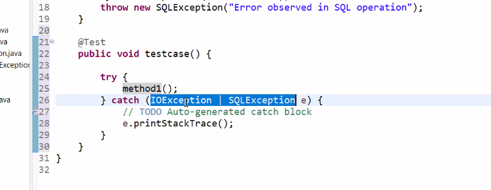

OR

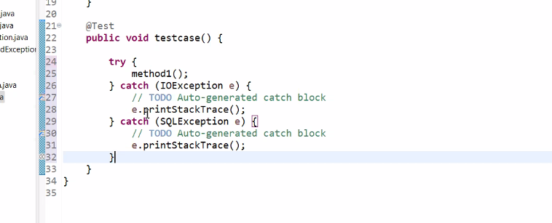

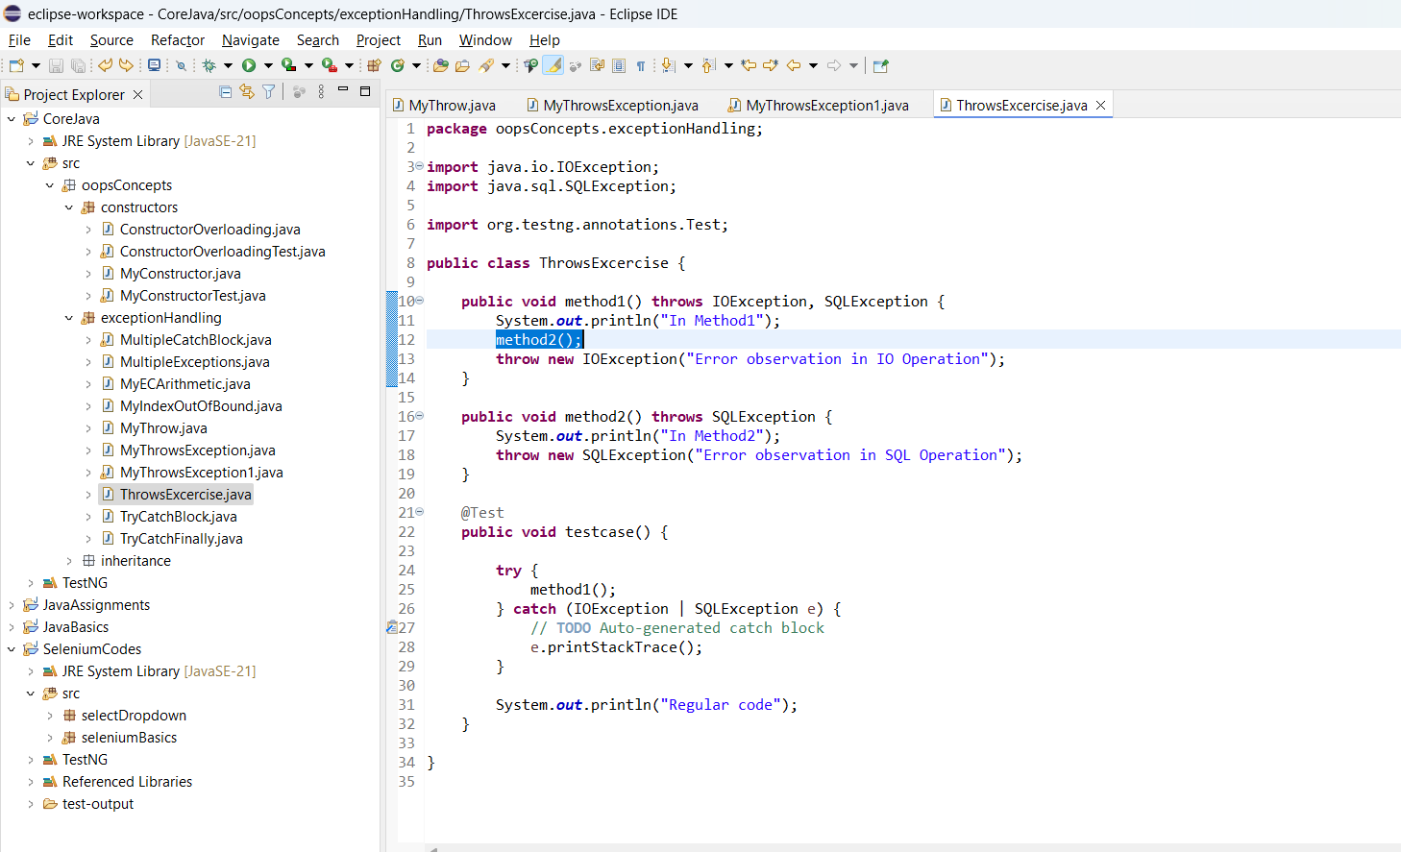

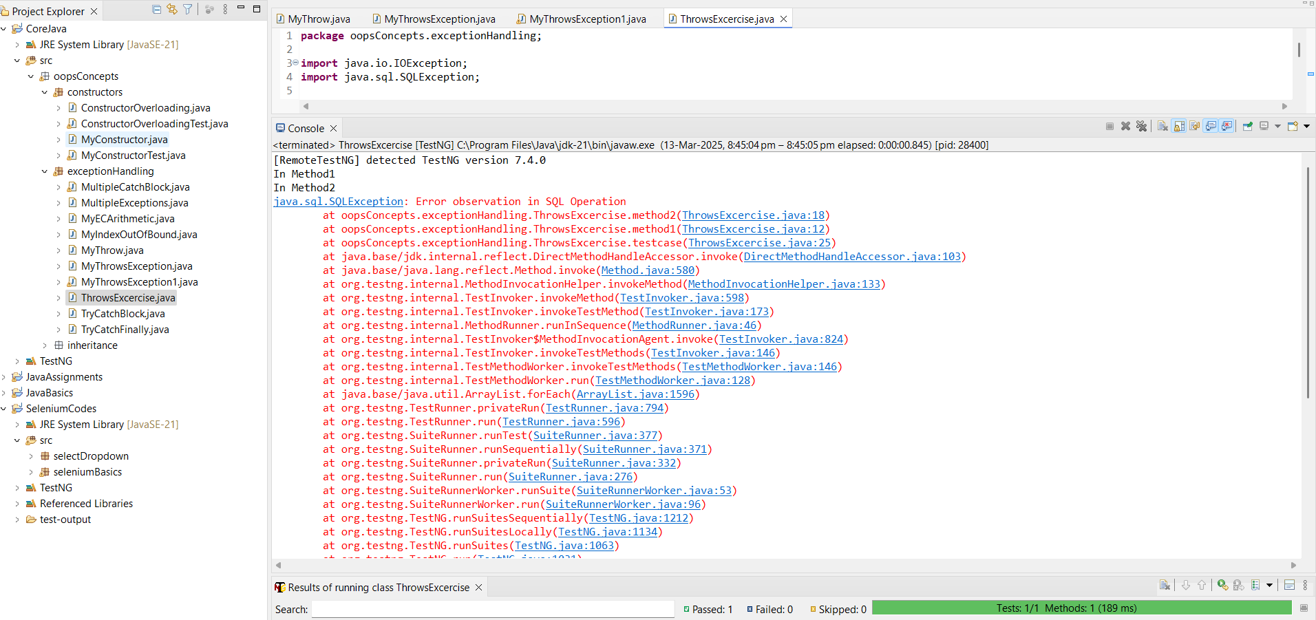

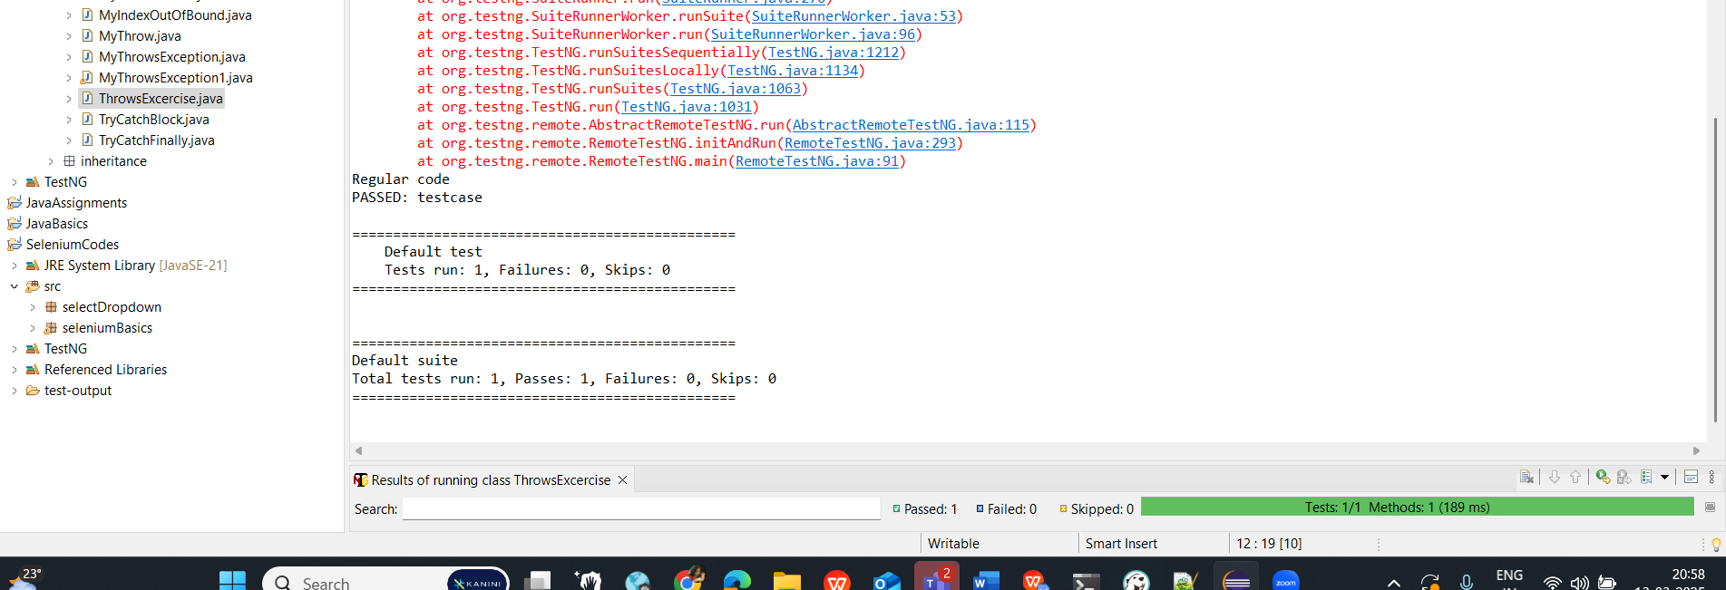

(Jumped to Selenium concept for today from here).

**CLASS 22: (Day 29)**

**Continued from Selenium - CLASS 9: (Day 29)**

**ENCAPSULATION**

Scenario: Different classes, Same methods -> Steps are same only the passed input data is getting changed

**Advantage of the generic class creation:**

Code Reuse-ability

Code optimization  
  
Example:

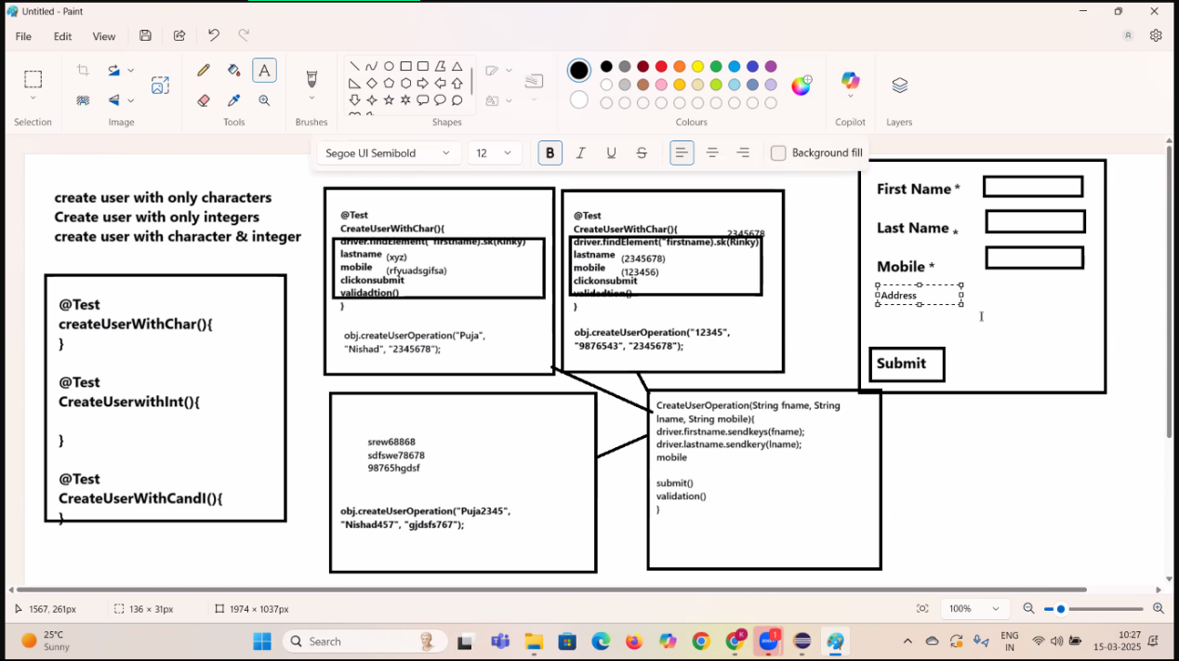

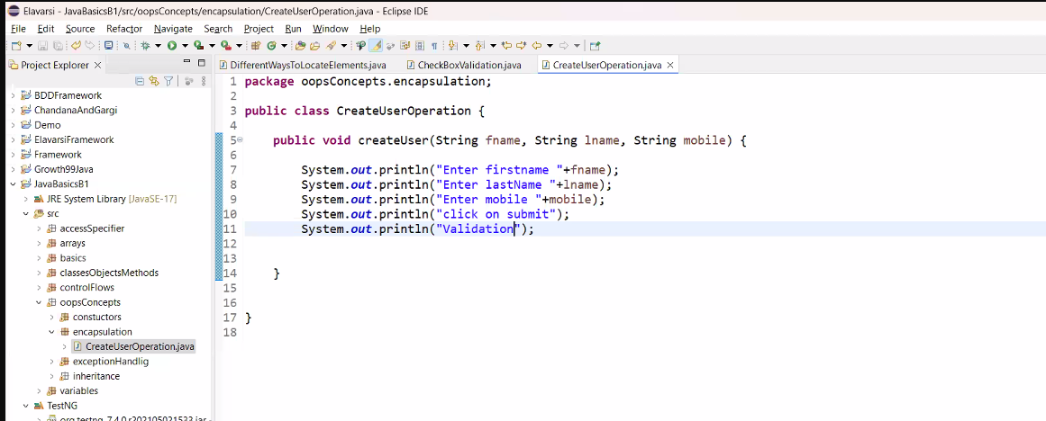

If a new field is added in UI in near future for that we can use Method Overloading method to add the TCs for the new field added,

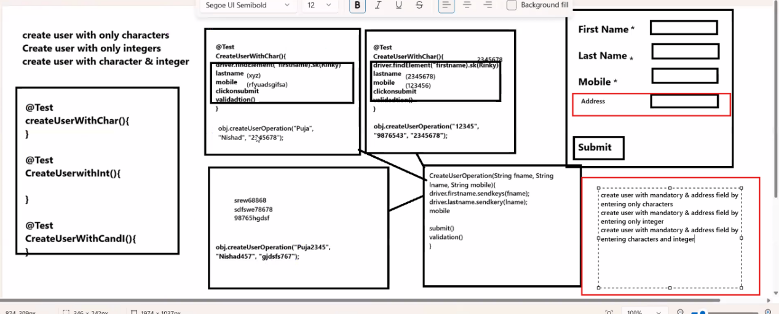

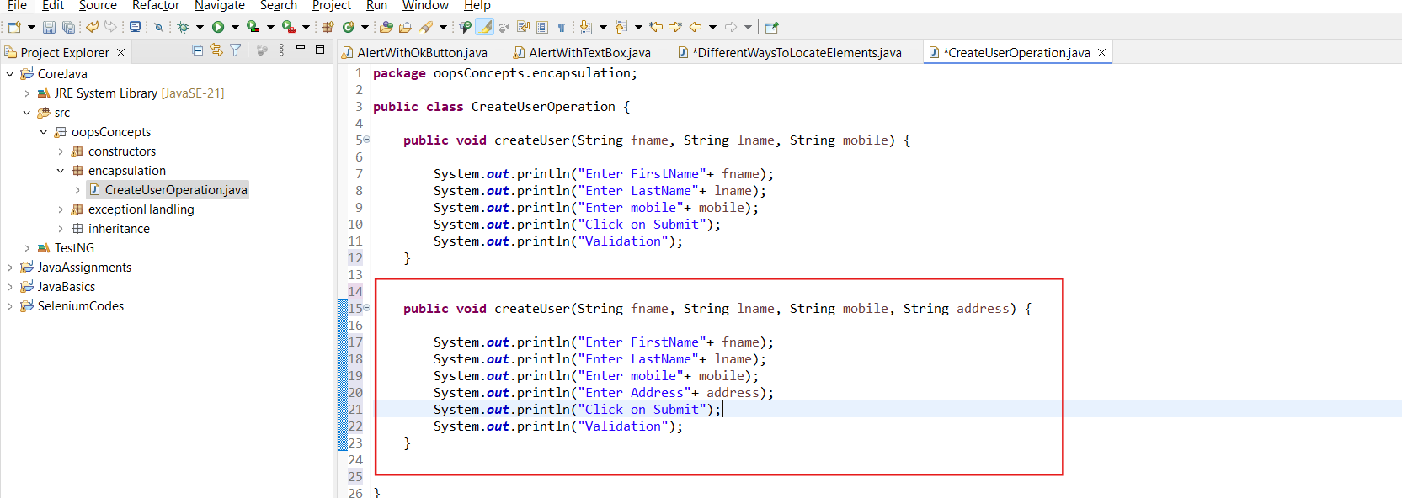

Down the line if some more multiple fields added in the UI then every time going back to test cases and add methods for all the fields is so complicated and increases the code length.

This is not the best approach, hence to overcome this issue, we use **Encapsulation.**

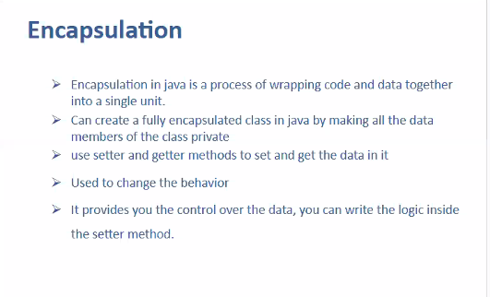

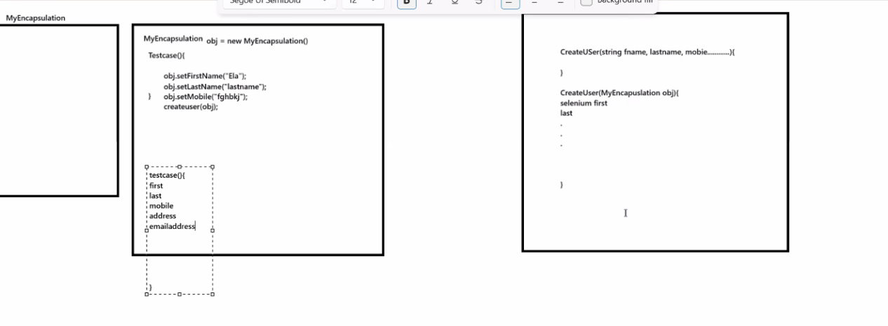

No need to create multiple method,  
create only 1 method

Based on the data available in the obj, selenium code going to get executed.

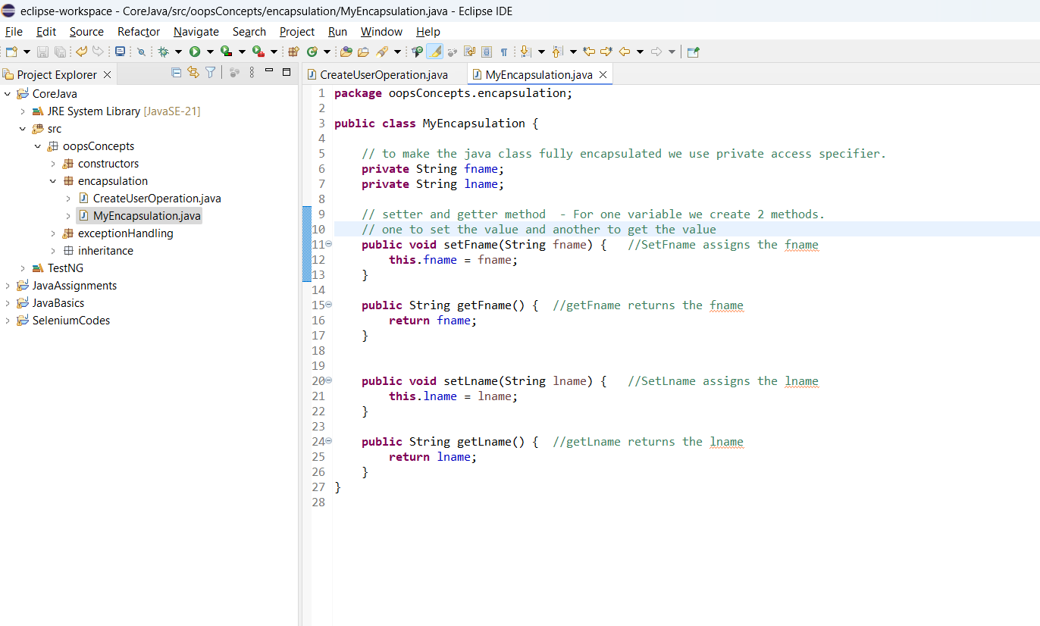

Right click > Source > generate Getter Setter

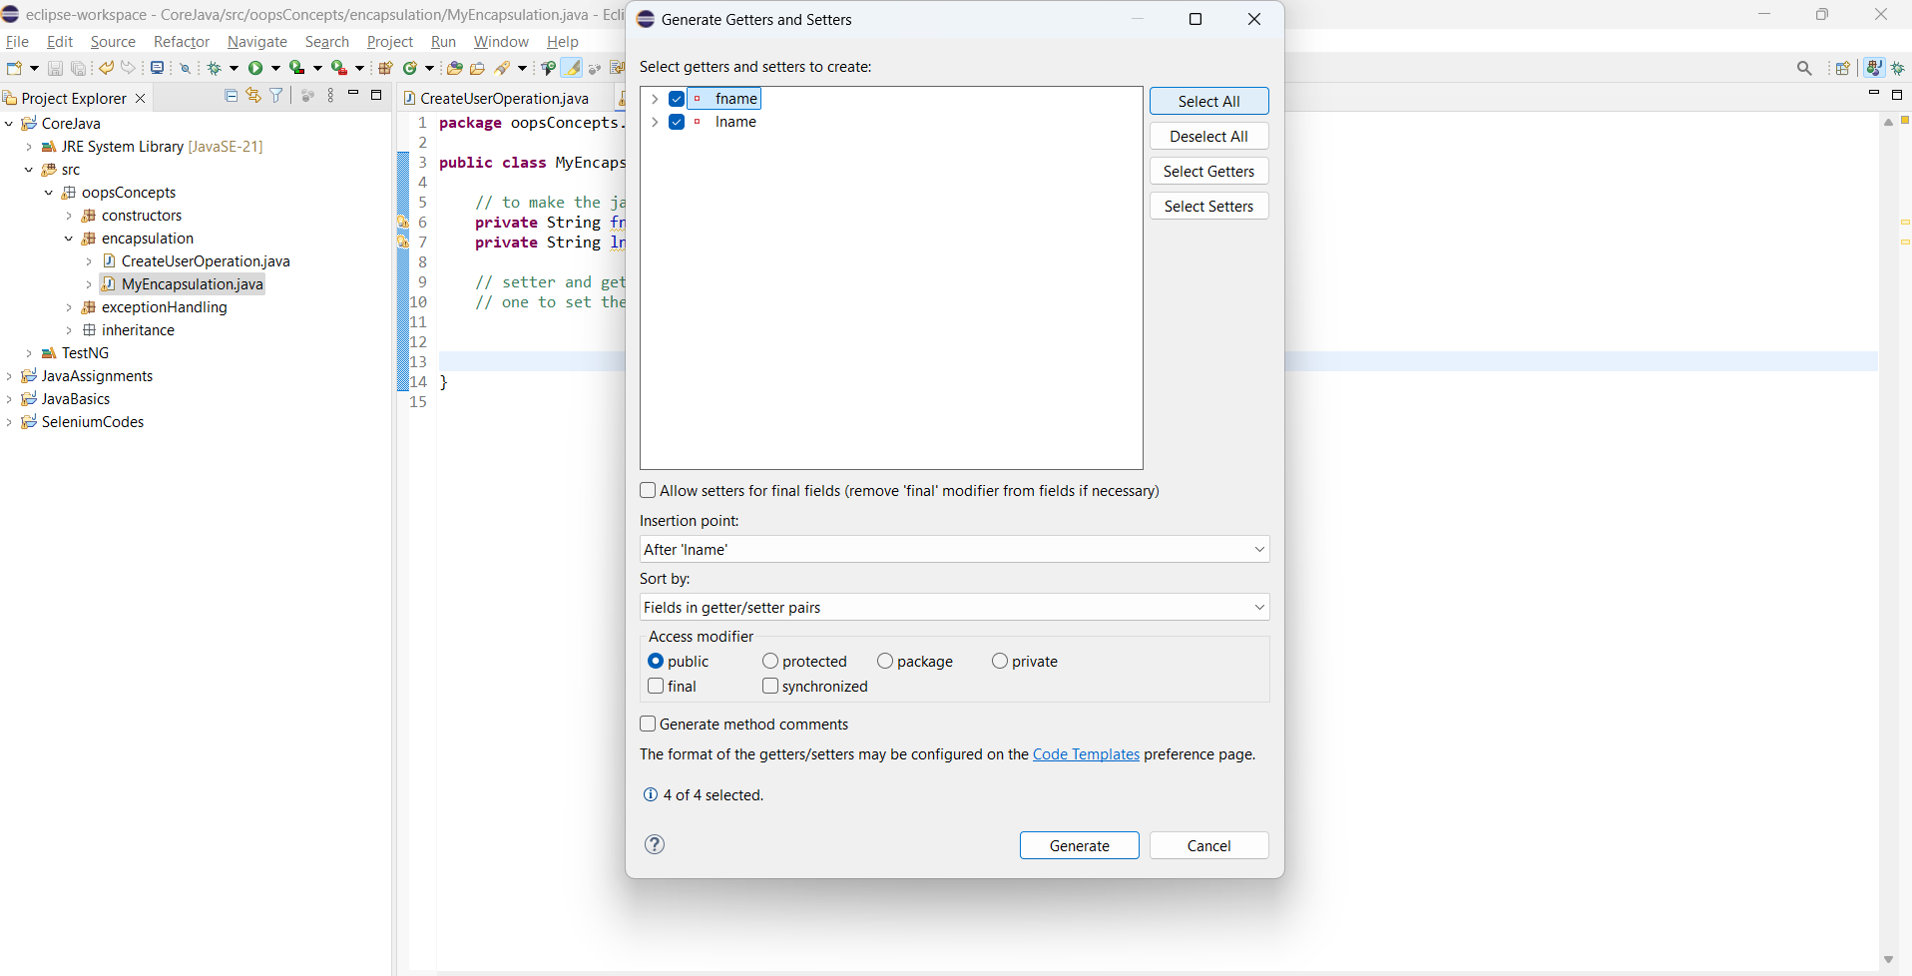

Example of Encapsulation:

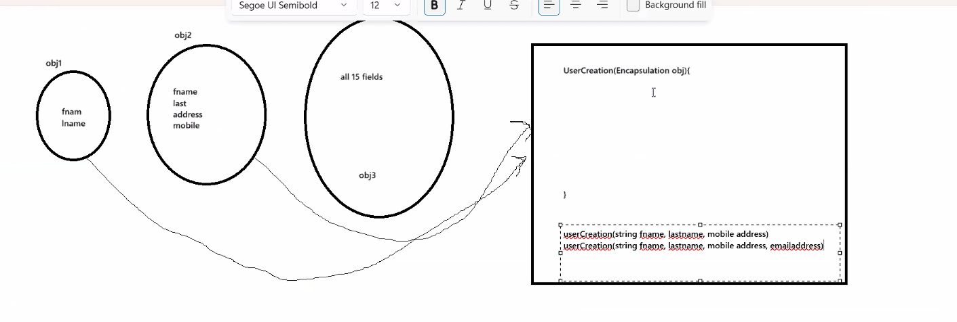

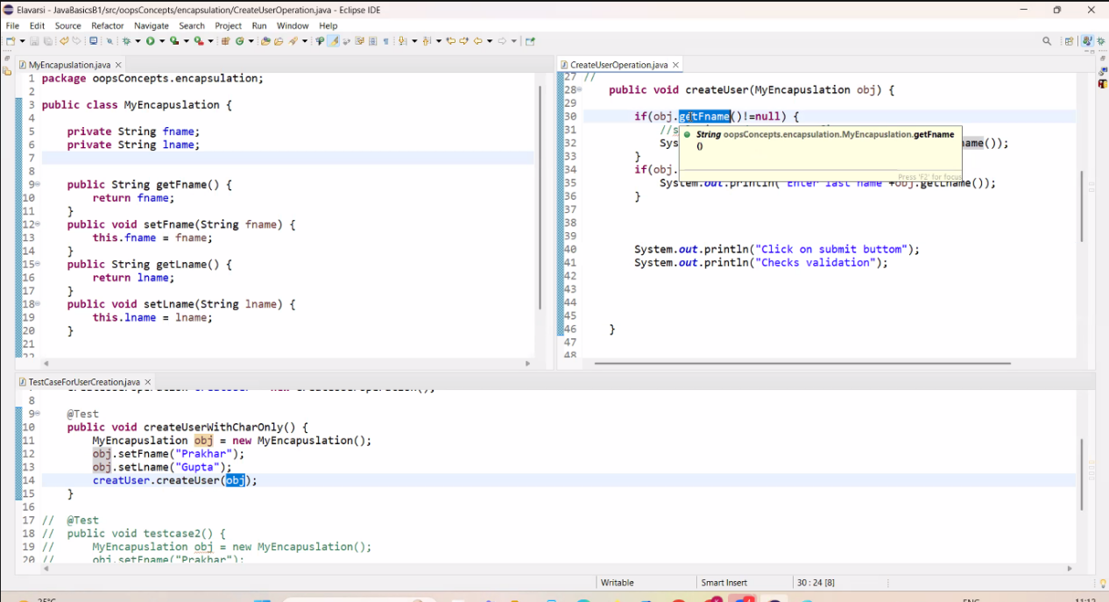

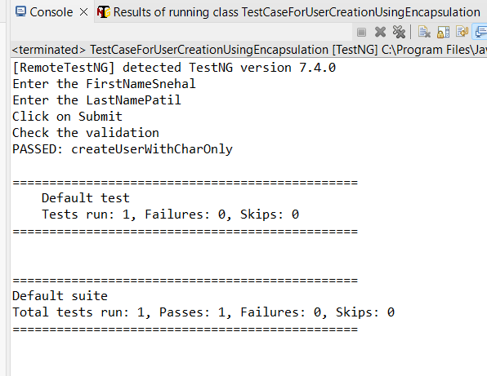

Encapsulation > MyEncapsulation.java

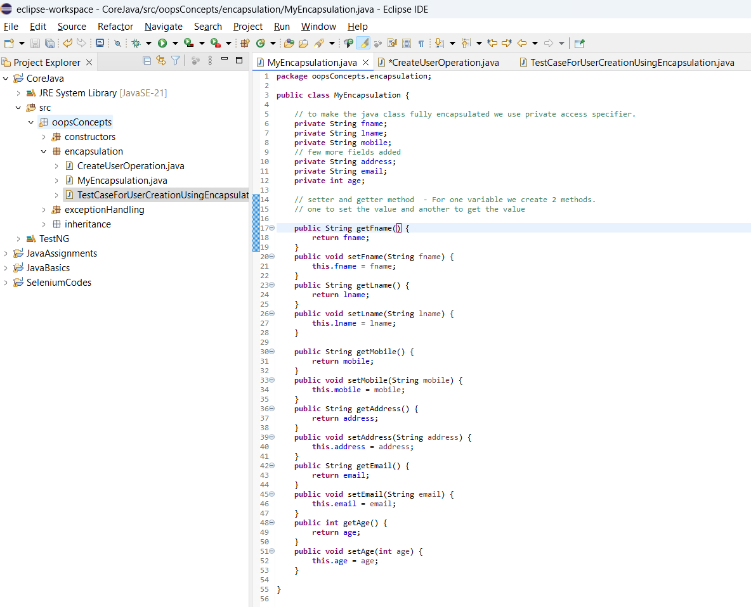

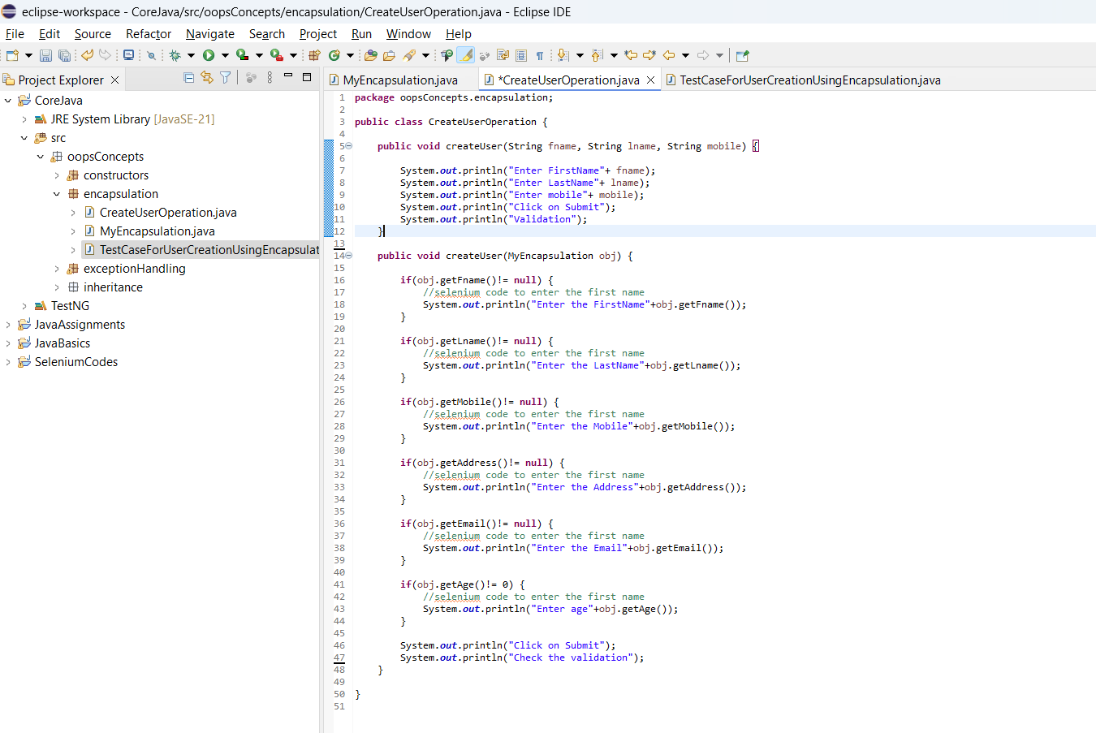

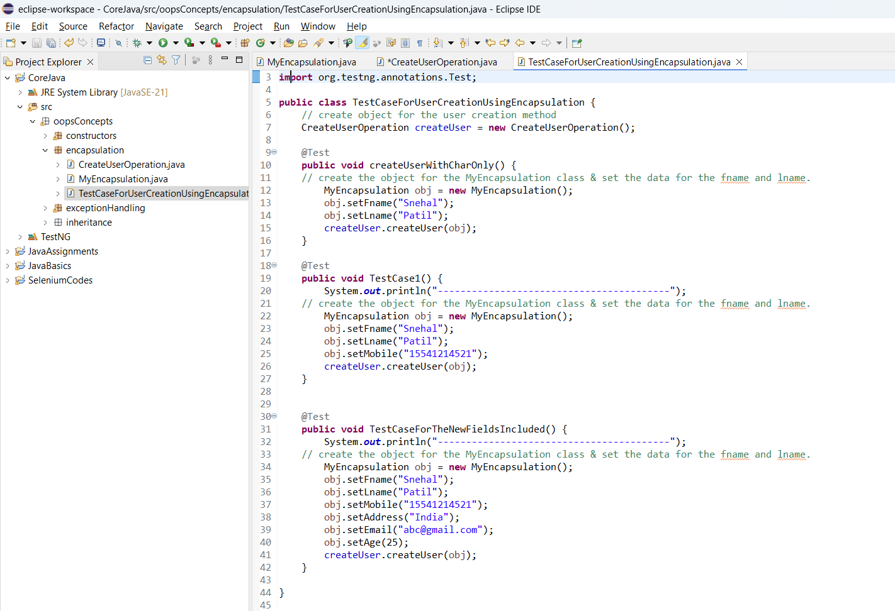

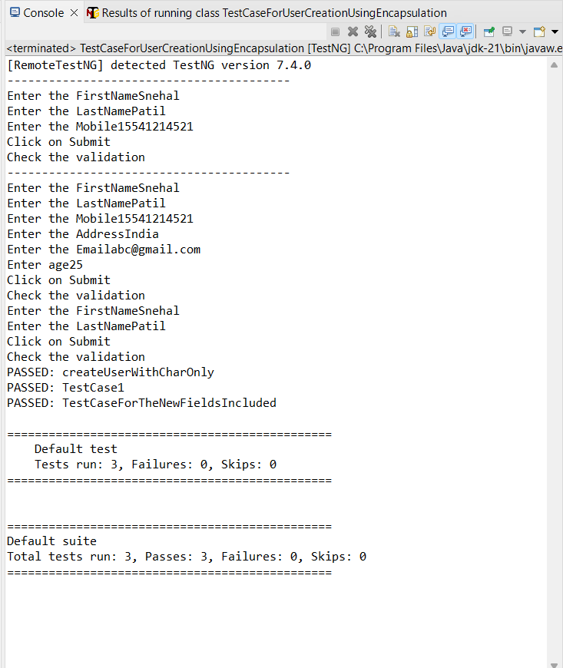

**CLASS 23: (Day 35)**

**ABSTRACTION**

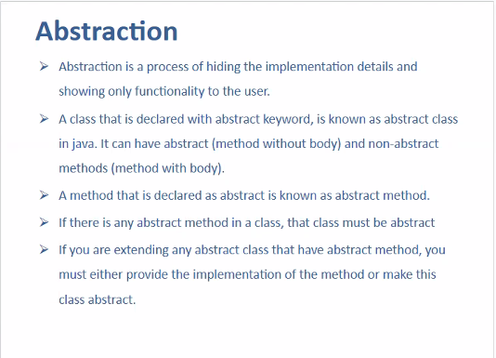

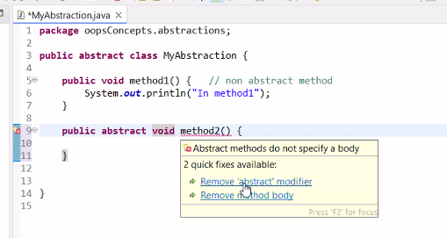

declaring a method without body or without code and with abstract keyword -> it is called abstract method.

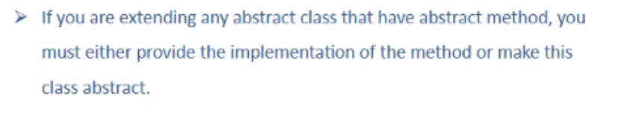

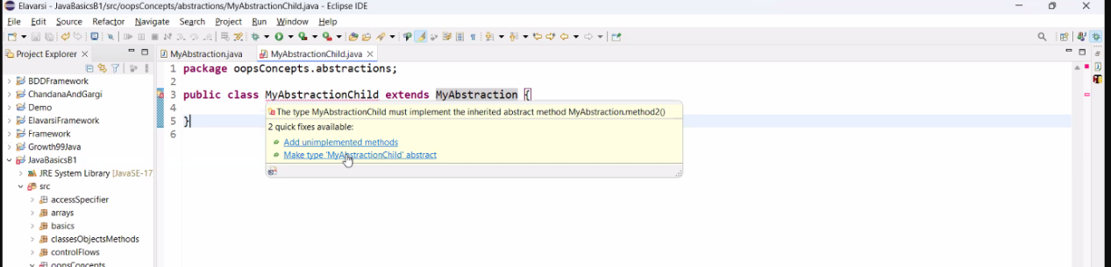

* We can implement the abstract methods in Child class Using Inheritance method.

**NOTE:**

* we can have abstract method only in a class.
* we can have only non abstract method only in a abstract class.
* we can have non abstract and abstract method in a abstract class.
* if class is not having abstract keyword, we can't have abstract method in the same class.
* Can I create object for abstract class? - NO.
* Where we can implement the Abstract methods? - In Child Class using Inheritance
* In Child class, can we have Abstract methods? - Yes, Class should be an Abstract is the condition.

1 2

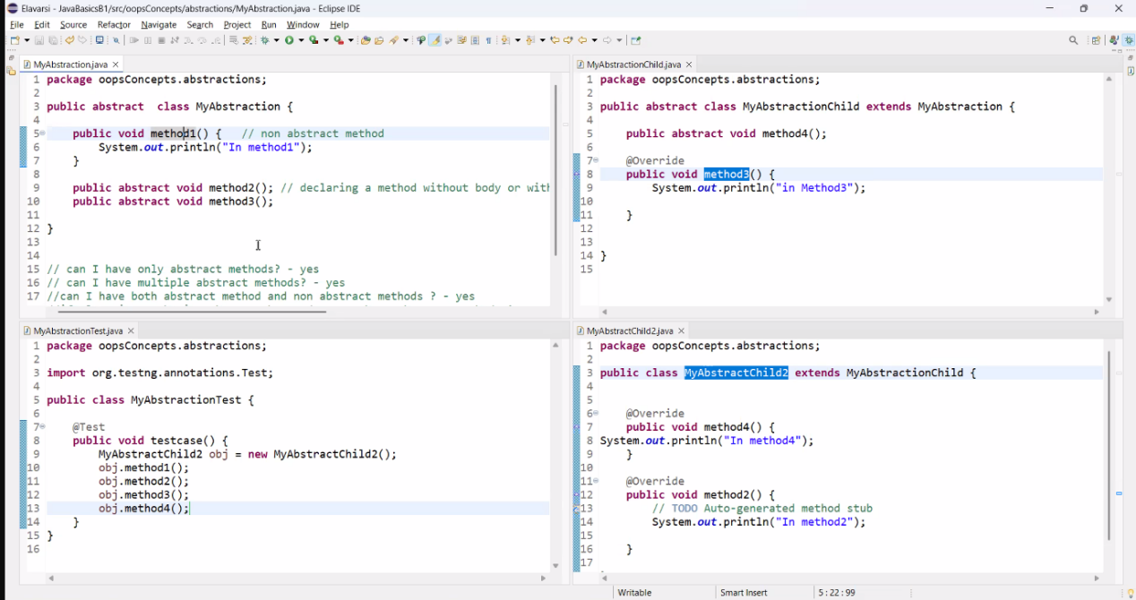

1. 3

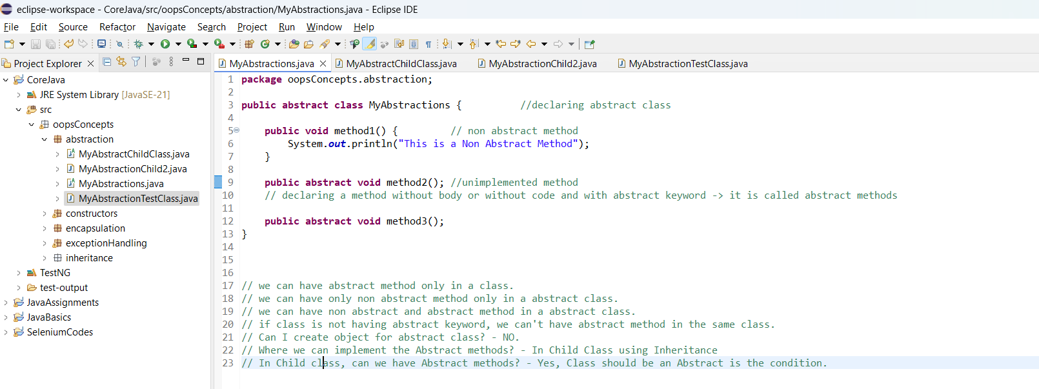

**When to use the Abstraction?**

Wherever we will have the same functionality to perform on multiple different platform (Webapp / Mobile / API), and have the different codes on each platform.

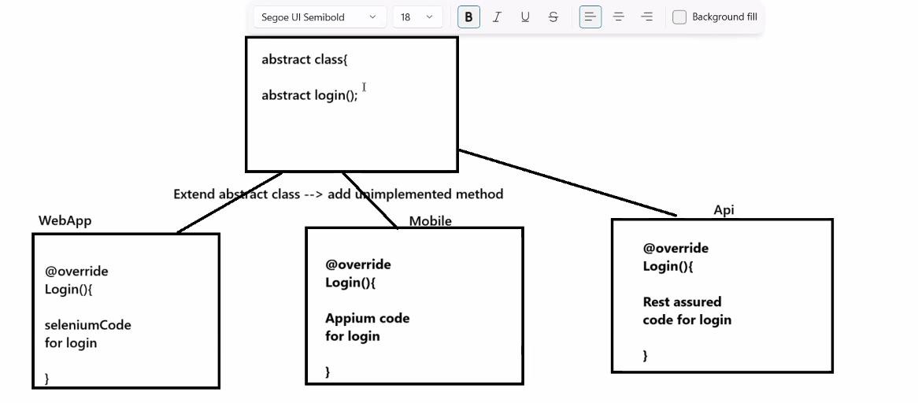

**INTERFACE:**

(It is an extended version of the Abstraction)  
  
Can I Implement Methods in Interface ? -> Yes, but method should be either static or default.

We cannot create object for the abstract class in interface? -> No

Where we can implement the Abstract methods declared in Interface? - In Child Class using Inheritance using implements keyword.

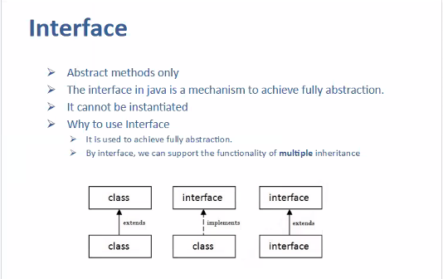

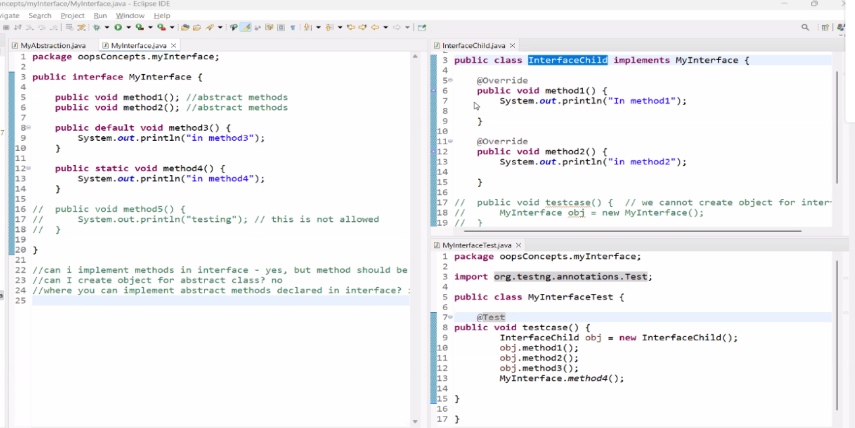

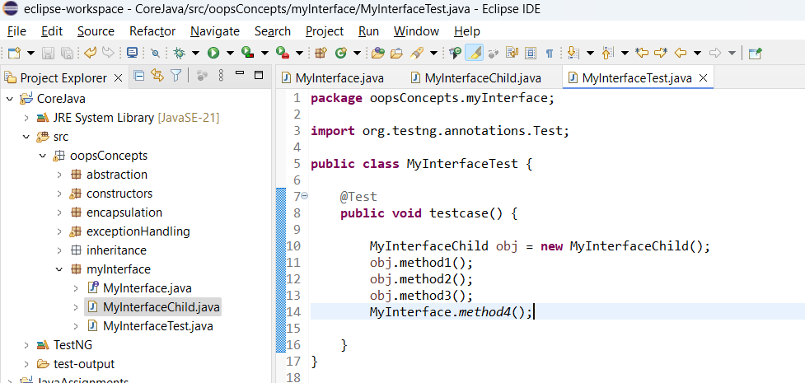

Assignment Task:

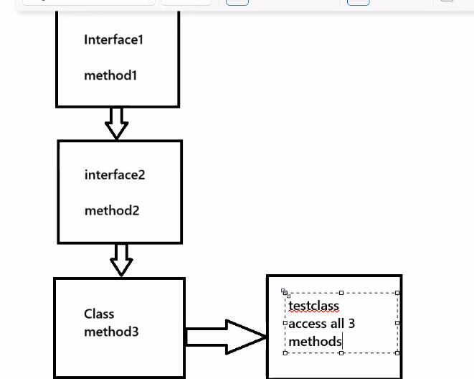

**NOTE**:

Class to Class inheritance - extends keyword

Interface to Class Inheritance - implements keyword

Interface to Interface Inheritance - extends keyword

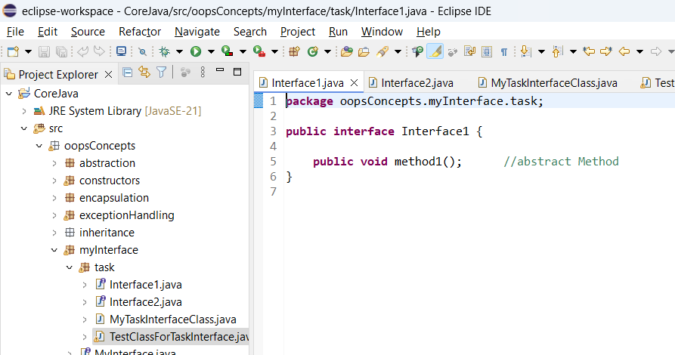

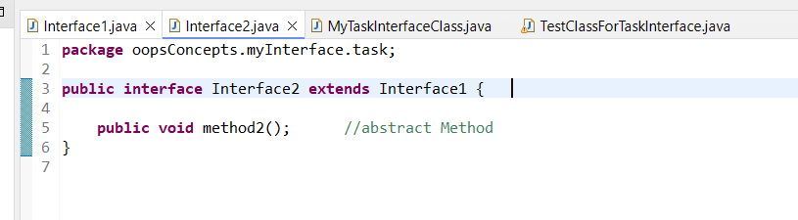

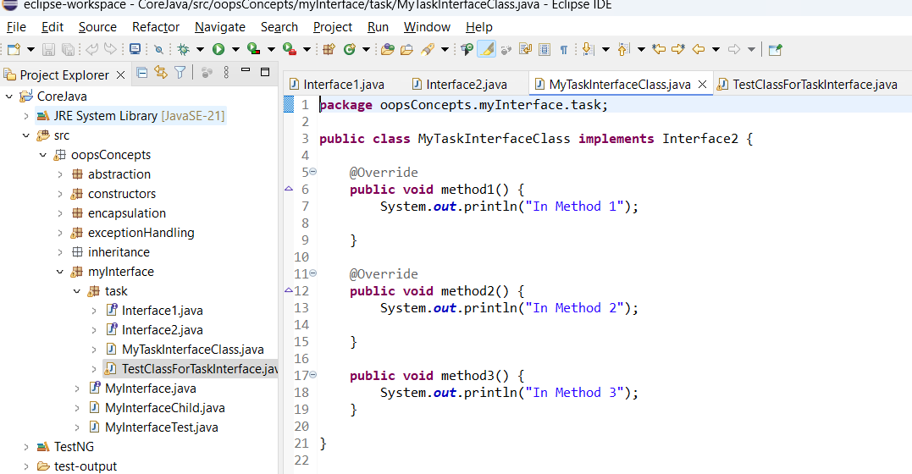

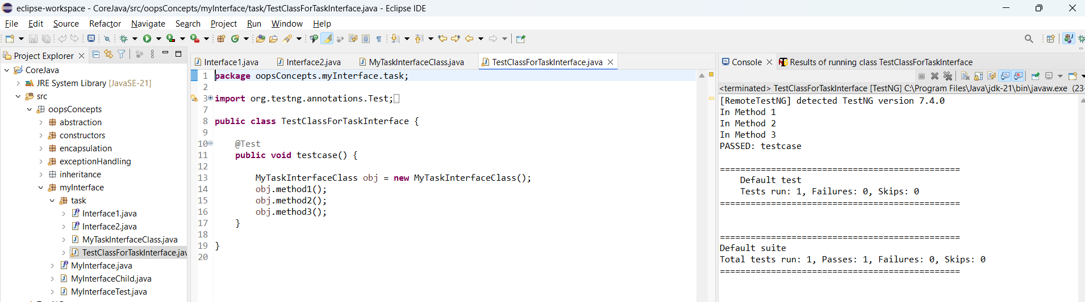

**Multiple Inheritance using Interface:**

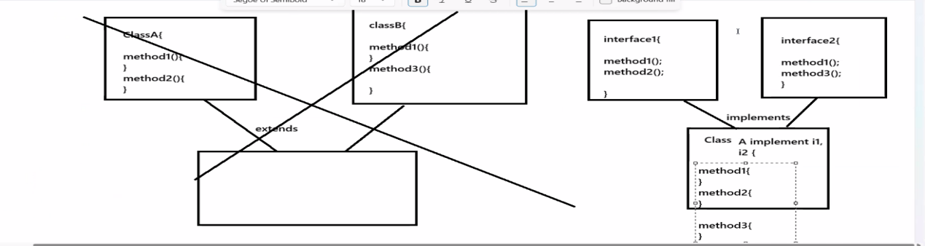

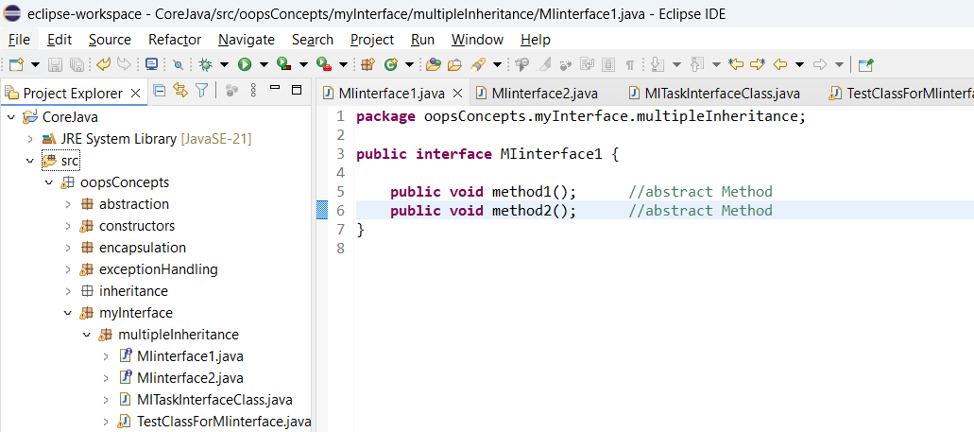

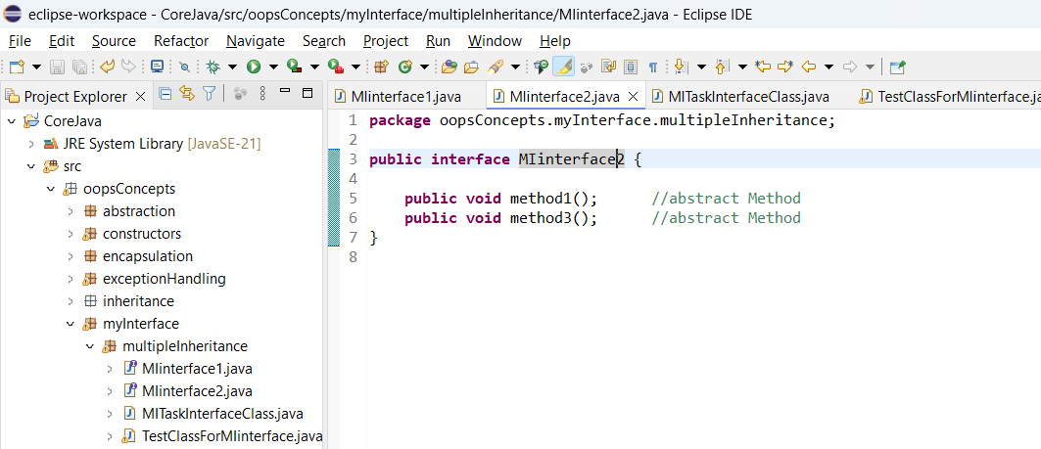

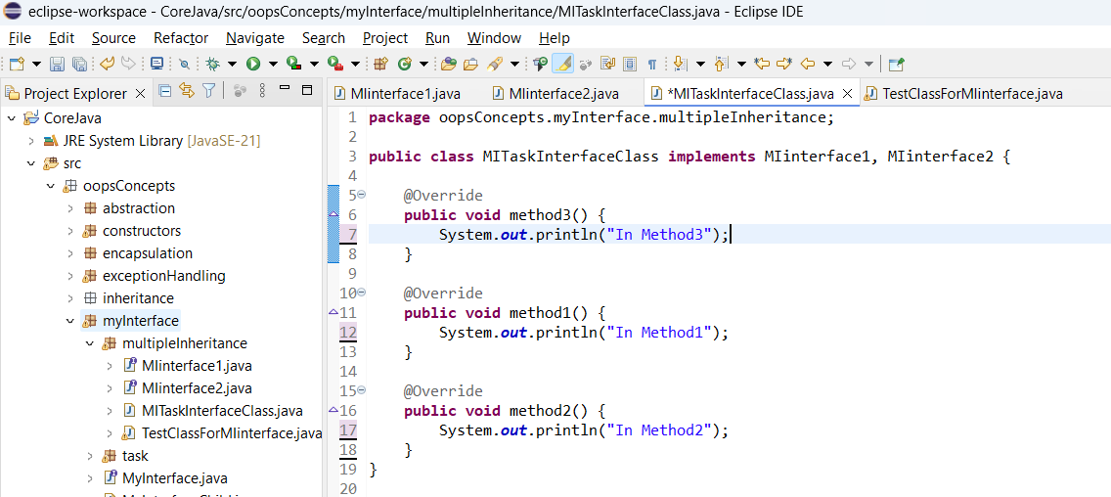

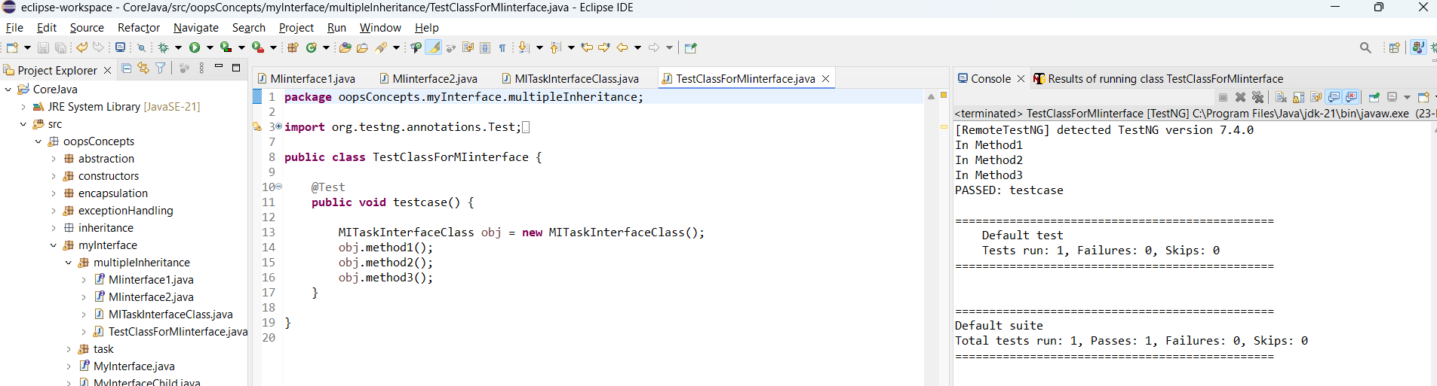

**CLASS 24: (Day 37)**

**Collection Framework:**

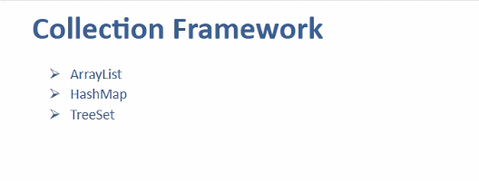

**ArrayList:**

* Difference between the Array and ArrayList:

**ArrayList ->**

* Array list Allows duplicate values
* In case of duplicate values - while removing the recent one gets removed.
* Order of insertion is maintained

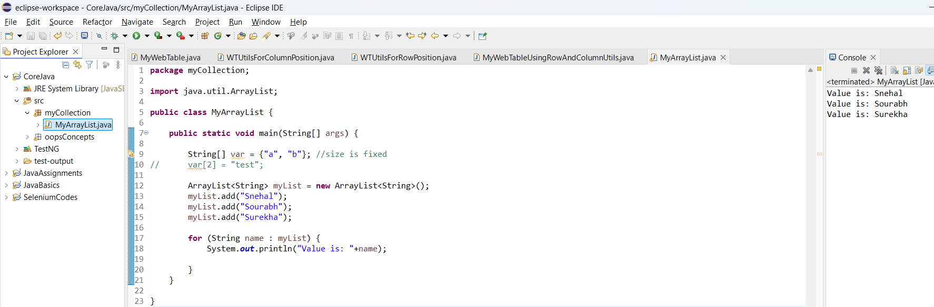

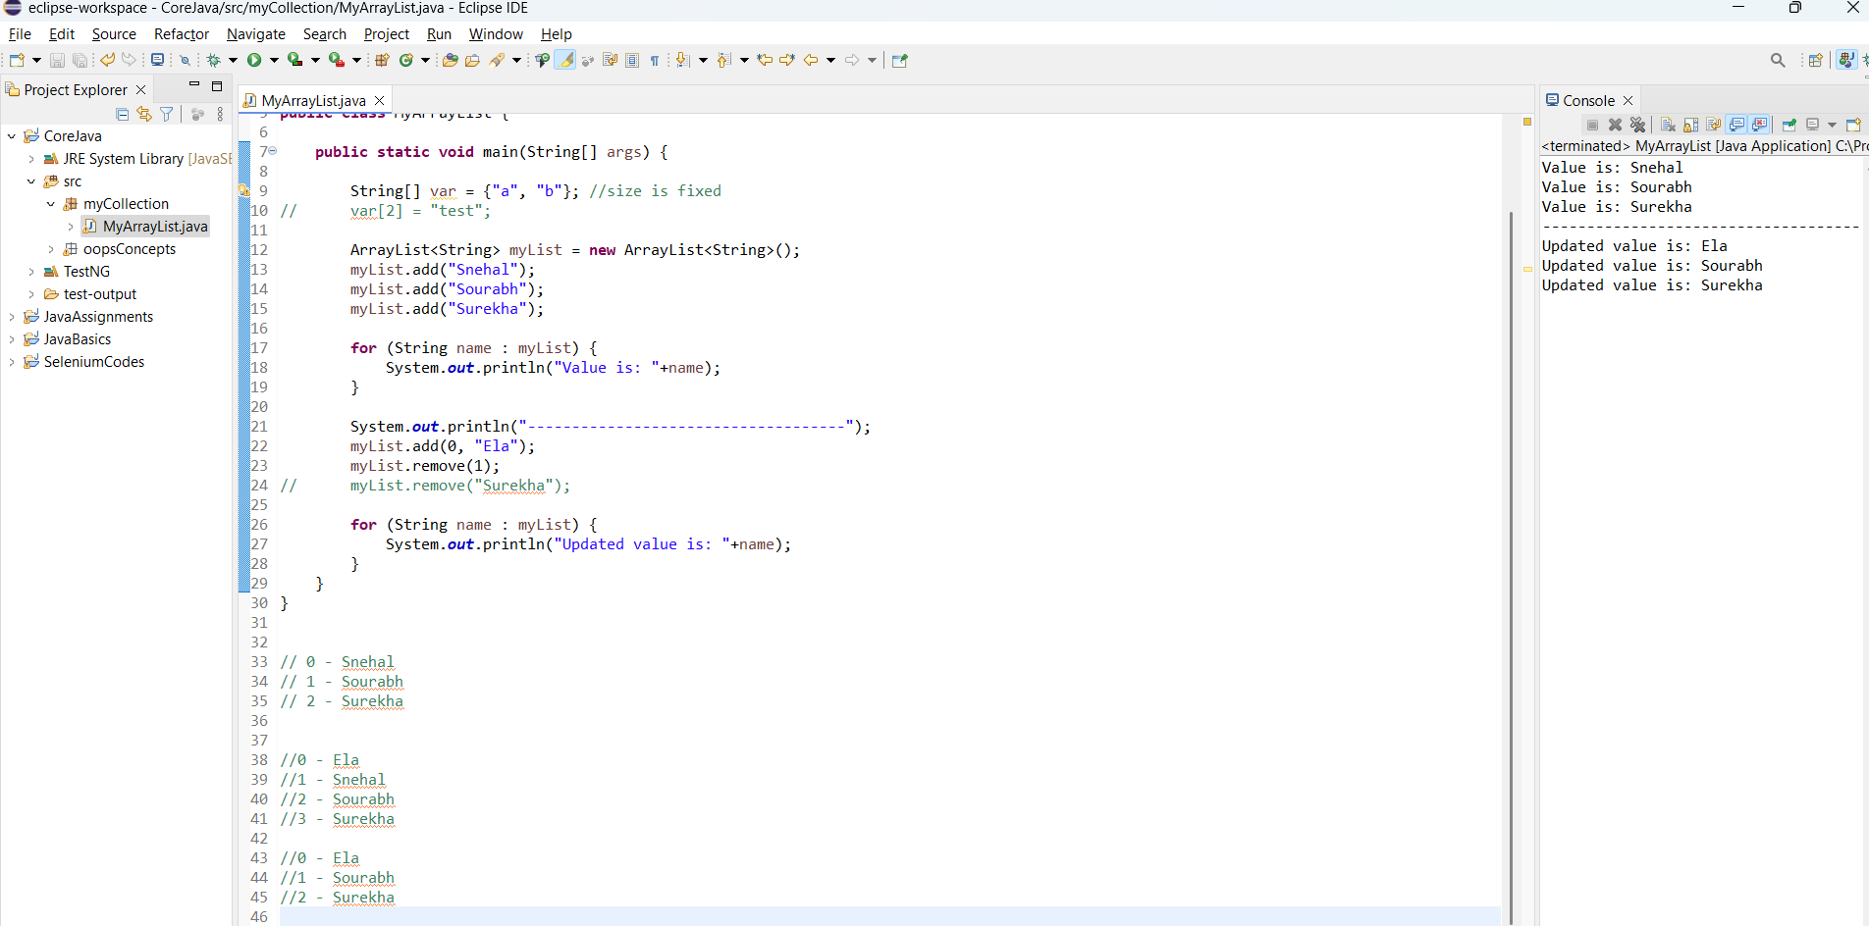

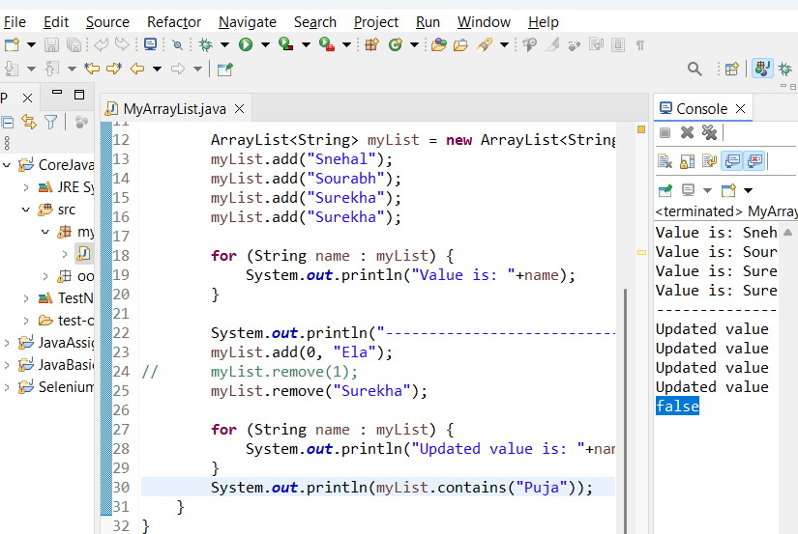

**MyHashMap:**

HashMap holds the data in Key Value pattern

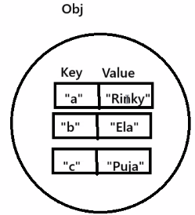

**Format for the HashMap - ForEach loop:**

**for** (Map.Entry<Integer, String> item : map.entrySet()) {

System.***out***.println(item.getKey()+" : "+item.getValue()); //11 : Asha

}

// Are duplicate values allowed in HashMap? -> Yes

// Are duplicate Key allowed in HashMap? -> Yes, but it overrides the existing value.

// Hence, the Key should be unique in Hashmap

// Is insertion order maintained in HashMap? -> No

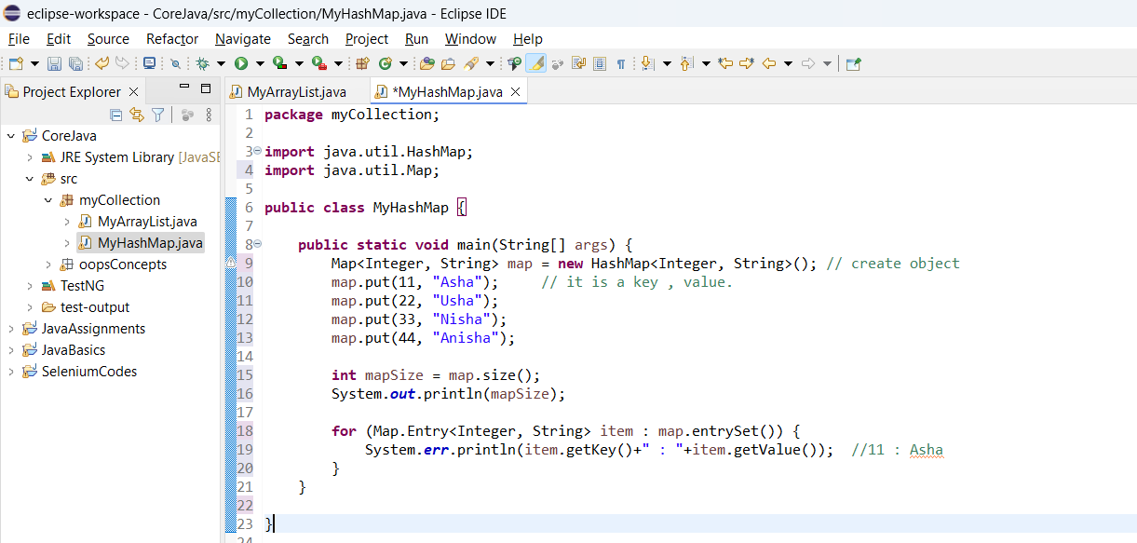

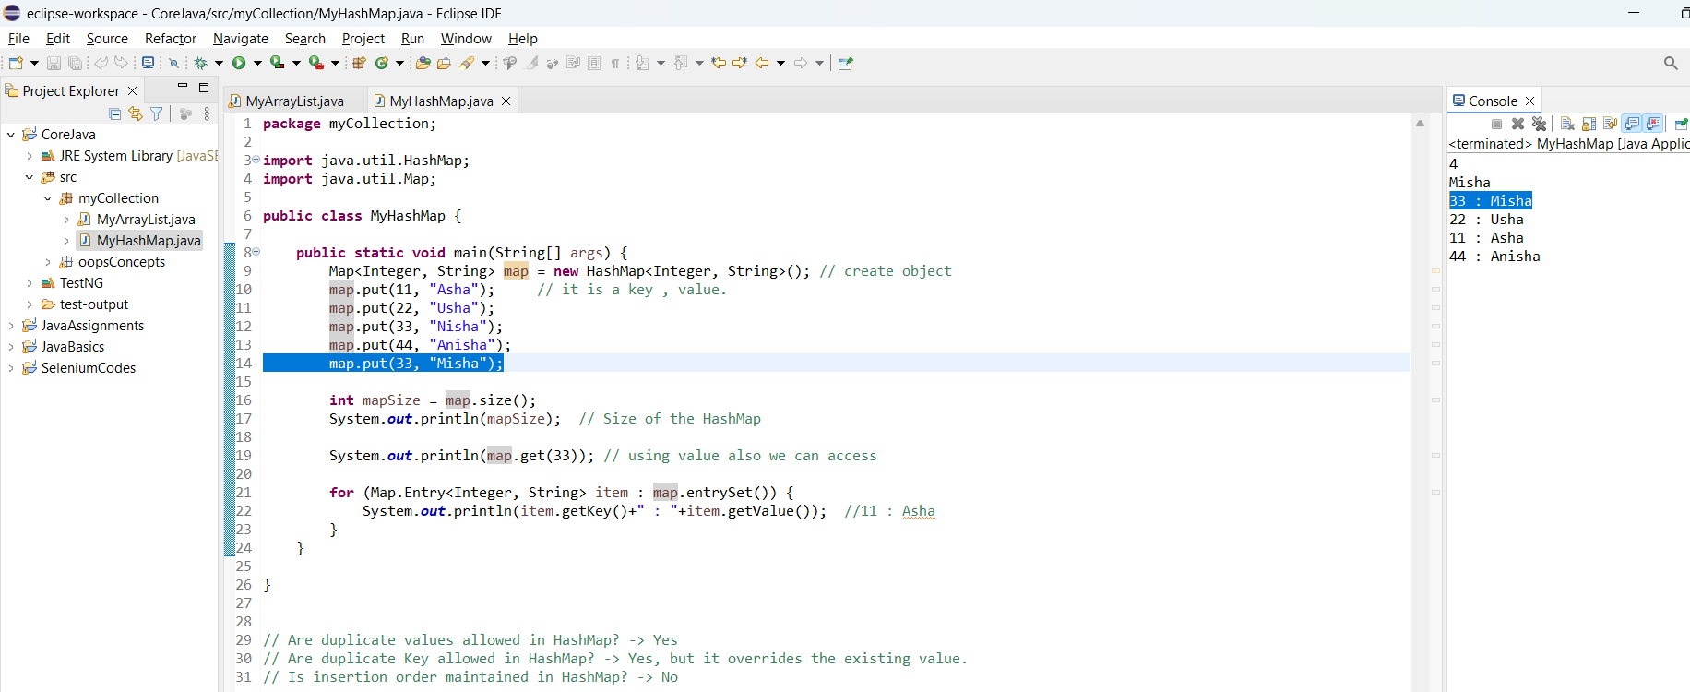

**When to use HashMap? :**Let’s consider the register / login form as shown in below image,

**Advantage:**Data Maintanance,  
Readability,  
Easy to update the data,  
Used more in Selenium Automation

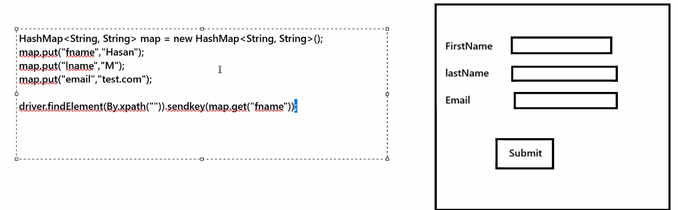

**TreeSet():**

Set<String> mySet = **new** TreeSet<String>();

// Is insertion order maintained in HashMap? -> No

// Prints data is ascending order and is case sensitive.  
// if any integer is given as string, that will be printed first.

// upper case will be prioritized first

// Duplicates are not allowed.

* Whenever user wants to print the output in Ascending order, user can go for TreeSet().

